Direct water cooling effect on a photovoltaic module
B Mtunzi and E Meyer
Fort Hare Institute of Technology
University of Fort Hare
P Bag X 1314, Alice; 5700; bmtunzi@ufh.ac.za

Abstract. This paper gives the details of photovoltaic water heating system (PVWHS) and the effects of direct water cooling on the performance of a photovoltaic module. One SP 70 mono-crystalline modules was used in this investigation. It was fixed on a north facing rack located on roof top. It had a batch water cooling container with water in direct contact with the back of the module. The water cooled module was noted to operate at an average temperature of 43°C on a sunny cloudless day, as compared to temperatures of around 70°C that would be noted on an uncooled module outdoors at solar noon. There was noted to be due to cooling effect of water. Water in direct contact with the back of the module enhances heat transfer. This setup may increase the life span of the module and reduce the degradation of modules.
- Introduction
During service exposure, it has been noted that pv modules’ efficiency drops due to heat accumulation at the back of the module. This has been noted to affect the power output of modules. The efficiency of the modules has been found to decrease by approximately 0.5%/°C with every increase of one degree in cell temperature after standard test conditions (STC, 1000W/m2,AM 1.5, and module temperature of 25°C) [1]. An increase of 30°C above STC temperature would imply a power reduction of 15%. On sunny summer days the module temperatures may rise to around 70°C implying a further reduction in power output and efficiency of the modules. Such temperature effects need to be taken into consideration and reduced. Improved cooling would imply an increase or improved power output.

Several comprehensive reviews have been published that summarise the cooling methods of pv modules, [2]. In their review, these researchers noted that either air or water could be used as cooling fluid to cool the pv modules. However, the cooling effect of these coolants still needs farther research.

Air cooling has been achieved through circulating air past the module and in the process taking away heat from the module. Water cooling involved the use of water tube risers that are soldered onto a copper conducting plate. This plate is fixed at the back of the modules. Water in these pipes then flows through thermosyphon effect and in the process cools the module or is circulated through by a pump. A situation that involves cold water getting in contact with the back of the module is assumed to be able to bring down the module operating temperatures. Water in direct contact with the back-sheet has the potential to improve the yield of the modules as there is less thermal resistance between the cells and water.

Water cooling has been noted to have many advantages over air cooling. Water has a thermal conductivity of 0.58 W/ mK, whereas the thermal conductivity of air is only 0.024 W/mK, [3]. This shows that heat can be drawn away from the back of the module more efficiently with water than with air. Also water has a much higher specific heat capacity than air being (4.20kJ/ kgK for water and 1.012 kJ/kgK for air), and this allows the water cooling system to absorb a lot more energy before heating up.

The energy balance of the photovoltaic module would follow the relationship on equation 1.
$Q_{total}=Q_{gain}-Q_{loss}$ (1)
Q_{total} is the total energy falling on the module $Q_{total}=AG$ (2)
Where A is the surface area of the module and G is the irradiance (W/m²) of the sun.
Q_{gain} is the total energy gained given by $Q_{gain}=α_{p}AG$ (3)
Where $α_{p}$ is the absorption factor of the silicon cells and
$Q_{loss}$ is the heat loss from the module through convection, radiation and reflection and the relationship is given as $Q_{loss}=U.A\left(T_{plate}-T_{ambient}\right)$ (4)
Where U is the overall heat loss coefficient of the module.
The thermal efficiency of the module could be presented by the following equation;
$η_{thermal}=\frac{Q_{gain}-Q_{loss}}{Q_{total}}$ (5) and this relationship gives the thermal efficiency of the module as :
$η_{thermal}=α_{p}-\frac{U\left(T_{plate}-T_{ambient}\right)}{G}$ (6)
Because of the coefficient of transmittance of the glass on the photovoltaic module and
$α_{p}$ absorption factor of the silicon solar cells, relationship 6 is formulated by Hottel-Willier as shown in equation 7.
$η_{thermal}=η_{opt}-\frac{U\left(T_{initial}-T_{ambient}\right)}{G}$ (7)
Where $η_{opt}$ is called the optical efficiency,
$T_{initial}$ is the temperature entering into the cooling box,
$η_{thermal}$ is the instantaneous efficiency of the module given by;
$η_{thermal}=\frac{\dot{m}C_{p}\left(T_{out}-T_{in}\right)}{G.A}$ (8)
Where $\dot{m}$ the mass flow is rate of the water in the collector; $T_{out}$ is the temperature of the water going out from the collector; $T_{in}$ is the temperature of the water entering the collector and
$C_{p}$ is the specific heat capacity of water equal to 4200J/kgk
- Experiment Arrangement
The PVWHS consists of a module with a perspex box at the back of the module and connected as shown on figure 1.

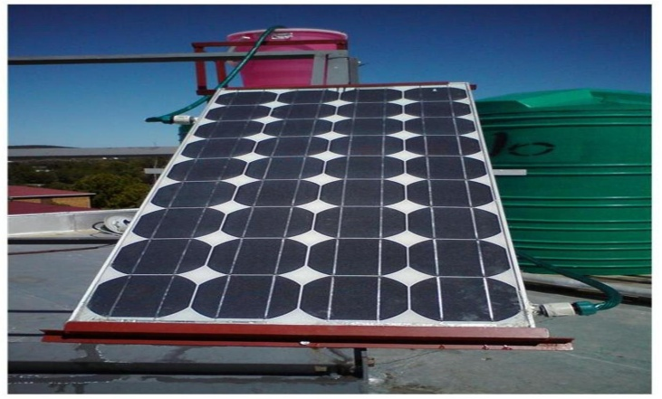

Figure1: System set up

The system operates under thermosyphon effect, implying that no pumps are used to drive or circulate water. Electrical energy is saved in this way. The module is fixed on the rack as shown in figure 1. The angle iron steel structure supports the modules. The iron rack is fixed at an angle of latitude of the location which is 33° to the horizontal.
  - Water Cooling on Module M2
A modified SP70, 70W mono-crystalline silicon module was used to carry out this investigation. The module had 36 cells connected in series. Its temperature coefficient for maximum power was noted to be at -0.45%/°C [4]. Also the module could produce a power output of 70W at 1000W/m² implying an electrical efficiency of 13.5%. The PVPM1000C was used to measure the actual I/V characteristic of the module.

Water at the back of the module gets heat from the module through convectional currents and conduction. Once heated, water becomes less dense and rises to the storage tank and it is replaced by denser cold water from the storage tank. This water circulation process continues until all water is heated. In the process of heating the water, the module gets cooled.
  - Measurements
Temperature measurements on module SP70 module were done and type K thermocouples were attached to the modules as indicated on figure 2. The back of module temperatures were also recorded.

+ -
1.10m
0.19m
0.48m
Junction Box

Coldwater in
Warm water out

thermocouples

Figure 2: Thermocouple locations at the back of module.

The mass flow rate was measured using a polypropylene RFO Gems transducer which was placed close to the cold water inlet point. The irradiance was measured with an SZ03 class 1 pyranometer. All the measurements were made and stored in the datataker data logger for results analysis.

3.0 Results and Discussions
For a particular day the thermal response for the incoming and outgoing water was as shown on figure 3.

Figure 3: Thermal response of the system

Water had to be added almost every 3 hours to cater for the leakages. From figure 3 it can also be noted that initially the heat transfer was not steady. This was due to the warm up phase and it took some time before stable heat transfer took place. Figure 4 shows the thermal efficiency of the module for the first three hour period ignoring the warm up phases.

Figure 4: Instantaneous thermal efficiency

In the regime phase the temperature difference between Tout and Tin remains almost constant, indicating stable heat transfer. Figure 5 illustrates the thermal efficiency against the reduced temperature function given as $\frac{T_{inlet}-T_{ambient}}{G}$ .

Figure 5: Thermal efficiency analysis of the pv module when used as a thermal collector
The module was found to have a thermal efficiency of 72%. This value falls within the range of solar thermal collectors which are found to be within the range 70%-80% [5]. The pv module could be used as a solar thermal collector. The point of intercept between the efficiency curve and the reduced temperature axis gives the stagnation point, where the fluid stops moving, see figure 5.

Figure 6 shows the thermal energy gained graph.

Figure 6: Thermal energy gain of due to the photovoltaic module

From 07:10 to 12:40, the thermal energy gained by the water was equivalent to 1.77 kWh. The cold water that was added to supplement lost water brought about negative energy hence reducing the overall energy gained per day. Using the PVPM1000, a I/V characterisation system, the maximum power output at solar noon was found to be 52.44W and the measured electrical efficiency of the module was found to be 8.38%, while the module’s efficiency at STC was 10.80%.

Conclusion
The PVWHS was noted to be able to heat the water from temperatures as low as 10˚c to 45˚C in 5 hours for an un-lagged system. The system was therefore found to be able to provide warm water during sunny days that can be used in households. The electrical efficiency of the module fell because of the mismatch between the solar cells in the module. However added to the thermal efficiency of the module the overall efficiency of the pv module was also improved to about 80.38%

References
[1] Falk Antony, Christian Durschner and Karl Heinz –Remmers, 2006. Photovoltaics for professionals.A reference
[2] Baljit Singha_ and M. Y. Othmanb, 2009. A review on photovoltaic thermal collectors; Journal of Renewable and Sustainable Energy 1.
[3] Thermal conductivity of materials.
http://www.engineeringtoolbox.com/thermal-conductivity-d_429.html accessed; 11/02/2011
[4] Temperature coefficients.
http://telemetryhelp.com/Datasheets/ShellSP70_USv1.pdf
[5] Soteris A. Kalogirou, 2004. Solar thermal collectors and applications

