Short Biography
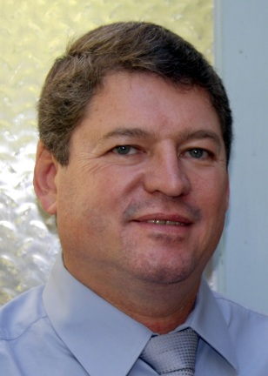 | Croukamp, Leon.¹ received his BSc. Hons (Engineering Geology) from the University of Pretoria,South Africa. He obtained his MSc. In 1996 in Engineering Geology and GIS from the University of the Pretoria. He is currently doing his PhD with research interest on the geotechnical properties of the moon towards “A Lunar Geotechnical GIS as an aid for exploration and settlement construction”. He worked as an Engineering and Environmental Geologist at the Council for Geoscience for 23 years before joining the University of Stellenbosch as a lecturer in GIS and Engineering Geology in the Civil Engineering Department. He is currently mentor for two M-level students and one Phd level student on the Inkaba programme and had been supervising 15 final year civil engineering student projects at the Matjiesfontein Geodesy Observatory to date. [124 words]  .¹Department of Civil Engineering, University of Stellenbosch - Stellenbosch, SA  Email: lcroukamp@sun.ac.za / leon.croukamp@gmail.com (private) / Mobile +27 83 291 1008  Supervisor : Combrinck Ludwig, Prof / Ludwig@hartrao.ac.za

