**Investigating the causes of unsatisfactory performance on the section involving vectors in basic mechanic**

**P Molefe and B M Sondezi**

University of Johannesburg (UJ), P.O. BOX 524, Auckland Park, 2006.

Email: [pmolefe@uj.ac.za](mailto:pmolefe@uj.ac.za)

**Abstract:** First year physics lecturers report difficulties with students’ learning of concepts and skills associated with solutions of basic mechanics problems. From a basic vector definition: a vector is a quantity with both magnitude and direction that is represented geometrically by a directed line (length of the line representing the magnitude; and an arrow representing the direction of a vector). The use of vectors in both forces and equilibrium concepts illustrated by free-body diagrams, are basics to all mechanics problems. Despite this, it apparently remains a difficult area for a significant number of students, even in the later years of their degree. Therefore, attention to this section at first year level is crucial as it forms a solid foundation to the mechanics and their related topics. It has been observed that students’ response before an assessment is always positive, whilst the assessment results show poor performance, which are the sources of concerns. The results of the investigation in this regard seem to suggest that students have insufficient knowledge and understanding of magnitude, direction, and the significance of free-body diagrams in resolving the related forces into components. In addition, students also seem to encounter difficulties in using trigonometric ratios.

1. Introduction

The Physics lecturers at the University of Johannesburg (UJ) has engaged in a short term, short scale investigation of students understanding of vectors. In this study, we examined the ability of students to determine and use qualitatively the magnitude and direction of the vector from knowledge of drawing a free-body diagram. From a basic vector definition a vector is a quantity with both magnitude and direction that is represented geometrically by a directed line (length of the line representing the magnitude; and an arrow representing the direction of a vector). The use of vectors in both forces and equilibrium concepts illustrated by free-body diagrams, are basics to all mechanics problems. In his report Knight (1995) [1] emphasized that the vector nature of forces, fields, and kinematics quantities requires that students have a good grasp of basic vector concepts if they are to be successful in mastering even introductory level physics. The fundamental concept of Newtonian mechanics is force, and forces are vectors, they must be added using vector addition to determine the net force along the axis of motion.

Dealing with vector quantities is somehow more complicated, than dealing with scalar as more mathematical manipulations are required. A fundamental introductory mechanics course at university level needs to include topics areas such as kinematics, dynamics, Newton’s Law of motion, work and energy, impulse and momentum, and rotational motion. In order to have a well-founded understanding of the concepts presented in these topics, a basic understanding for the drawing a free-body diagram and its interpretation is needed.

Student learning is our primary criterion for determining teaching effectiveness. Poynter (2005) [2] in their study indicated that, “in spite of clear instruction in procedures for vector addition, many students tend to forget to draw final side of the triangle (resultant) when calculating the vector sum, or have difficulties when vectors are in non-standard positions”. Literature indicates that a quarter of students who had completed a calculus-based physics course and a half of students who had completed an algebra-based physics course could not add vectors in two dimensions [4]. In the study by Shaffer [3] he found that in some cases, inability to perform basic vector operations is the obstacle. They also found that in many instances, the difficulties are fundamentally conceptual, rather than mathematical.

Studies referred to above suggest that students seem to have their own ways of conceptualizing the vector concept. Despite most students’ previous exposure to vector concepts, there are still misconceptions and difficulties related to vectors. These studies suggest that instructors in introductory physics course must give explicit consideration to students’ familiarity with the learning of vectors.

The aim of this study was to investigate the causes of unsatisfactory performance on the section involving vectors in basic mechanics. The objective of this study was to examine the ability of students to determine and use qualitatively the magnitude and direction of the vector from knowledge required to draw a free-body diagram. The questions of the assessment test were designed to measure students’ basic level knowledge on of vectors; it incorporated a drawing of a free-body diagram, the addition of vectors algebraically and graphically, the expression of vectors in terms of magnitude and direction, the use of trigonometric functions to calculate the direction of the vectors.

All students who participated in this study have obtained Admission Point Score in the range of 50-60% in physical science in their National Senior Certificate (NSC).Most students were enrolled for engineering degree(s), others science degree with physics as their major with mathematics being the other enrolled course, whilst some were not doing mathematics 1.

1. Methodology

A general pre physics skills test of 20 multiple choice questions was given to students in the beginning of the course to check if the students possess the basic knowledge of vectors that will allow them to understand fundamental mechanics topics. Five questions of the 20 multiple choice questions were designed to measure students’ knowledge of basic level of vectors, these questions were based on kinematics, algebraic addition of vectors and, expressing vectors in terms of magnitude and direction. In addition similar question including problem solving questions were given to students throughout the course. Also students were finally given familiar questions in the final semester examination in order to determine whether conceptual understanding had been gained.

The tests were administered to 290 four year curriculum physics 1 students from the University of Johannesburg (UJ). Only 266 students wrote the physics skills test (PST) and only 269 managed to write the final exam. The examination was marked by two lecturers and was moderated by the internal examiner from the physics department. Four questions from the exam were chosen for this study, a multiple choice question, a conceptual understanding question and two questions needing a correct free-body diagram and calculation of the direction of motion.

1. Results and Discussion

Initial Analysis

Q8: In the diagram below you are looking at a mass on a frictionless surface from above. Three forces act on the mass as illustrated in the diagram. F3 > F2 and F2 > F1. The magnitude of the resultant force acting on the mass will be:

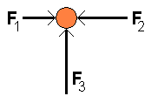

|  |  |  |  |  |  |  |  |
| --- | --- | --- | --- | --- | --- | --- | --- |
| A | B | C | D | E | F | G | H |
| **F3 - F2 - F1** | **F3 + F1 - F2** | **F3 + F2 - F1** | **F3** | Slightly bigger than F3 | **F1 + F2 + F3** | I do not know the answer because I do not understand the Physics in this question. | I do not know the answer because I do not understand some of the words used in this question |

Question used early in the physics skills test investigation about the knowledge of vectors. The analysis of question 8 in this test was specifically investigating the students’ knowledge of vector addition and understanding of Newton’s second law. This question revealed that 94% of students from high school had misconceptions of fundamental and elementary concepts. Only 6% of the students gave option (E), the correct answer. This indicates that a significant percentage of students do not have a conceptual understanding of the definition of a vector and vector addition. They cannot make use of the Cartesian plane (axes) to determine the magnitude and directions of vectors. Of course, they would have an idea of definition of a vector quantity and knowledge of resultant vector. The histograms of the class tests (vector question) performance are presented in fig.1. Encouraging features of these histograms is the high percentage of the students passing vector question in class test (CT2). It is evident from both graphs that students perform better on the question in CT2 compared to (class test 1) CT1.



Figure 1: A histograms of class tests performance.

Students seem to be gaining confidence and were expected to do well in the semester tests. This was derived from the observed improvement in the vectors related questions in their class tests results. Surprisingly, observations in fig.2 paint a different picture; the results are very poor as compared to performance in CT2.

Of particular relevance to similar questions given to the students in different assessments in this module, performance in the semester tests reveals that students either just achieved a pass or failed. Even after been given a problem on vectors in every assessment, students had difficulties in drawing the free-body diagram and calculating the direction of acceleration of motion. In fig.4 assessment 3, only half of the students were very successful in answering/drawing the correct free-body diagram and only 82.3% of those successfully answered assessment 4 correctly. It was also observed that in general, many students were not able to draw the correct free-body diagrams and consequently could not resolve vectors in their component form. As a result they could not add or subtract vectors graphically and qualitatively as reflected by students’ performance shown in fig.4.



Figure 2: A histogram showing the students’ performance versus the number of students in percentage of correct students’ responses in respective questions given in different assessments.

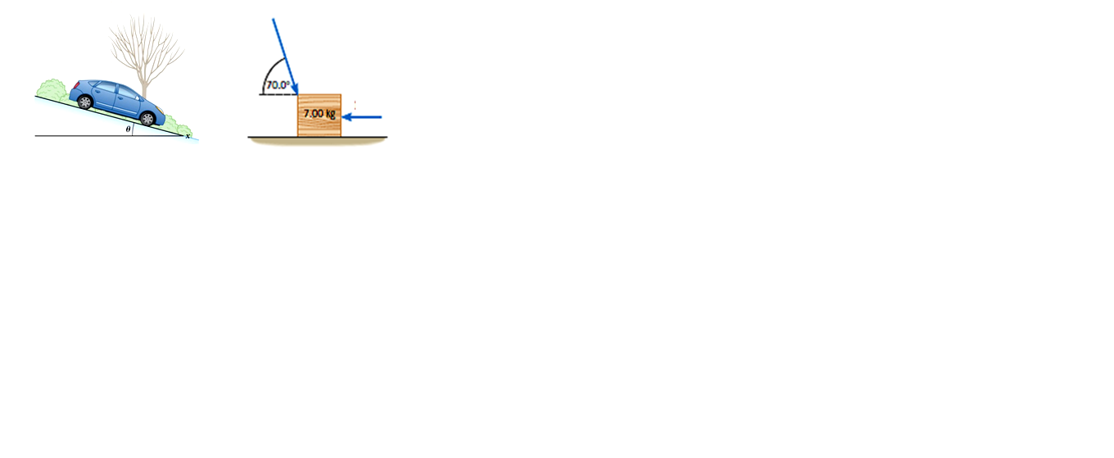**A close look at some of vector questions and students responses (%) in figure 3.**

Figure 3: Questions used in the assessment 3, 4 & 5. Fig.3 (a) students were asked to draw a free-body diagram before calculating the direction of acceleration of motion. Fig.3 (b) there was no hint given for drawing a free-body diagram before calculating the horizontal acceleration.

A multiple choice question is as follows:

Two vectors **A** and **B** are added together to form a vector **C**. The relationship between the magnitudes of the vectors is given by *A* + *B* = *C*. Which one of the following statements concerning these vectors is true?

A. **A** and **B** *must be displacements*.

B. **A** and **B** *must have* *equal lengths.*

*C.* ***A*** *and* ***B*** *must point in opposite directions.*

*D.* ***A*** *and* ***B*** *must point in the same direction.*

*E.* ***A*** *and* ***B*** *must be at right angles to* each other.

In the above question given to the students in the assessments 1 shown in fig.4 shows that students improved in their conceptual understanding with almost 51% of students giving option (D) the correct answer. Though there is improvement, 49% of students do not have a conceptual understanding of addition of vectors.

With reference to the conceptual question given to students, it is revealed that students gained understanding of addition of vectors and calculation of the resultant vector. The 69.4% of them managed to explain their correct answer, which was positive given that in the early investigation question only 6% of them chose the correct answer.



Figure 4: A histogram showing the percentage of correct students’ responses in respective questions given in different assessments.

In assessment 3 students were asked to draw a free-body diagram of fig.3 (a) and answer assessment 4 related to assessment 3. It must be mentioned that though almost 50% drew the correct free-body diagram, less than 41% of students assessed managed to answer assessment 4 correctly see fig. 4. Fig.3 (b) was given to students for assessment 5; this question was testing the same skill. In this question students were not guided to draw the free-body diagram before they could calculate the magnitude and direction of acceleration in motion. It was observed that 36% of the students knew that they must draw a free-body diagram and calculated the correct magnitude and direction of motion. In both assessments (4 and 5); some students seemed to be recalling memorized definition of summations of vectors, apparently not understanding how to represent that from the free-body diagram and failed to get the correct magnitude and direction of the vector.

1. Conclusion and Recommendations

In the course taught by the authors, we have made modifications to the content of the course and to the questions that were specifically intended to improve students understanding of vectors in mechanics. Although the degree obtained from the modification and the results of students vary, none of the modifications have been more than moderately successful. One consistent result has been to increase the fraction of students who attempted answering vector related questions in the exam, to employ the use of free-body diagrams and vectors calculating net force and acceleration of the motion.

This study recommends that some intervention be made early in the year and the amount of time allocated to understanding of basic mechanics concepts be increased because the mechanics concepts are the core in introductory first year physics.

As a result of this investigation, we have become more aware of the degree to which the application of a free-body diagram is a challenge to students. As this study progresses, we hope to learn more about the nature of students difficulties with regards to vectors.

1. Acknowledgements

The authors acknowledge the assistance from the department of physics at large.

References

[1] Knight, R.D. (1995). Vector knowledge of beginning physics students. *The Physics Teacher.***33**, 74-76.

[2] Poynter A, & Tall, D. (2005). Relating Theories to Practice in the teaching of mathematics.

[3] Shaffer, P.S & McDermott, L.C. (2005). A research-based approach to improving students understanding of the vector nature of kinematics concepts. *American Association of Physics Teachers.* **73** (10), 921-931.

[4] Nguyen, N., & Meltzer, D., (2003). Relating theories to practice in the teaching of mathematics. (*in preparation*).

[5] Mhlongo, M.R. (2011). The pre-knowledge of the physics I students on vectors. *Proceedings of the South African Institute of Physics,* University of South Africa (pp.608-6613).