## South African Institute of Physics (SAIP) Conference Proceedings: Author guidelines, submission and review procedures

**SAIP2018: Submission deadline 28 July 2018**

**http://events.saip.org.za/event/SAIP2018**

Both poster and oral presenters at the SAIP conference are invited to submit short papers for consideration towards the conference proceedings. The *SAIP Conference Proceedings* use author-supplied PDFs for its online publication. Authors **must** prepare their papers in PDF format strictly following the A4 style templates (for either Microsoft Word or LaTeX2e) as provided on the SAIP INDICO conference website.

The following points summarize the key issues you need to consider, or comply with, when preparing your paper and submitting it for the *SAIP Conference Proceedings*.

## Aim and scope:

* The purpose of the *SAIP Conference Proceedings* is to collect, in a volume, some of the latest, interesting and relevant research in physics and physics-related disciplines in South Africa and Africa.
* The *SAIP Conference Proceedings* is published as a general collection rather than as a discipline-specific periodical with the expectation that all papers will fall within one of the recognised divisions of the SAIP.

## Content guidelines:

* Submitted papers are expected to contain evidence of some new results, to be free of plagiarism and to not unduly duplicate previously published material.
* All papers should have sufficient physics content to justify being considered as a contribution to the proceedings.
* Consideration will be given to research work undertaken within large collaborations e.g. SKA, ATLAS, ALICE, etc.
* Review papers will not be considered appropriate for the conference proceedings.

## Author responsibilities:

* By submitting a paper, the author and all co-authors are assumed to agree with the terms and conditions as outlined in this document.
* Only papers presented at the conference will be considered and an author or co-author must have presented the paper.
* All submitted papers must be accompanied by a Paper Submission Form. If the corresponding author is a student, their supervisor must assist to complete and sign Part B of this Paper Submission Form.
* Supervisors whose students submit papers will be required to act as reviewers.

## Formatting guidelines and templates:

* Templates (MS Word and Latex) are available on the SAIP INDICO conference website. The Paper Submission Form can also be found there.
* The PDF version of the short paper must be A4 size and 3-6 pages in total length.
* Figures and table should be included in the appropriate places within the main text.
* All poorly formatted papers not corresponding with the template, or papers which do not meet the length specification, or papers without correctly completed Paper Submission Forms, will be rejected without review. **Authors must take care to format their papers using the template.**

## Paper Submission:

The ***abstract submitter*** should upload, before the deadline, the ***correctly formatted PDF*** versions of the short paper as well as the properly completed Paper Submission Form.

***1.*** Login to the SAIP INDICO system and browse to ***My conference*** → ***My contributions***.

***2.*** Choose ***View*** next to the relevant abstract: note that this will be visible for accepted abstracts for the abstract submitter.

***3.*** Choose ***Upload Paper***.

***4.*** In the pop-up box again choose ***Upload Paper***.

***5.*** To the right side of the ***Browse*** button, click on ***more*** so that a second ***Browse*** button appears. The window should appear as below.

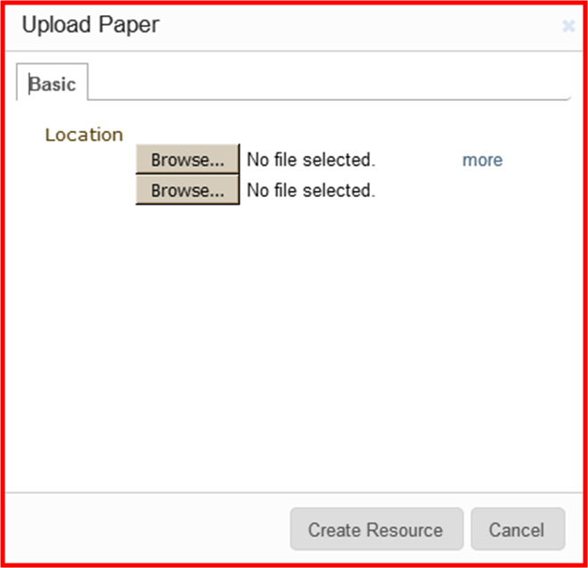

***6.*** Use the two browse buttons to select the PDF files of your short paper and your Paper submission Form, respectively.

***7.*** Choose ***Create Resource***, thenclick ***Submit***.

## Review procedure:

* After the submission deadline the PDF of each paper will be distributed to reviewers
* At least two subject specialists will be chosen to review and report on each short paper
* A final decision, or a request for revision, will be communicated to the corresponding author.
* The call for reviewers will be under taken twice for each paper. At that point, if no suitable reviewers have been found, the paper will be rejected due to lack of review.

Once all the necessary corrections have been made to the accepted papers, the proceedings will be made available for downloading from the conference webpage.