Laser surface alloying of aluminium (AA1200) alloy for improving hardness property
T.G. Rambau, A.P.I. Popoola*, M. Abdulwahab
Department of Chemical and Metallurgical Engineering, Faculty of Engineering and the Built Environment, Tshwane University of Technology,
Pretoria, X680 South Africa 0001

*Corresponding author: popoolaapi@tut.ac.za

Abstract. Investigation was carried out on the improvement of hardness property of AA1200 aluminium alloy using stellite-6 ceramic reinforcement powder. A continuous wave of 4.4 kW Rofin Sinar Nd:YAG laser emitting 1.064 µm wavelength was used in this study. The laser beam was used to scan across the surface of the metal thereby feeding the stellite-6 powder particles from the side through an off-axis nozzle. The laser power was varied in the range of 3-4 kW and the scanning speed in the range of 1.0-1.2 m/min; whereas the beam diameter and the powder flowrate were kept constant at 3 mm and 3 g/min respectively. The examination of aluminium matrix composites was done using optical and scanning electron microscopes, and energy dispersive spectroscopy (EDS). A good metallurgical bonding resulted between substrate and reinforcement with the following laser processing parameters: power of 3 kW and scan speed of 1.0 m/min. The improved average hardness of 780, 707, 529 and 443 HV_{0.1} was achieved; the hardness of the AA1200 is 24 HV_{0.1}. The intermetallic compounds and hardened microstructures resulted in a significant increase in hardness values; which is about 33 times the substrate hardness.

Introduction
Aluminium metal matrix composite are being considered in most industrial applications because of the properties they exhibit. The attraction of aluminium in the industries today is based on their advantages such as light weight, low cost, good electrical conductor, excellent workability and low density. However, there are some drawbacks which limit the application of these alloys in industries. The surface properties of aluminium alloys can be improved by using laser surface alloying technique. This process can alter the chemical composition and microstructure without affecting the bulk material. Laser alloying process involves the use of a laser beam to melt the substrate and the addition of the alloying elements into the melt pool [1-2, 5].
Surface alloying can produce improved surface properties on a relatively low cost substrate. For example the properties of aluminium can be improved by alloying with nickel, silicon carbide and other alloying compounds/elements [3]. The microstructure, homogeneity and chemical composition can be affected readily by the process parameters used. The major process parameters are: Laser power, beam diameter, scan speed, amount of alloying element added and extent of overlapping during large area of alloying [4].
The development of Aluminium Metal Matrix Composites (MMC) using TiB₂ as reinforcement was reported [6] and the main aim was to improve the hardness of the substrate. Rofin Sinar Nd:YAG laser was used in this study for alloying and argon was used as a shielding gas to prevent oxidation. There was an achievement of good metallurgical bond and the ceramic powder was dispersed across the Al-matrix. Hardness test was done on the sample and the maximum depth of 1.17 mm was attained. There was an increase in hardness from the substrate which is 24±0.4 HV to that of aluminium matrix composites which was 58± 0.2 HV [6].
Mabhali et al, (2010) reported on the laser alloying of aluminium to improve surface properties. Laser alloying of AA 1200 was carried out using a solid state Nd:YAG 4.4 kW laser. Ti, Ni and SiC were used as reinforce materials with different powder ratios. Phases such as α-Al, SiC, TiC, Al₃Ni, Al₃Ni₂ and Al₃Ti were present. The formation of intermetallic compounds resulted in an increase in surface hardness after alloying. High hardness of 477.6±105.6 HV_{0.1} was achieved with 70wt% Ni + 10wt% Ti + 20wt% SiC [5, 7].
Laser surface alloying is mostly used to increase resistance against wear and corrosion; also to improve the hardness property. The main advantage of laser alloying is the ability to apply the alloying elements selectively to that part of the substrate/component that needs resistance to degradation. The alloying material is distributed uniformly across the melt pool resulting in fine grain structures due to rapid cooling [8]. Some of the advantages of this process include low distortion of components due to low heat input, low heat affected zone, fine control of melt zone depth and treatment of complex ores. However, the major drawback of this process is high cost of equipments [9].
This paper reports the hardness improvement performed on aluminium alloy matrix laser alloyed with stellite-6 powder.

2. Research methodoloy

Materials and methods
Laser surface alloying process with stellite-6 was done on aluminium (AA 1200) base alloy (table 1). The dimension of the substrate was 100 x 100 x 6 mm. The plate was subjected to sand-blasting to clean the surface and to reduce the reflectivity of the sample, thus increasing the absorptivity. The experiment was executed using Rofin Sinar 4.4 kW Nd:YAG laser emitting 1.064 µm wavelength. The off-axis nozzle was used to deliver the powder particles from the feed hopper to the substrate. The power and the scan speed were varied whereas other parameters such as beam diameter, powder flowrate and gas flowrate were kept constant (table 2). Argon shielding gas was used to prevent oxidation by air. Stellite-6 was used as reinforcement for the AA 1200 alloy.
Table 1. Chemical composition of AA1200 substrate.
Elements | Cu | Si | Fe | Al
Chemical composition (wt %) | 0.12 | 0.13 | 0.59 | Balance

Table 2. Process parameters for laser alloying of AA1200 alloy with 75 % overlap.
Sample  No. | Sample | Power | Scan speed | Beam diameter | Powder flow | Shielding  gas | Shielding gas flow
1 | Al-Stellite (AS-1) | 3 kW | 1.0 m/min | 3 mm | 3 g/min | Argon | 2 l/min
2 | Al-Stellite (AS-2) | 3 kW | 1.2 m/min | 3 mm | 3 g/min | Argon | 2 l/min
3 | Al-Stellite (AS-3) | 4 kW | 1.0 m/min | 3 mm | 3 g/min | Argon | 2 l/min
4 | Al-Stellite (AS-4) | 4 kW | 1.2 m/min | 3 mm | 3 g/min | Argon | 2 l/min

Sample preparation
The treated samples were prepared metallographically for characterization. The samples were cut cross sectionally followed by hot mounting. The samples were ground down from 320-1200 grit with SiC paper. The samples were then polished with different cloths from 9, 6 to 3 µm followed by the last stage of OP-S with 0.04 µm suspension. Flat mirror-like surface is required from this last stage for better conduction of subsequent analysis.

Hardness test
Vickers microhardness tester was used for hardness evaluation. The hardness was done under a load of 100 g and a spacing of 150 µm with a dwelling time of 15 seconds. The indentations started at the surface of the laser alloyed through the base of the aluminium alloy.

Microscopy analysis
Light optical microscope (LOM) and scanning electron microscope (SEM) were used to characterize the samples. Light optical microscope was used to reveal the overview of the sample whereas SEM was used to determine the elemental chemical composition and the morphology of the samples.

3. Results and discussion
3.1. Characterization of the laser alloyed zone (SEM and EDS)
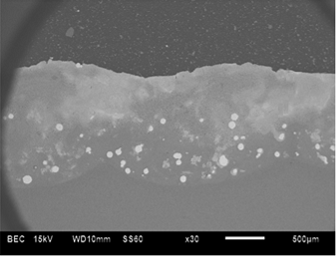
Figure 1: Laser alloyed Al-Stellite-6 sample
3.1.1. Optical microscope. Figure 1 above reveal the micrograph of laser alloyed Al-Stellite-6 sample 2. The micrograph of Al-Stellite 2 reveals good dilution and bonding of the laser alloyed tracks. Some fraction of stellite-6 was not melted, they remained the same and were distributed within the Al matrix. The reason for the unmelted powder particles was due to high melting point of stellite-6 which is in a range of 1260-1357 ˚C.
3.1.2. SEM characterization. The interaction between aluminium base metal and stellite-6 powder was adequate at the top of the alloyed zone because of higher temperatures which were attained. The alloyed layer consists of fine heterogeneous microstructure of dendritic and needle-like structures due to excellent dissolution of stellite-6 with the base metal (Figure 2 (a)). Inadequate melting between the powder and the substrate has led to the formation of unmelted powder particles (Figure 2 (b)) especially below the alloyed zone. These unmelted particles are situated at the bottom of the laser alloyed zone and also plays an important role in increasing the hardness property of newly developed aluminium metal matrix composites.
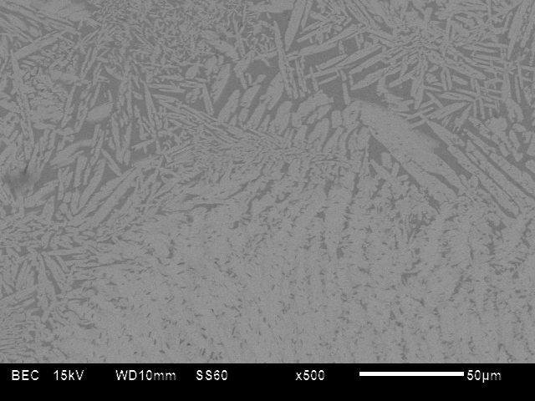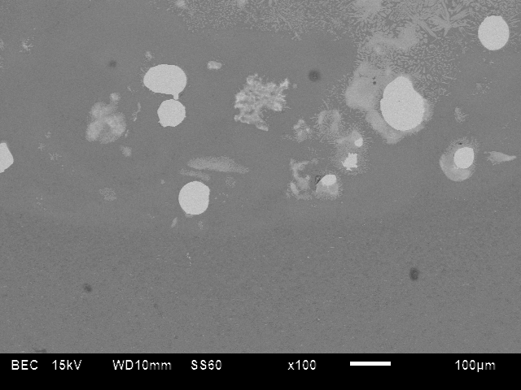
Dendritic microstructure
Needle-like structures
Unmelted powder
Base metal
(a) (b)

Figure 2: (a) and (b) Laser alloyed sample AS-2
There was good metallurgical bonding at the interface of the laser alloyed zone. No cracks were visible at the interface and at the overlapping region. The unmelted powder particles were confirmed to be Co-Cr base alloy by area identification. The high percentage of Co and Cr increases the melting point and this also led to the increase in hardness. According to Popoola et al. 2011, substances that consist of an assembly of several substances often melt partially because they are not homogeneous.
The microstructure that developed after the solidification of the molten pool comprises of dendritic microstructure and needle-like microstructures (Figure 2 (a)). Dendritic microstructures developed when the crystal is growing during the solidification of the molten material and it is present where the solid and liquid phase coexists.
3.1.3. EDS characterization. Area 1 on the micrograph below shows the unmelted powder particle of Co-Cr base alloy which is stellite-6. Area 2 depicts the combination of aluminium base metal and stellite-6 wherein aluminium was found in higher percentages and stellite-6 in smaller percentages (Figure 3). The dark area(s) indicated by 3 reveals the aluminium as 100%. Dark area is aluminium, partially light area is the blend of aluminium and stellite-6 and light particle is unmelted stellite-6 powder (Figure 3).
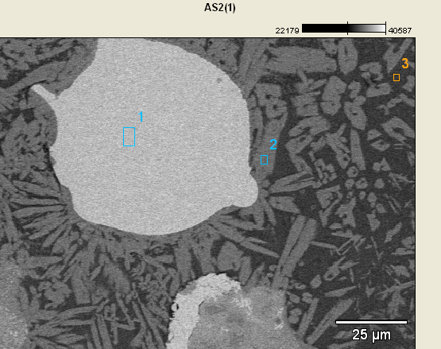
Figure 3: Micrograph showing the spotted areas
The bottom of the laser alloyed region comprises of adequate melting of the powder particles with aluminium base metal. The unmelted particle increases the hardness properties of the newly formed aluminium matrix because they are heavier than the aluminium base metal.

Hardness characterization
The average hardness was calculated by finding the average of a minimum of 10 indent values from the results obtained. There was an increase in hardness of the laser alloyed matrix compared to the substrate. Table 3 below shows the average hardness of all the samples at different processing parameters.

Table 3. Microhardness test data.
Hardness along the alloyed zone
Sample No. | System composition | Power (kW) | Scan speed (m/min) | Average hardness (HV_{0.1})
AS-1 | Al-Stellite | 3 | 1.0 | 780
AS-2 | Al-Stellite | 3 | 1.2 | 529
AS-3 | Al-Stellite | 4 | 1.0 | 707
AS-4 | Al-Stellite | 4 | 1.2 | 443

The Figure below shows the average hardness of all the samples and their corresponding error bars.

Figure 4: Hardness profile for the alloyed samples
There was an increase in hardness of about 33 times that of the substrate. The increase in hardness is caused by the formation of intermetallic compounds and hardened microstructure and as well as the presence of unmelted powder particles. The optimal laser processing parameters that resulted in high hardness were 3 kW power and a scanning speed of 1.0 m/min.
AS-4 depicts low hardness because of severe cracks and pores which were evidenced along the newly formed matrix composites. Sample AS-2 and AS-3 also shows an astounding increased hardness but with cracks distributed across some fractions of the alloyed region.
The formation of new phases on the laser alloyed zone led to an increase in hardness compared to that of the substrate. The newly formed phases include the combination of Al-Co, Al-Cr from the XRD analysis.

Conclusion and recommendations
4.1. Conclusion
The following conclusion can be drawn based on the results that were obtained during the execution of the experiment.
- Power of 3 kW resulted in good metallurgical bonding of the newly formed matrix with the base metal and improved hardness property.
- The formation of Al-Co and Al-Cr intermetallic phases led to the increase in hardness value.
- The power of 4 kW resulted in severe cracks along the interface of the laser alloyed matrix, but with improved hardness property.
- High speed resulted in low hardness and low speed resulted in high hardness.
  - Recommendation
- It is recommended to use a power of 3 kW for laser alloying of aluminium with stellite-6 powder to obtain an improved hardness property.
- It is also recommended to use a speed of 1.0 m/min to yield high hardness property.

- Acknowledgement
This material is based upon work supported financially by the National Research Foundation. The National Laser Centre, CSIR, Pretoria is appreciated for laser facility.
6. References
[1] Mabhali L A B, Pityana S L, Sacks N 2010 Laser Surface Alloying of Aluminium (AA1200) with Ni and SiC powders, Materials and Manufacturing Process, pp 1397-1403.
[2] Popoola A P I, Pityana S, Ogunmuyiwa E 2011 Microstructure and Wear Behaviour of Al/TiB₂ Metal Matrix Composites, Southern African Institute of Mining and Metallurgy, pp 120-8.
[3] Ready J F 1997 Industrial Application of Lasers, Academic Press, pp 380-2.
[4] Narendra B D 1998 Laser in Surface Engineering, ASM Int, pp121-138.
[5] Mabhali L A B, Pityana S L, Sacks N 2010 Laser Surface Alloying of Al with Mixed Ni, Ti and SiC powders, PICALO, Shangri-La Hotel Wuhan, Peoples Republic of China, pp 1-6.
[6] Popoola A P I, Pityana S L, Popoola O M 2011 Inter. J. Electrochem. Sci. pp 5038-51.
[7] Mabhali L A B, Pityana S L, Sacks N 2012 Laser Surface Alloying of AA1200, Mol. Cryst. and Liq. Cryst. pp 138-148.
[8] Luxon J T, Parker D E 1985 Industrial Lasers and their Applications, Prentice-Hall and Engineering. pp 248.
[9] Crafter R C, Oakley P J 1993 Laser Processing in Manufacturing, Chapman and Hall, pp 292.

