Radiation shielding calculations using MCNPX transport code for cost optimization of the shielding material to be used at iThemba LABS.

Zipho Ngcobo^{1,2}, Muzi Ndwandwe¹, Robert Bark², Johann Van Rooyen³, Zukile Zibi⁴

- Dept of Physics, University of Zululand, Private Bag X1001, Kwa-Dlangezwa 3886
- iThemba LABS, Box 722, Somerset West, 7129, Cape Town
- Radiation & Reactor Theory Group, NECSA, P. O. Box 582, PRETORIA, 0001
- zukile@gmail.com (worked in the RRT Group at NECSA at a time)

Abstract. At iThemba Laboratory for Accelerator Based Sciences (iThemba LABS), the shared use of the Separated-Sector Cyclotron has reached capacity. The new facility is proposed to respond to this demand known as Radioactive Ion Beams (RIBs) project. This facility will include a 70-MeV negative-ion cyclotron with the development of 5 radioisotope production stations and two production stations for RIBs for nuclear physics and materials science research. A Target/Ion-Source (TIS) Test Facility is suggested to test targets for RIB production. The proposed new H⁻ cyclotron has the potential of producing strong sources of ionising radiation. There is a need to protect humans and materials from ionising radiation by providing adequate shielding to attenuate these particles, thus bringing their flux to acceptably low levels determined by the International Commission on Radiation Protection (ICRP) for designated personnel accessing this facility. The Monte Carlo for Neutral Particles eXtended (MCNPX) code was used for the purpose of investigating the correct thickness of the shielding of the cyclotron vault and the TIS Test Facility vault. Results obtained confirmed that 4m and 3m thicknesses of concrete shielding will be adequate in the proposed cyclotron vault and TIS Test Facility vault respectively.
Introduction
Because large currents of up to 350 µA of 70 MeV protons will be provided by the proposed new cyclotron -, strong sources of ionising radiation will be produced. This could result from many sources and is not restricted to the proton beam itself as it accelerates towards the target. It could also result from the fission products from the target irradiated by the beam. The most challenging entities, which are part of the indirect ionising radiation, are neutral neutrons and photons. We then simulate a person standing on the other side of the shielding so we can measure the fluence-rate of ionising radiation at that point. This fluence-rate must be converted into better understood quantities like effective dose rates and absorbed dose rate, because these quantities are used to determine the maximum annual occupancy times in the radiation area for radiation workers, general workers and the public. This correct thickness of the shielding wall, once determined, will form the basis for guidance in the broader shielding of the whole facility. The iThemba LABS RIB project will require a huge financial commitment and thus building towards the final stage will involve steps that will confirm its feasibility. For that reason, the TIS Test Facility is proposed to test target materials and technology for the overall RIB project [1]. While the negative-ion cyclotron will produce ionising radiation, the operation of the TIS Test Facility will use protons from the SSC to bombard a uranium carbide target so it can fission. Part of the fission products are prompt neutrons at high energies. It is necessary to investigate whether the 3 m concrete shielding in this vault will be sufficient for areas outside the experimental room to be occupied safely by personnel.
The aim of this study is to decide on the thicknesses of the shielding necessary for the two facilities: new cyclotron vault & TIS Test Facility vault so that dose rate limits received in the simulation is below dose rate limits as determined for different personnel accessing the these two facilities.

1.1 Radiation safety and criteria for judging radiation shielding
Table 1 lists the radiation limits to which personnel may be exposed to. Below are the assumptions that were adopted so as to deduce and project effective dose rates from Sieverts/year to Sieverts/hour of the Radiation worker and equivalently it was done for the Public and Non-Radiation Workers.
Exposure time is 8 hours per day; 5 days per week; 4weeks per month and 12 months in a year. This gives the total number of hours per year to be 1920 hours of possible exposure to radiation areas. Therefore, for a Radiation Worker with the limit of 20mSv/yr, we convert this value into 20 000 µSv/hr. Using the factor of 1920 hours, the effective dose rate limit becomes 10.417 m Sv /hr. The same was done for the Public and Non-Radiation Worker personnel.

Table 1: Effective dose rate limits as recommended by ICRP 2007
Personnel | Effective dose rates (mSv/year) | Projected effective dose rates (µSv/hour)
Radiation Worker | 20 | 10.417
Public/ non-Radiation worker | 1 | 0.521

This means that in areas where the dose rate is greater than specified amount, the corresponding personnel will be prohibited to access that specific area.
1.2 Variance Reduction Technique
The simulation code tracks one particle at a time from start to finish. In cases where the particle takes a long time to reach tally points (areas of interest), an even longer time will be needed to reach acceptable statistics.
The variance reduction technique (VRT) may then be used not only to get good statistics but to get them more quickly. The VRT may be necessary in order to sample rare events. Geometry splitting/roulette and cell importance biasing was used.

2. Research methodology
This section describes what we wanted to calculate and how did we come to achieve that.
2.1 The new-cyclotron
Calculations in the new cyclotron vault involved concrete shielding of 4 m in thickness. Now this is deep penetration transport and capture of neutrons makes it difficult for transported particles to reach the phantom, which means the statistics are not satisfactory. We then need the Variance Reduction Technique (VRT) to force particles towards the point where we need more particles, specifically we used geometry splitting and cell importance biasing.

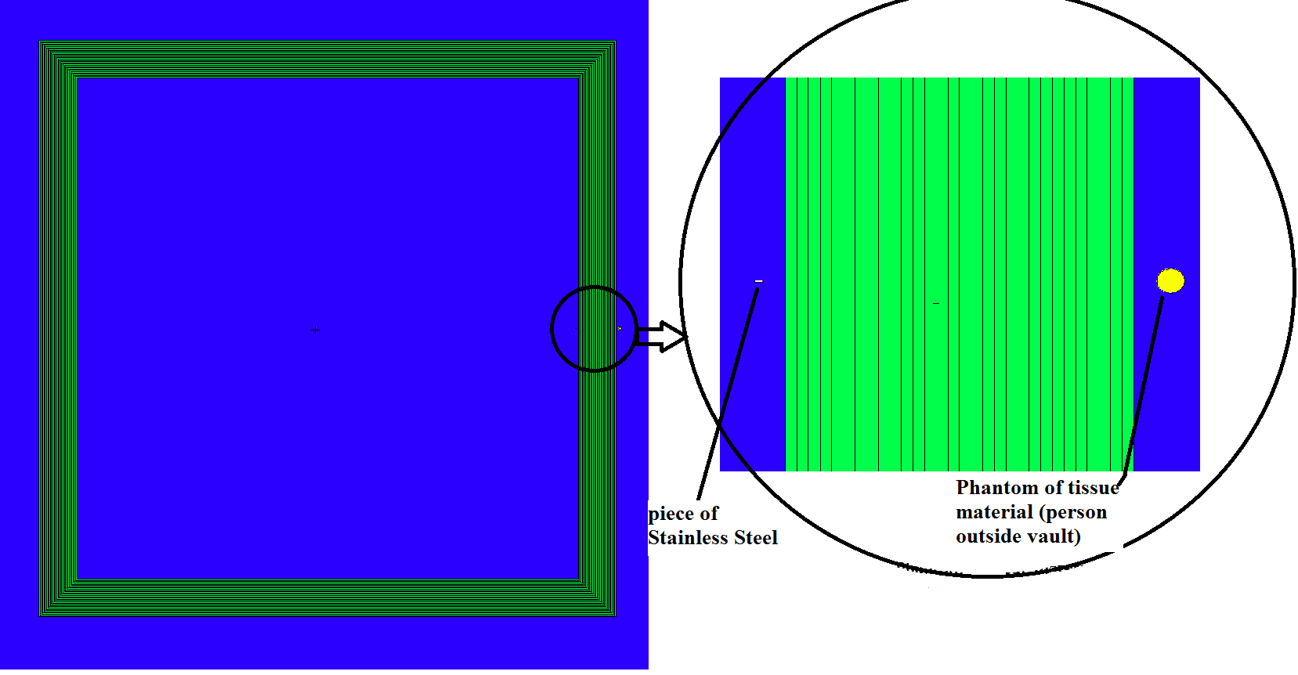
Figure 1: The top view plan of the simplified negative-ion cyclotron vault. The beamline (piece of Stainless Steel) to be activated by incidental proton beams is shown together with concrete shielding with geometry split as a means for Variance Reduction Technique. The phantom is placed where fluence-rate of radiation is investigated.
To simulate a person (phantom) on the outside of the shield and the registered dose-rate, the flux of particles averaged over a cell is tallied. This is the F4 tally. Here the phantom with a tissue equivalent material (TEM) was placed directly adjacent to the outer surface of the shield.
2.2 TIS Test Facility
The actual geometry of the TIS Test Facility vault is shown in Figure 2. It shows the vault open. Areas of interest are shown with phantoms 153; 154; 155; 156; 157 and 158. The aim was to check if the area of the corridor leading to the spectrometer (at left) will be accessible during beam operations; also that on the areas on top of the spectrometer and on top of the vault will be safe as well. However, when geometry splitting is done, the ‘air’ material in the opening imposed artificial biasing on the simulation and more neutrons were transported towards phantom 154, 155, 156 and 157 and unrealistic results were found in phantoms 150, 152 and 152, which are shown in the second geometry, Figure 3. The interest in the second geometry is on the radiation threat posed by the beam pipe transporting RIBs from the vault to the experimental room. For realistic results these regions of interests had to be considered separately.

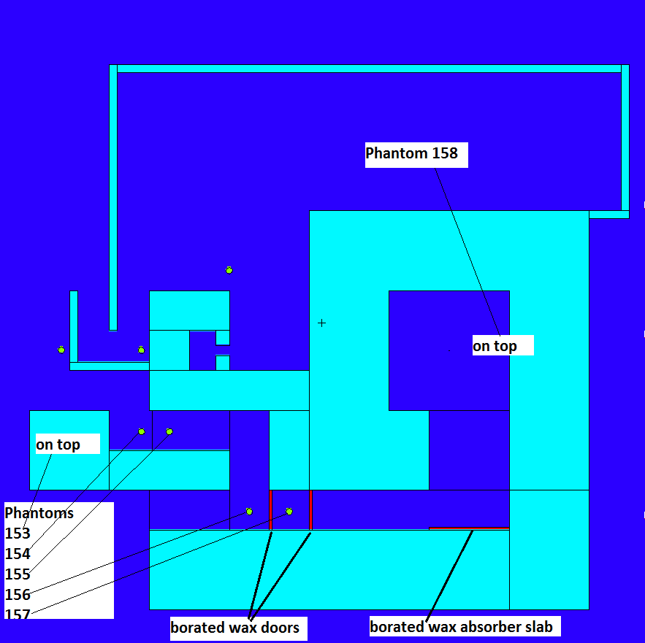 |  | 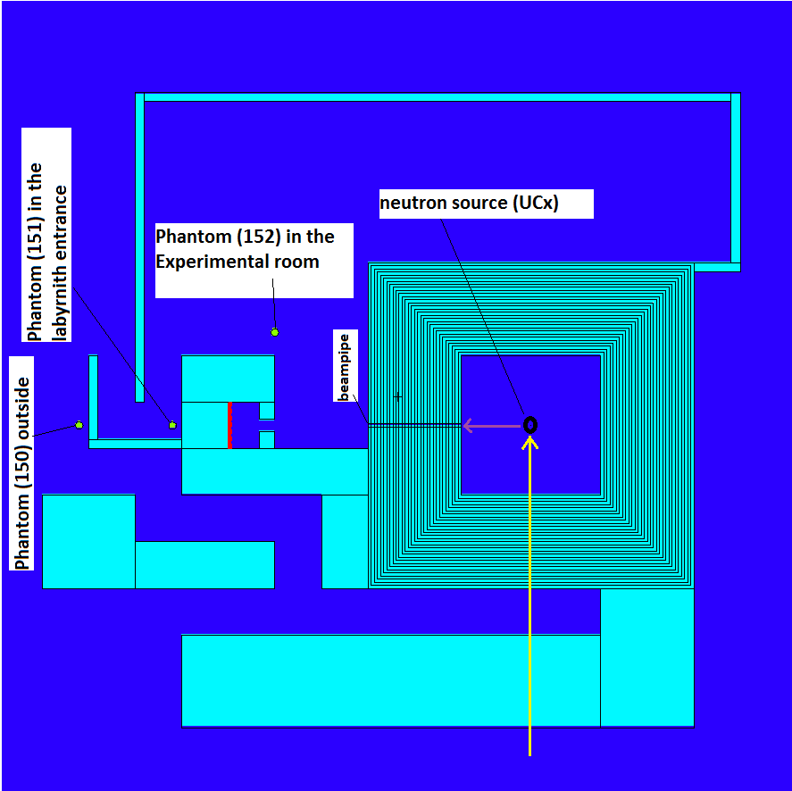
Figure 2: The geometry of the plan view of the TIS Test Facility vault. |  | Figure 3: The geometry of the plan for the purposed of Variance Reduction Technique.
3. Data analysis, Findings and Discussion
3.1 Results of the Negative-ion Cyclotron Vault
Neutrons generated by irradiating an Fe target with a 70 MeV proton beam of 350 µA:

Table 2: Average number of neutrons leaving the stainless steel target when irradiated by proton beam
Neutron counts  (particle/cm²) | relative error (%)
4.04E+13 | 0.0004

The inner surface started with 2.19 x 10¹⁴ particles/cm² and on the outside we recorded at least 1.75 x 10⁵ particles/cm². Secondary photons were attenuated by the added 100 cm concrete as expected by an order of magnitude. The energy of neutrons at this point is still high enough for photon production. 400 cm thickness reduced the effective dose rate by total of nine orders of magnitude from the inner surface of the vault wall to the outside.
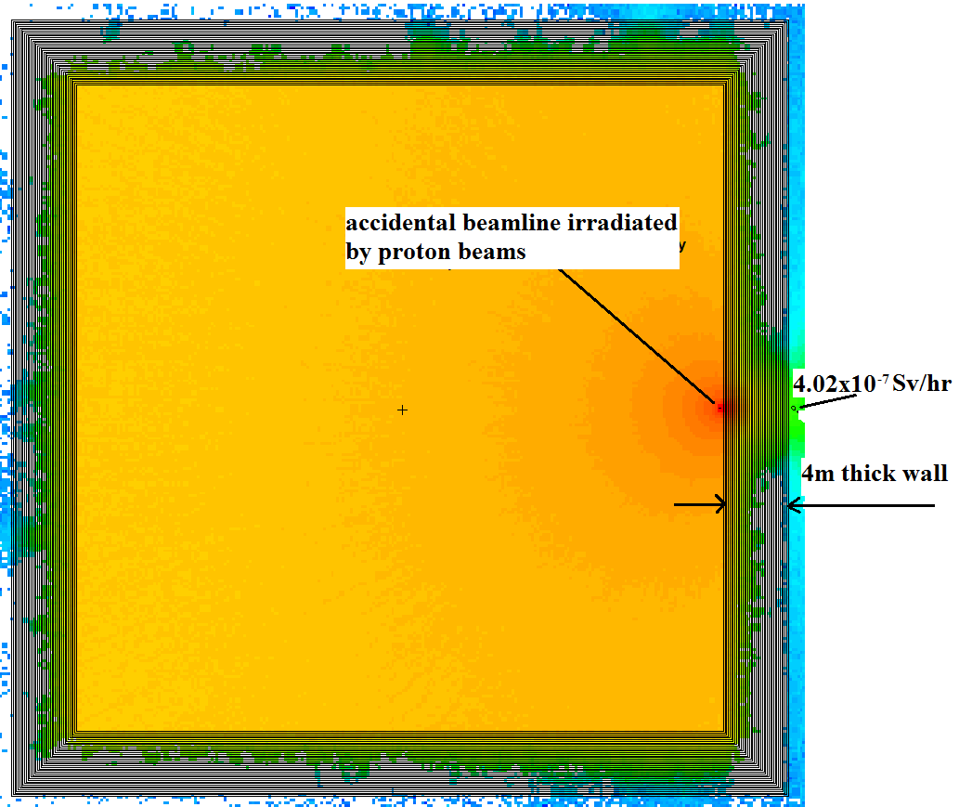 | In Figure 5, we recorded an effective dose of 0.4 µSv/hr at the phantom. This value is much less compared to 43.9 µSv/hr that was received in the 3 metre thick concrete.  Should the ground floor concrete slab be 4 m thick as well, the flux towards underground will be effectively reduced.  For the 4 metre thick concrete calculation, phantom dose rate of 0.4 µSv/hr was registered and corresponding to this is the absorbed dose rate of 0.6 x 10⁻⁷Gy/hr
Figure 5: Mesh tally plot in the xy-plane showing the intensity distribution of neutron dose rates from the incident point through ordinary concrete of 4 metre thickness.

3.2 Results of the TIS Test Facility vault

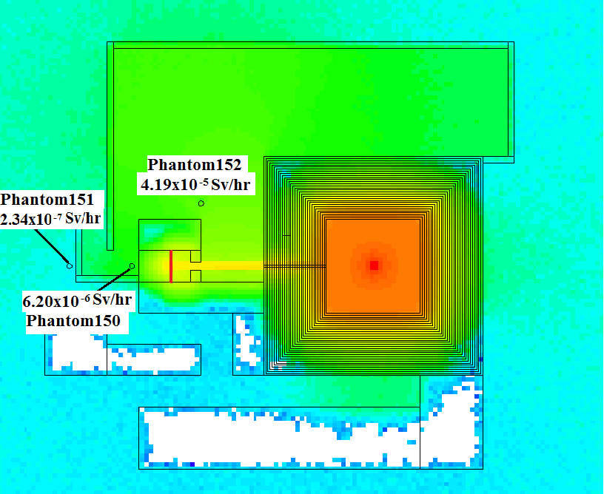 |  | 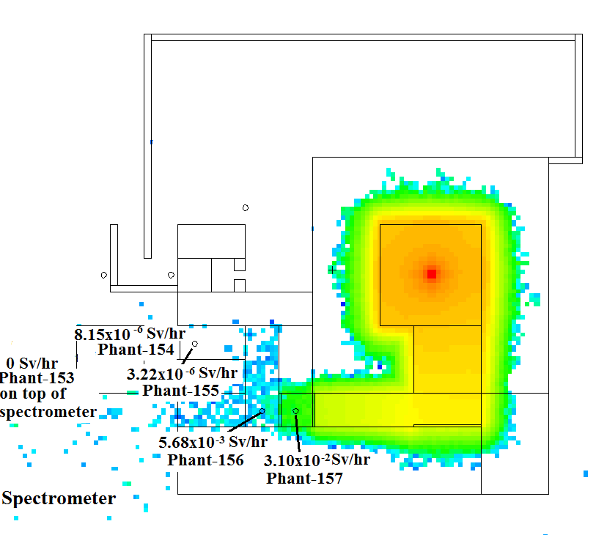
Figure 6: Mesh tally plot in the xy-plane showing the intensity distribution of neutron dose rates from the target point through ordinary concrete of 3 metre thickness. |  | Figure 7: Mesh tally plot in the xy-plane showing the intensity distribution of neutron dose rates from the target point through an open vault to show the effectiveness of the borated wax doors

Figure 6 confirms the beamlike exit of neutrons from the TIS Test Facility vault through the beamline. This escape is the main contributor to that of the high dose rates in the experimental room where Phantom 152 is placed. This figure with its colour-coding also shows the effectiveness of the beam dump in achieving radiation containment, particularly of neutrons.

Figure 7 shows the allocation of phantoms in areas of interest with corresponding dose rates. The aim is to see whether the corridor will be accessible during the RIB experiments as the corridor leads to the entrance of the spectrometer.

3.3 Analysis against Literature review
Similar calculations have been done at the INFN-Legnaro Lab for the 70-MeV cyclotron facility SPES. My calculations are in agreement with the SPES calculations for a 3 m thickness of concrete. It must be noted that the SPES calculation was done using FLUKA code and the dose-rate dropped 8 orders of magnitude, as did the TIS Test Facility for 3 m thickness. For both calculations the attenuation rate for the first 50 centimetre dropped by 2 orders of magnitude, with SPES dropping from 10⁹ µSv/hr to 10⁷ µSv/hr and Test Facility vault dropping from 10⁸ Sv/hr to 10⁶ Sv/hr. The rest of 50 cm the dose was dropping by a magnitude up to 300cm gave a similar behaviour as well for both.

3.4 Evaluation of results of the negative-ion Cyclotron vault
The registered total dose rate for the 4m thick concrete at the phantom was 0.4 mSv/hr, which is just below the limit for the Public and Non-Radiation Workers. This value is clearly safe for Radiation Workers as well. Where the phantom was placed will actually be a target station which will not be accessible by anyone when the beam is running

3.5 Evaluation of results of the TIS Test Facility vault
Table 3: Effective dose rate recorded in the phantoms in the Cyclotron and TIS Test Facility vault
Effective dose rates (µSv/hr) | Effective dose rates (µSv/hr)
phantom (81) cyclotron | 0.4
phantom (150) RIB labyrinth | 1.5
phantom (151) RIB outside yard | 0.053
phantom (152) RIB exp room | 14.6
phantom (154) RIB exit/entrance passage | 8.15
phantom (155) RIB exit/entrance passage | 3.22
phantom (156) RIB after 2nd boron door | 5680
phantom (157) RIB after 1st boron door | 31000

Phantom 152 which was placed in the experimental room registered 14.6 µSV/hr which is higher than the acceptable limit. However this reading is for during the experiment which is out of bound even for Radiation Workers.

- Conclusion & Recommendations
4.1 New cyclotron vault: safety & cost-effectiveness
Dose rate levels that were registered for the worst case give confidence that a 4 m thickness of concrete shielding walls will make the facility safe during beam operations as per specifications of beam energy and current.

A 4 m thickness of concrete shield instead of the 5 m which was first proposed means a huge cut in the budget.

A highly unlikely accidental beam-loss event was also simulated and dose rate levels well below the limits were registered, giving confidence that corridors and offices can be accessed maximally during operation of the cyclotron.

4.2 TIS Test Facility vault: safety & cost-effectiveness
Guided by Phantom 154, safety levels are NOT met with 3 m walls for the Test Facility vault operated at 350 µA current of 70 MeV proton beam for Public/Non-Radiation Workers to access the area where Phantom 151 is located. This area should be out of bounds during experiments. However, it will be safe if the vault is operated only at 100 µA current of 66 MeV proton beam, as currently envisaged. This means the calculated absorbed doses will be reduced by a factor of at least 0.3 in magnitude.

No major additional construction will be needed for the Test Facility vault, which is a big saving. However, some additional roof shielding will be needed to provide the required thickness, unless the roof area is made inaccessible (“out of bounds”) and skyshine can be shown to be at acceptable levels.

Putting two consecutive borated-wax doors will reduce dose levels towards the corridor (compare phantoms 156 &157). A boron strip against the wall will reduce dose rates, especially for absorbing high energy neutrons that have longer ranges.

The access corridor will also have to be closed off, preventing access to the spectrometer. The yard area outside the building will not be out of bounds to the public during experiments, so sufficient shielding and access labyrinths have to be provided, as suggested. Access to the experiment room will be prohibited during RIB experiments, even for radiation workers, as is normal at iThemba LABS.

- References
[1] R. Bark, iThemba LABS Radioactive Ion Beam Project Workshop presentations, iThemba LABS, Western Cape, South Africa, 20 to 26 September 2011
(http://www.tlabs.ac.za/rib.htm: 23/12/2011)
[2] NRF Annual Performance Report, National Research Foundation, Pretoria South Africa 2010/11
[3] G.F. Steyn, T.J. van Rooyen, J.H. Hough, F.M. Nortier, S.J. Mills, Design calculations for a local radiation shield of a radioisotope production target bombardment station, Nuclear Instruments and Methods in Physics Research Section A: Accelerators, Spectrometers, Detectors and Associated Equipment”, Volume 316, Issues 2-3, 1 June 1992, Pages 128-133
[4] F. M. Lukhele, E. Z. Buthelezi, O. M. Ndwandwe, Radiation Shielding calculations by means of MCNPX, MSc Thesis, University of Zululand, South Africa, January 2006
[5] The EURISOL Design Study (GANIL, Caen, France) 2009
[6] J. van Rooyen, Handbook for Transport and Shielding of Ionising Radiation, unpublished, January 2011
[7] L. Sarchiapone, D. Zafiropoulos, Radiation Protection Aspects of SPES Project - Phase Alpha, SPES 2010 International Workshop, Legnaro National Laboratory, Italy, 12-15 November 2010.
[8] T. E. Sibiya, T. Nam, J. Van Rooyen, Radiation shielding design, verification and dose distribution calculations for industrial and insect irradiation facilities, MSc Thesis, University of Witwatersrand, South Africa, August 2010
[9] F. B. Brown, Fundamentals of Monte Carlo Particle Transport, Lecture notes for Monte Carlo course Los Alamos National Laboratory, USA, LA-UR-05-4983
[10] J. K. SHULTIS; R. E. FAW, An MCNP Primer, Kansas State University, Manhattan, USA, 2006
[11] X-5 Monte Carlo Team, MCNP Version 5 Volume11 User’s Guide, LA-CP-03-0245, Los Alamos National Laboratory, USA , 24 July 2003
[12] D.B. Pelowitz, editor. MCNPX Version 2.6.0 User’s Manual, Report LA-CP-07-1473, Los Alamos National Laboratory, USA, April 2008.
[13] R. Lieder, Introduction to Nuclear Reactor Physics, lecture notes, MaNuS programme, University of the Western Cape, South Africa, 2010.
[14] Z. Zibi, A. Albornoz, Benchmarking of MCNP Modelling of HTR Cores against Experimental Data from the ASTRA Critical Facility, MSc Thesis, North-West University, South Africa, May 2010
[15] J. M. Ziegler, The Stopping and Range of Ions in Matter software,
(http://www.srim.org : 11/01/2012)
[16] The American Heritage® Science Dictionary. (http://www.thefreedictionary.com/modulus: 11/01/2012)

