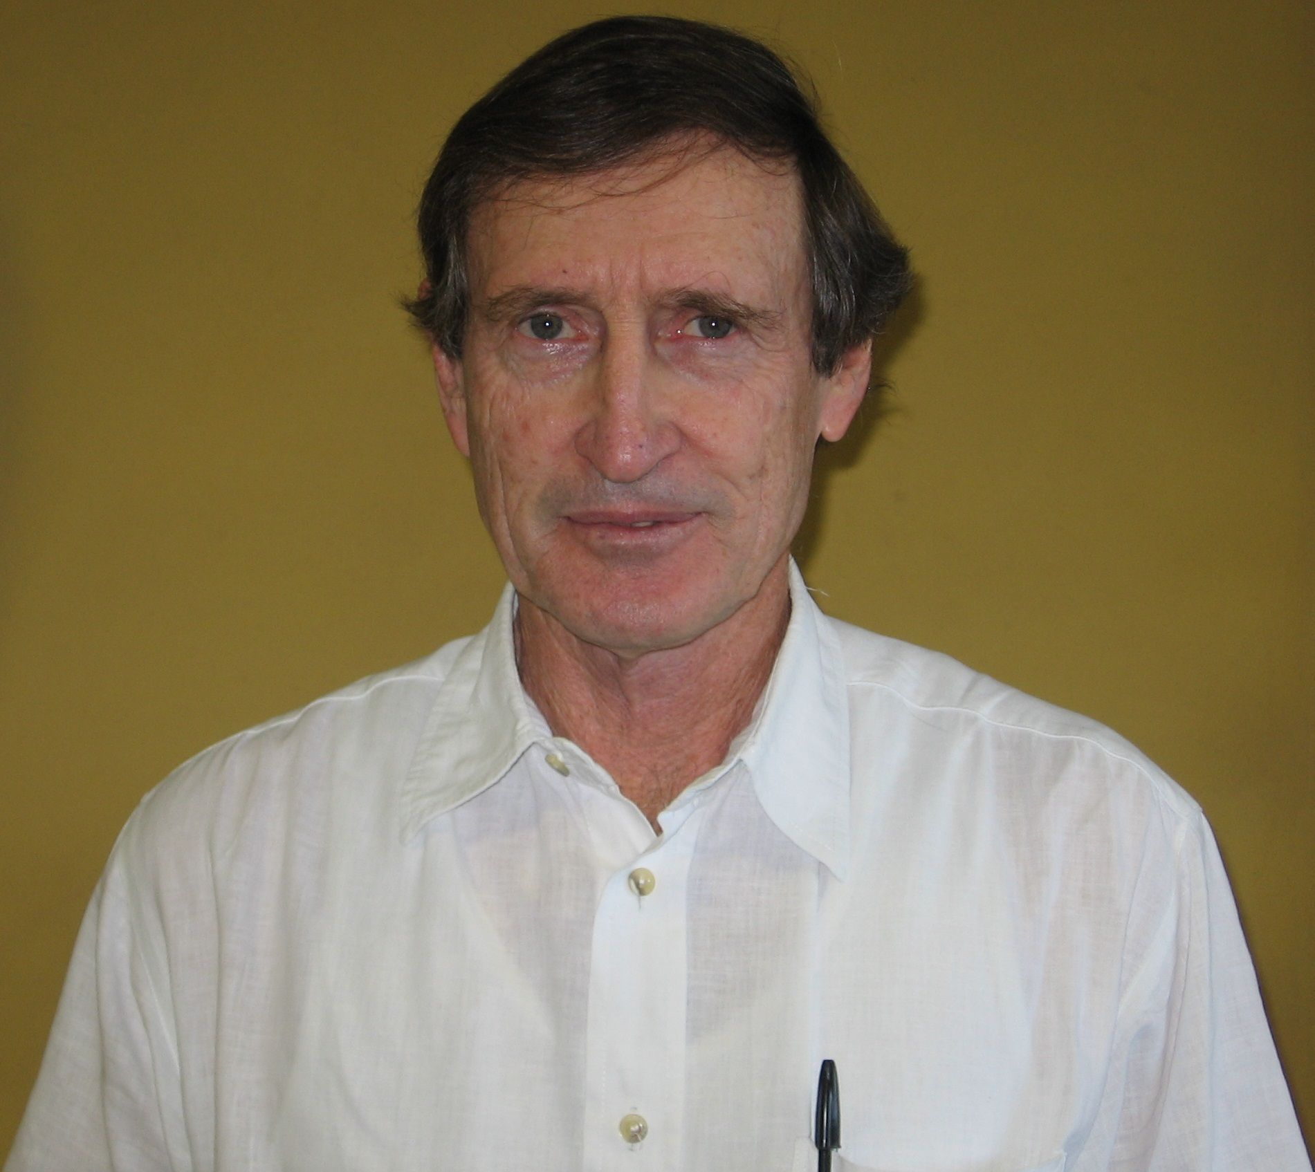 | Peter Booth obtained his initial degrees and an MSc at Rhodes University, Grahamstown, South Africa. He was awarded a PhD from the University of Cape Town (1990) on the Proterozoic geology at the Bushmanland/Richtersveld contact in Namaqualand. Peter commenced his working career in 1968 as an exploration geologist for mining and exploration companies (12 years in diamonds, gold, base-metals and uranium). In 1980 he joined the staff of Nelson Mandela Metropolitan University in Port Elizabeth where he lectured, and supervised post-graduate students until his retirement in 2008. He focused his research mainly on the Cape Fold Belt, and has published 45 papers, half of which appear in national and international journals. He was made a fellow of the Geological Society of South Africa in 2009. In his retirement he continues with research on the Cape Fold Belt, based in Port Elizabeth, supervising Masters and Doctoral students at NMMU.  Department Geosciences, NMMU, P O Box 77000, Port Elizabeth, 6031. peter.booth@nmmu.ac.za Tel: + 27 (0) 41 504 2325

