Example: Short Bio and Pic

- to submit online under by Saturday, 20 September 2014
- Short Bio not more than 150 words :
Name - 10pt Times New Roman
Body copy - 9pt Times New Roman
single spaced
fully justified
indicate [word count])
- Pics – jpegs only
- follow instructions to Add Files: http://events.saip.org.za/internalPage.py?pageId=5&confId=40

________________________________________________________________________

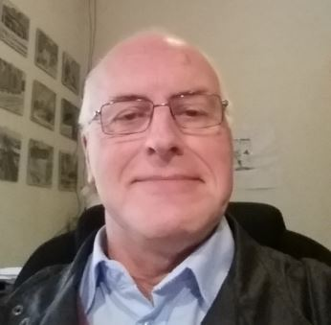 | Van Bever Donker, Jan.¹ received his MSc (Geology) from the University of Leiden, the Netherlands in 1974. He obtained his PhD in 1979 from the University of Cape Town. He is a structural geologist with a strong emphasis on fieldwork and joined the University of the Western Cape in 1979. During his 35 year tenure at UWC he built up the Geology Department from a first year service course for Geography students in the Faculty of Arts to the department it currently is with some 50 M and D students and the only structured MSc programme in Petroleum Geoscience south of Nigeria.  ¹Department of Earth Sciences, University of the Western Cape - Cape Town, SA  Email: jvanbeverdonker@uwc.ac.za/ e.mail address (private) janvbdonker@gmail.com / Mobile +27 83 414 0526

