Example: Short Bio and Pic

- to submit online under by Saturday, 20 September 2014
- Short Bio not more than 150 words :
Name - 10pt Times New Roman
Body copy - 9pt Times New Roman
single spaced
fully justified
indicate [word count])
- Pics – jpegs only
- follow instructions to Add Files: http://events.saip.org.za/internalPage.py?pageId=5&confId=40

________________________________________________________________________

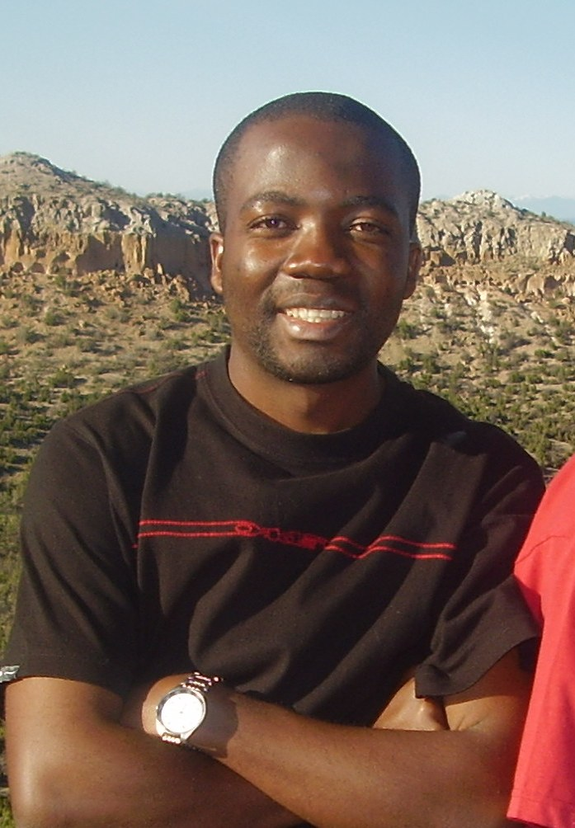 | Nformi, Emmanuel N.¹ received his BSc (Geology) from the University of Buea, Cameroon in 2005. He obtained his Honours in 2008 and MSc in 2011 on the Inkaba Programme in Applied Geology from the University of the Western Cape, South Africa. He is currently doing his PhD with research interest geared towards “Exploration Play Analysis of deepwater Orange Basin of South Africa from a Sequence Stratigraphic Perspective”. He has done field studies on part of the Douala Basin in Cameroon, the Permian Submarine Fans of the Karoo sub Basin (South Africa), the Basin and Range Province of the USA (as well other geologic terranes in the USA) and currently doing research in the Orange Basin of South Africa for his PhD. [124 words]  .¹Department of Earth Sciences, University of the Western Cape - Cape Town, SA  Email: 2801278@uwc.ac.za / e.mail address (private) / Mobile +27 xx xxx xxxx  Supervisor : Surname, Name, Title / e.mail address …………

