# SAIP2017

# Paper Submission Mission Information - SAIP2017 Proceedings

**Sections A & C must be completed by all authors (including students) who submit papers. Section B is compusory for students who submit paper(s).**

**Section A: Paper Submission Information**

|  |  |
| --- | --- |
| **Paper /Abstract ID** | A search is performed for the non-resonant and resonant pair production of a  Standard model Higgs boson h as well as a newly introduced Higgs-like scalar S through the decay of a heavy scalar H. The channels H → SS, Sh, hh are studied under the h and S decaying to 4W , with the final state having four leptons and missing energy due to the presence of neutrinos. this search is performed with 36.1 fb −1 of data accrued by the ATLAS detector at √s = 13 TeV. |
| **Paper title** | Search for the resonant pair production in the H → SS, Sh, hh channels decaying to 4W with a four lepton final state at √s=13 TeV at the ATLAS  detector |
| **Author (Primary) Name & Surname:** | Mampionona Ralaimiaramanana |
| **Author (Primary) Email Address:** | Rajaoferason |

**Section B: For Students & Supervisors**

|  |  |
| --- | --- |
| **Supervisor Name & Surname:** | Prof. Bruce Mellado |
| **Supervisor Email Address:** | Bruce.Mellado.Garcia@cern.ch |

**For this paper, the supervisor must agree/disagree with the following statements.**

|  |  |  |
| --- | --- | --- |
|  | **Yes** | **No** |
| 1. **I am aware that the above-mentioned paper is being submitted for possible publication in the Proceedings of the 2017 SAIP Conference and hereby give consent to the submission** | **yes** |  |
| 1. **I have proof-read the paper and I am satisfied that the presented work is that of the listed authors** | **yes** |  |
| 1. **I am satisfied that the paper is written in appropriate English and is sufficiently free of grammatical and spelling errors** | **yes** |  |
| 1. **I am familiar with the required manuscript format and I am satisfied that this paper meets the criteria** | **yes** |  |
| 1. **I am satisfied that the scientific content of this manuscript is of sufficient standard for it to be considered for publication in a reputable journal and consequently also in the Proceedings of the South African Institute of Physics Conference 2017** | **yes** |  |

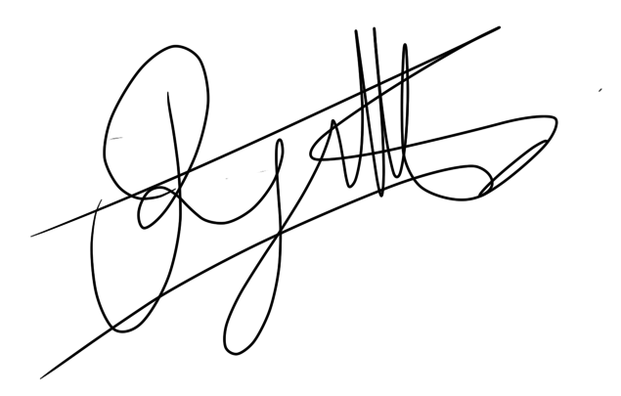

**Student Name & Surname: Mampionona R. Rajaoferason Signature: ………….……………..…… Date: 15/08/2017**

**Supervisor Name & Surname: Prof. Bruce Mellado Signature:** 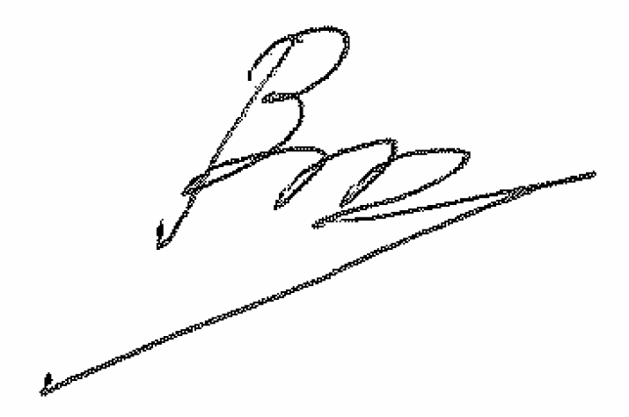 **Date: 15/08/2017**

**Section C: Suggested Reviewers for all Submissions**

**Note: In order to improve the scientific quality and ensure credibility of published proceedings of *South African Insititute of Physics (SAIP) conferences*, it is essential that manuscripts be evaluated by competent individuals.  Unfortunately, the physics community in South Africa is small and the onerous responsibility of reviewing manuscripts cannot be left to a few individuals.  As a supervisor of a student submitting a paper, you will automatically be added as a referee for the 2017 SAIP Conference proceedings. In addition please ensure that you provide a list of suggested reviewers below.**

|  |  |  |
| --- | --- | --- |
| **Suggested Reviewers in your Research Field**  **(Both local & International)** | | |
|  | **Reviewer Names & Surname** | **Reviewer’s Email Addresses** |
| **Suggested reviewer #1** | Prof. Yaquan Fang | [fangyq@ihep.ac.cn](mailto:fangyq@ihep.ac.cn" \t "_blank) |
| **Suggested reviewer #2** | Dr. Magda Chełstowska | magda.chelstowska@gmail.com |
| **Suggested reviewer #3** | Dr. Sahal Yacoob | [sahal.yacoob@uct.ac.za](mailto:sahal.yacoob@uct.ac.za) |