Role of swift heavy ion irradiation on the structural and magnetic properties of Ti_{0.95}Co_{0.05}O_{2−δ} epitaxial thin films
P Mohanty¹, C Rath², C J Sheppard^{1,} and A R E Prinsloo¹
¹Department of Physics, University of Johannesburg, P. O. Box 524, Auckland Park 2006, South Africa
²School of Materials Science and Technology, Indian Institute of Technology (Banaras Hindu University) Varanasi, Uttar Pradesh 221005, India

E-mail: cjsheppard@uj.ac.za
Abstract. Defects such as oxygen vacancies are found to play a vital role in determining the physical and magnetic properties of Ti_{1−x}Co_{x}O_{2−δ}. These defects can be created during growth or may be induced by ion irradiation or implantation. In this work, the structural and magnetic properties of epitaxial Ti_{0.95}Co_{0.05}O_{2−δ} thin films deposited on LaAlO₃ single crystal substrates under dense electronic excitation are discussed. Films were deposited by pulsed laser deposition (PLD) technique. X-ray diffraction (XRD) studies revealed that reflections, beside those corresponding to the planes (004) and (008) of the anatase phase of TiO₂, are suppressed, indicating epitaxial growth of the films along the c-axis. In order to investigate the important role of defects on the physical properties of the thin films, these were irradiated with 100 MeV Ag⁷⁺ ions with fluences 1×10¹¹, 1×10¹² and 1×10¹³ ions.cm⁻². XRD of the irradiated films indicate successive amorphization of the films with increasing ion dose. The magnetic measurements indicate a significant enhancement in the magnetization of the film irradiated with a fluence of 1×10¹³ ions.cm⁻². This unexpected increase in magnetization is explained on the basis of the bound magnetic polaron (BMP) model. The findings suggest the pivotal role of ion irradiation on tailoring the structural as well as the magnetic properties.
1. Introduction
Semiconductor spintronics unites both logic-processing functionalities (electronic charge) of a semiconductor and information-storage functionalities (electronic spin) of a ferromagnetic material. The main obstacle to realize such spintronics devices are the low Curie temperature (T_{c}) and controversial origin of magnetism in these systems [1].
In oxide based systems, room temperature ferromagnetism (RTFM) was first discovered by Matsumato et al. [2] in Co doped TiO₂ thin films making it a potential diluted magnetic semiconductor (DMS) material. Several models or mechanisms have been used to explain the origin of ferromagnetism in these systems, including the bound magnetic polaron (BMP) model, Ruderman-Kittel-Kasuya-Yosida (RKKY) exchange interaction, Stoner type model and charge transfer mechanisms [3, 4]. All these models or mechanisms could not explain the origin of magnetism satisfactorily. Although the exact mechanism of the magnetic correlation is still unclear, the possible coupling between charge carriers created by defects like oxygen vacancies and magnetic moment is unanimously accepted [5]. However, clustering of Co in the TiO₂ matrix resulting in ferromagnetic order is not accepted [6]. Ferromagnetism in Co doped TiO₂ polycrystalline thin films deposited by pulsed laser deposition (PLD) technique refuting the presence of Co clusters in the films has also been reported [7]. Films deposited under low oxygen partial pressure or annealing of the films under reduced atmosphere are found to demonstrate ferromagnetic behaviour at room temperature. Defects like oxygen vacancies also greatly influence the ferromagnetic properties of undoped TiO₂ thin films [8]. The challenge is therefore to create defects in the material systematically.
Ion irradiation used for defect engineering has been employed as a potential tool in material science [9]. Irradiation may dissolve the magnetic clusters in the host lattice and create disorder like amorphization in the system depending on the energy of the incident ion beam [9]. It can also create change in the crystal structure, enhance phase formation and defect annihilation with suitable selection of projectile ion, energy and fluence [10]. The material modiﬁcation can be complex depending upon the magnitude of electronic energy loss (S_{e}) as compared with a material-dependent threshold value, S_{eth}, beyond which swift heavy ions (SHI) can create amorphized latent tracks or can induce crystalline-to-crystalline phase transition [11, 12]. Recently, the role of SHI on structural and magnetic properties of Co doped TiO₂ polycrystalline thin films deposited on Si substrates have been reported [13].
To investigate the effect of ion irradiation on epitaxial thin films of Co doped TiO₂, this study utilized c-axis oriented LaAlO₃ (LAO) as the substrate, because of the small lattice mismatch it has with TiO₂ [14]. Secondly, owing to the important role of defects in tuning the magnetic property, the thin films were irradiated with 100 MeV Ag⁷⁺ ions with fluences 1×10¹¹, 1×10¹² and 1×10¹³ ions.cm⁻². The present work focuses on the modification in structural and magnetic properties of Ti_{0.95}Co_{0.05}O_{2−δ} thin films with the use of swift heavy ion irradiation.
2. Experimental
Co doped TiO₂ powdered samples were used to prepare the target for the pulsed laser deposition (PLD) by pressing the samples together in pellets and sintering these at 900 ºC for 24 hours. The target was ablated using a KrF excimer laser (Lambda Physik COMPex 201 Model, Germany) at constant laser energy of 240 mJ and 10 Hz repetition rate. Commercial LaAlO₃ (LAO) single crystal substrates were used for film deposition. The substrate temperature was maintained at 700 ºC during film deposition. Films were fabricated at 10 mTorr oxygen partial pressure. The target was rotated continuously during laser ablation. The deposited films were irradiated with 100 MeV Ag⁷⁺ ions at room temperature using a 15 UD tandem pelletron accelerator at IUAC, New Delhi, India with fluences 1×10¹¹, 1×10¹², and 1×10¹³ ions.cm⁻². The magnetic measurements of all the samples were investigated using a superconducting quantum interference device (SQUID) vibrating sample magnetometer (VSM) from Quantum Design in a magnetic field up to 1 T and temperature ranging from 5 to 300 K. Structural characterization was performed using a D8 Advance x-ray diffractometer from Bruker with LynxEye 1D-PSD detector in θ-2θ geometry. Film thickness and elemental compositions were measured with Rutherford’s backscattering spectrometry using stream of α particles (He²⁺). The measured thickness of the pristine film was calculated to be ~ 100 nm.
3. Results and discussion
The XRD pattern of the as deposited thin film indicates the anatase phase of TiO₂, as seen in Fig. 1. All the reflections except (004) and (008) are suppressed due to the epitaxial growth of the film along c-axis. After 100 MeV Ag⁷⁺ ion irradiation with fluences 1×10¹¹, 1×10¹² and 1×10¹³ ions.cm⁻², successive amorphization is clearly seen from the XRD profile shown in Fig. 1.
The interaction of ion beams with material modifies its physical properties. Ion beam irradiation is found to induce defects, anneal pre-existing defects, induce structural phase transformation and also influence the crystallinity of the target material [10]. SHI passes through the surface with velocity comparable to an electron’s Bohr velocity and loses its energy while traversing through matter. The
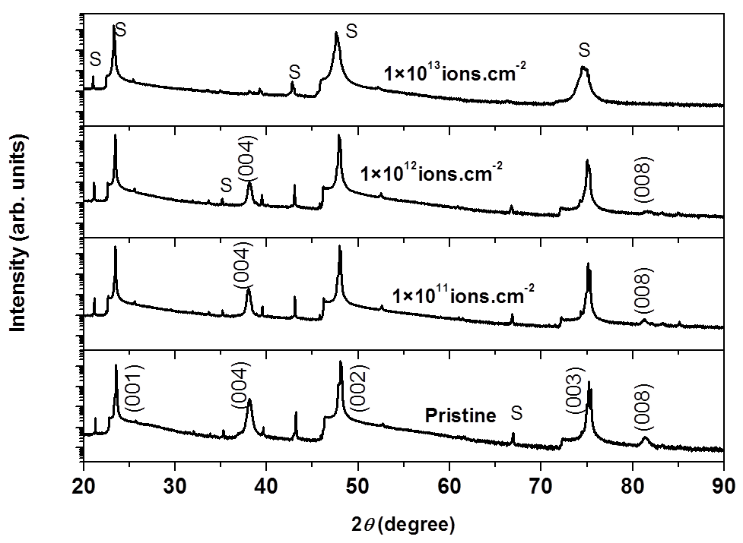
Figure 1. XRD pattern of pristine and irradiated Ti_{0.95}Co_{0.05}O_{2−δ} thin films deposited at 10 mTorr oxygen partial pressure on LaAlO₃ substrate. The fluence used is indicated in each panel. ‘S’ denotes the reflections related to LaAlO₃ substrate.

total energy loss can be expressed as the contribution of two independent energy loss processes: (i) electronic energy loss, (dE/dx)_{e} ~ S_{e}, attributed to electronic excitation and ionization due to the inelastic collision with electrons dominating at high energy regime and (ii) nuclear energy loss, (dE/dx)_{n} ~S_{n}, due to the elastic collisions with the atoms of the solid with the nuclei of the projectile ion. The former process is dominant for ions in the mega electron volt (MeV) energy range and the latter is valid for ions in the kilo electron volt (keV) energy range. In the present study, the energy of the projectile ions is selected such that it can pass through the film thickness and get buried inside the substrate. The 100 MeV Ag⁷⁺ ions deposit ~ 18.16 keV.nm⁻¹ in inelastic collisions (electronic energy loss S_{e}) with electrons, ~ 90.86 eV/nm in elastic collisions (nuclear energy loss S_{n}) with nuclei as estimated using SRIM (The Stopping and Range of Ions in Matter) simulations code [15]. The projected range of the ions is approximately 9650 Å which is greater than the film thickness i.e. ~ 1000 Å. Since the threshold for track formation in TiO₂ film is approximately 6.2 keV.nm⁻¹, it is expected that the changes produced in the films are dominantly due to the electronic energy loss [16]. From the XRD it is clear that the film gets completely amorphized at a fluence of 1×10¹³ ions.cm⁻², as shown in Fig. 1.
In order to investigate the magnetic properties of the pristine and irradiated films, magnetization measurements as a function of applied magnetic field under zero filed cooling (ZFC) and field cooling (FC) conditions, with a probing field of 50 Oe and temperature ranging from 5 to 300 K, were performed. These results are shown in Fig. 2. As Co is a magnetic metal and can contribute to the magnetization of the film in the form of Co clusters instead of substituting the Ti site, it is necessary to determine the Co concentration in TiO₂. This was performed by using Rutherford’s backscattering
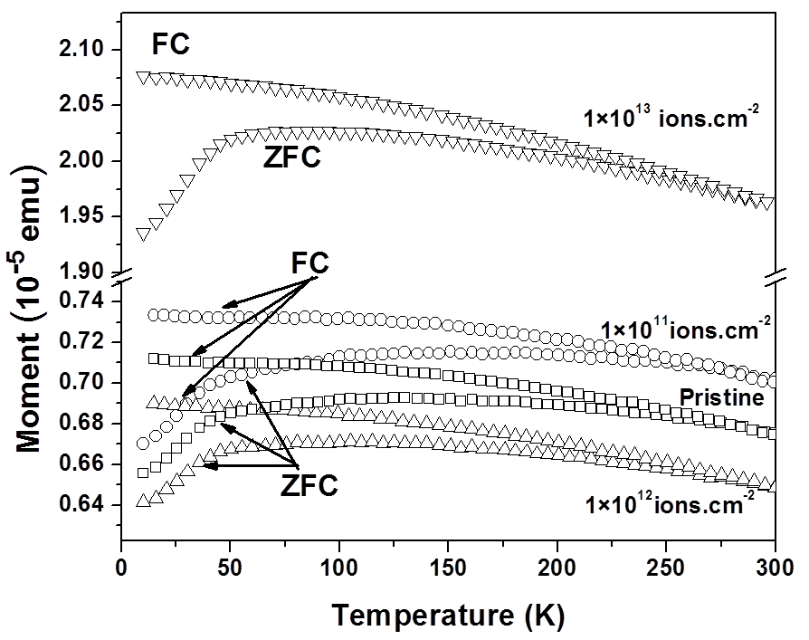
Figure 2. Magnetization as a function of temperature of pristine and irradiated Ti_{0.95}Co_{0.05}O_{2−δ} thin films deposited at 10 mTorr oxygen partial pressure on LaAlO₃ substrate.

spectrometry (RBS). RBS measurements indicated that the actual Co concentration is 5 atomic %. In order to form Co clusters in TiO₂ matrix, a Co concentration of greater than 7 atomic % is needed [2]. In the measured films the Co concentration is less than the critical concentration and thus the contribution to magnetization because of Co cluster is ruled out. From Fig. 2 it is clear that the magnetization relative to ZFC and FC measurements are irreversible, as the two measurements do not coincide. From Fig. 2 it is also evident that the T_{c} of the films is above 300 K. Fig. 3 illustrates the magnetization as a function of applied magnetic field at 300 K and 5 K for the pristine as well as irradiated thin films. From the obtained magnetization values the diamagnetic contribution from the LAO substrate was carefully deducted. The magnetization increases with increasing magnetic field and almost saturates. While decreasing the field, the magnetization did not retrace the same path and show a prominent hysteresis for the pristine as well as irradiated thin films. The saturation magnetization (M_{s}) increases for the fluence 1×10¹¹ ions.cm⁻². However, it decreases with fluence 1×10¹² ions.cm⁻². Surprisingly, the M_{s} increased abruptly for the film irradiated with 1×10¹³ ions.cm⁻² that shows complete amorphization at this fluence. A similar trend is obtained in M-H behaviour measured at 5 K (see Fig. 3 (b). Thakur et al. [17] reported ferromagnetism in undoped TiO₂ when irradiated with 200 MeV Ag ions with a phase change from anatase to brookite. Sanyal et al. [18] reported ferromagnetism with low energy Ar irradiated TiO₂ thin films. In case of Co doped TiO₂ polycrystalline thin films, the saturation magnetization M_{s} decreases with increasing ion fluence [13]. The decrease in M_{s} was explained as a consequence of formation of magnetically disordered region around the ion track that does not contribute to the ferromagnetic order [13]. However, in the present
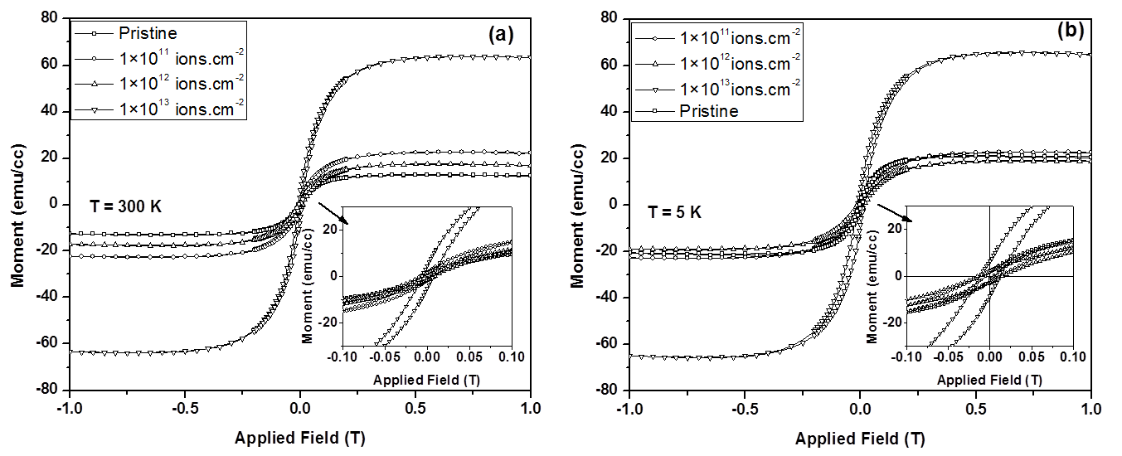
Figure 3. M-H plots for the pristine and irradiated Ti_{0.95}Co_{0.05}O_{2−δ} thin films deposited at 10 mTorr oxygen partial pressure on LaAlO₃ substrate and measured at temperatures: (a) 300 K and (b) 5 K. The insets show the zoomed view of the hysteresis loops in low field region.

case the M_{s} is increased with ion irradiation which is quite different from the response of the polycrystalline films towards swift heavy ions.
There are several mechanisms proposed for the observed magnetism in Co doped TiO₂ system: (i) Bound magnetic polaron percolation (BMP) model, (ii) indirect RKKY exchange interaction, and (iii) impurity band exchange model. Among these models or mechanisms BMP and RKKY models are quite convincing. Bound magnetic polarons are formed due to Coulomb and magnetic exchange interactions surrounding a defect like oxygen vacancy [4, 19]. In the BMP model carriers are localized due to electrostatic interaction with some defect [19]. The magnetic polarons are well deﬁned, non-overlapping, isolated entities, only at low carrier densities and suﬃciently large temperatures. The size of the polarons increase as the temperature decreases, eventually overlapping with neighbouring BMPs. This overlap causes the alignment of their spins, therefore forming ferromagnetic (FM) clusters. The FM transition takes place when an ‘inﬁnite cluster’ (of the size of the system) is formed, i.e. when the percolation of BMP occurs. The model is valid in the low carrier density regime and when the magnetic impurities are larger than the density of carriers [19]. In case of RKKY model, the itinerant electron plays a vital role. The itinerant electron interacts with the localized moments and tends to order them. For RKKY model to be applicable, the system should have sufficient itinerant electrons. With ion irradiation it has been found that the conductivity of TiO₂ films decreases and films become insulating [20]. Thus, the mechanisms leading to ferromagnetism in these films at lower and higher fluence are definitely different. The competing effect between these two mechanisms leading to ferromagnetic ordering results in the anomaly seen in the magnetization for the intermediate fluence as observed from the M-H measurements at 5 and 300 K. Thus, bound magnetic polaron (BMP) mechanism is mostly dominant for the amorphous film irradiated with fluence 1×10¹³ ions.cm⁻² demonstrating maximum magnetization.
4. Conclusions
Ti_{0.95}Co_{0.05}O_{2−δ} thin films were grown on single crystal LaAlO₃ substrates. The anatase phase of the film was retained with ion irradiation. However, the crystallinty degraded with ion irradiation and the films became completely amorphous at fluence 1×10¹³ ions.cm⁻². ZFC-FC magnetization revealed prominent bifurcation below 300 K, indicating that the T_{c} of the film is well above room temperature. Magnetization as a function of applied magnetic field measured at 300 K and 5 K confirms the ferromagnetic behaviour of the films. The M_{s} initially increased for the film irradiated with fluence 1×10¹¹ ions.cm⁻² then decreased for the fluence 1×10¹² ions.cm⁻² and finally the magnetization increases dramatically for the amorphous film irradiated with fluence 1×10¹³ ions.cm⁻². This unusual increase in the magnetization can be explained on the basis of BMP model.
Acknowledgements
PM gratefully acknowledge Dr. R. J. Choudhary, UGC-DAE Consortium for Scientific Research, Indore, India for the measurement facilities. AREP and CJS acknowledge the financial support of UJ and the NRF (grant number 93551).
References
- Yamada Y, Ueno K, Fukumura T, Yuan H T, Shimotani H, Iwasa Y, Gu L, Tsukimoto, Ilkuhara Y and Kawasaki M 2011 Science 332 1065
- Matsumoto Y, Murakami M, Shono T, Hasegawa T, Fukumura T, Kawasaki M, Ahmet P, Chikyow T, Koshihara S and Koinuma H 2001 Science 291 854
- Janisch R, Gopal P and Spaldin N A 2005 J. Phys. Condens. Matter 17 R657
- Coey J M D, Venkatesan M and Fitzgerald C B 2005 Nat. Mater. 4 173
- Sundaresan A, Bhargavi R, Rangarajan N, Siddesh U and Rao C N R 2006 Phys. Rev. B 74 161306(R)
- Manivannan A, Seehra M S, Majumder S B and Katiyar R S 2003 Appl. Phys. Lett. 83 111
- Mohanty P, Mishra N C, Choudhary R J, Banerjee A, Shripathi T, Lalla N P, Annapoorni S and Rath C 2012 J. Phys. D: Appl. Phys. 45 325301
- Mohanty P, Kabiraj D, Mandal R K, Kulriya P K, Sinha A S K and Rath C 2014 J. Magn. Magn. Mat. 355 240
- Kanjilal D 1997 Vacuum 48 979
- Wesch W, Kamarou A and Wendler E 2004 Nucl. Instrum. Methods Phys. Res. B 225 111
- Szenes G 1995 Phys. Rev. B 51 8026
- Benyagoub A 2006 Nucl. Instrum. Methods Phys. Res. B 245 225
- Mohanty P, Singh V P, Mishra N C, Ojha S, Kanjilal D, Rath C 2014 J. Phys. D: Appl. Phys. 47 315001
- Lotnyk A, Senz S, Hesse D 2007 Thin Solid Films 515 3439
- Zeigler J F, Biersack J P and Littmark V 1985 The Stopping and Range of Ions in Solids (New York: Pergamon)
- Nomura K-I, Nakanishi T, Nagasawa Y, Ohki Y, Awazu K, Fujimaki M, Kobayashi N, Ishii S and Shima K 2003 Phys. Rev. B 68 064106
- Thakur H, Thakur P, Kumar R, Brookes N B, Sharma K K, Singh A P, Kumar Y, Gautam S and Chae K H 2011 Appl. Phys. Lett. 98 192512
- Sanyal D, Chakrabarti M, Nath P, Sarkar A, Bhowmick D and Chakrabarti A 2014 J. Phys. D: Appl. Phys. 47 025001
- Calderon M J and Sarma S D 2007 Ann. Phys. 322 2618
- Mohanty P, Ph.D. Thesis 2015 Structure, Magnetic and Transport Properties of Nanostructured Ti_{1−x}Co_{x}O_{2−δ}

To whom any correspondence should be addressed

