Effect of temperature and CH4/ZrCl4 molar ratio on ZrC layers deposited in a vertical-wall CVD system

**S Biira1,2, BAB Alawad1, H Bissett3, JT Nel3, TT Hlatshwayo1,PL Crouse4, JB Malherbe1**

1Department of Physics, University of Pretoria, Pretoria, 0002 South Africa

2Department of Physics, Busitema University, P.O Box 236, Tororo, Uganda

3Applied Chemistry Division, The South African Nuclear Energy Corporation (Necsa), P.O Box 582, Pretoria, 0001 South Africa

4Department of Chemical Engineering, University of Pretoria, 0002 South Africa

E-mail address: [bsaphina@yahoo.co.uk](mailto:bsaphina@yahoo.co.uk)

**Abstract**. The synthesis of ZrC layers was performed in an in-house developed, vertical-wall chemical vapour deposition (CVD) system operating at atmospheric pressure. Zirconium tetrachloride and methane were used as zirconium and carbon sources respectively, with an excess of hydrogen as reducing agent. Argon was used to carry the vaporised ZrCl4 at 300 °C to the reaction chamber. The deposition of ZrC was carried out on graphite substrates at temperatures in the range of 1200 °C –1600 °C. The molar ratio of CH4/ZrCl4 was varied from 6.04 to 24.44. Response surface methodology was applied to optimise the process parameters for the deposition of ZrC. A central composite design was used to investigate the effects of temperature and molar ratio of CH4/ZrCl4 on the average crystallite size. Quadratic statistical models for crystallite size was established. Scanning electron microscopy (SEM) images show that the coatings became more uniform with increased particle agglomeration as temperature increased.

1. Introduction

The use of ZrC has been proposed as replacement for SiC, or in addition to the standard SiC layer, in TRISO (tristructural-isotropic) layers. This is because ZrC is a better barrier than SiC against Ag diffusion and is more resistant to Pd attack [1,2]. The physical and chemical properties of ZrC layers depend on chemical composition, crystallite size and morphology, orientations of crystal planes, structural defects, porosity, and the presence of impurities. These factors are a function of the methods and conditions used in growing ZrC coatings. Chemical vapour deposition (CVD) produces coatings with very low levels of impurities and low porosity [3]; this is why it is the preferred method. Compared to SiC, little research has been published on the use of ZrC in nuclear reactors. The main reason is that SiC has proven nuclear applications. Another reason for this might be that it is difficult to grow good quality ZrC. This paper reports on the development of a deposition process for the preparation and optimisation of ZrC layers at temperatures ranging from 1200 °C to 1600 °C and CH4/ZrCl4 molar ratios ranging from 6.04 to 24.44. After choosing temperature and the CH4/ZrCl4 ratio as the dominant variables influencing the properties of ZrC, in order to achieve optimum conditions for growing ZrC coatings, a statistical experimental design methodology (central composite design) was applied to explore the effects of these variables [4].

1. Experimental

## Apparatus and deposition process

**Figure 1.** Process and instrumentation diagram for the CVD reactor set-up.

In this study a vertical-wall thermal CVD system illustrated in Figure 1, was developed in-house at The South African Nuclear Corporation (Necsa). It is composed of a 10 kW RF power supply system, a gas supply and delivery system, the reactor system, and an exhaust/scrubber system. ZrC was deposited on graphite substrates from ZrCl4-Ar-CH4-H2 gas mixtures. Methane, hydrogen and argon flow rates were measured by flow meters and directed into the reaction chamber as shown in Figure 1. The deposition was carried out for typically 2 hours at atmospheric pressure. Hydrogen and argon flow rates were constant at 853 sccm and 562 sccm respectively. This gave a 1.0 g/h mass transfer rate of ZrCl4. Table 1 gives the details of the deposition parameters.

* 1. Design of experiments and response surface methodology

Response surface methodology (RSM) was applied to analyse and model the effect of the independent variables on the response(s) [4]. The ZrC deposition process was investigated using a central composite design (CCD). The temperature (*T*) and the CH4/ZrCl4 molar ratio (*M*) were chosen as the independent variables. For this paper, the average crystallite size was selected as the dependent (response) variable. For the purpose of analysing the raw data and testing the goodness of fit of the model, an analysis of variance (ANOVA) was implemented. The details of testing of model adequacy and suitability were explained elsewhere [5].  The 13 experiments and the point types generated, are indicated in Table 1. The experiment was designed and statistical analysis was done using DESIGN-EXPERT® 7.0 [6], which is a commercial statistical software package.

**Table 1.** Parameters for CVD experiments and average crystallite size.

|  |  |  |  |  |  |
| --- | --- | --- | --- | --- | --- |
| **Exp. Number** | **Point type** | **Temperature (°C)** | **CH4/ZrCl4** | **CH4 flow rate (sccm)** | **Crystallite size (nm)** |
| 1 | Axial | 1400 | 24.44 | 43.3 | 21.8 |
| 2 | Axial | 1400 | 6.04 | 10.7 | 23.9 |
| 3 | Factorial | 1541 | 8.73 | 15.5 | 29.1 |
| 4 | Factorial | 1259 | 21.75 | 38.5 | 28.4 |
| 5 | Centre | 1400 | 15.24 | 27.0 | 31.9 |
| 6 | Axial | 1600 | 15.24 | 27.0 | 34.1 |
| 7 | Centre | 1400 | 15.24 | 27.0 | 32.0 |
| 8 | Centre | 1400 | 15.24 | 27.0 | 34.2 |
| 9 | Centre | 1400 | 15.24 | 27.0 | 33.4 |
| 10 | Factorial | 1259 | 8.73 | 15.5 | 25.8 |
| 11 | Factorial | 1541 | 21.75 | 38.5 | 27.8 |
| 12 | Centre | 1400 | 15.24 | 27.0 | 32.6 |
| 13 | Axial | 1200 | 15.24 | 27.0 | 26.3 |

1. Results and Discussion

## 3.1 Crystallographic structure and Phase composition

Figure 2 shows a typical XRD pattern of ZrC coatings deposited at a substrate temperature of 1259 °C at CH4/ZrCl4 of 21.7. Ten reflections of ZrC were observed, and matched with the International Centre for Diffraction Data (ICDD) file number 03-065-8833 for the material. They indicate that polycrystalline face-centred cubic structure of the ZrC coating has been deposited. The average crystallite size of the samples was determined from the Scherrer equation [5]. The raw experimental data are presented in Table 1.



**Figure 2.** Typical XRD pattern for ZrC deposited at 1259 ºC for CH4/ZrCl4 molar ratio of 15.23**.**

* + 1. Average crystallite size.

The execution of the response surface methodology produced the regression equation (1) which represents the relationship between the crystallite size and the independent variables T (temperature) and M (CH4/ZrCl4 molar ratio).

|  |  |
| --- | --- |
|  | (1) |

A quadratic model was found to be statistically significant. The model’s corresponding p-value is less than 0.05 (95% confidence). The lack-of-fit is not significant with the *F*-value and p-value of 4.93 and 0.0787 respectively. The R-squared and adjusted R-squared values are 91% and 85%, indicating that the regression model gives a good description of the relationship between the temperature and CH4/ZrCl4, and the crystallite size.

To fully describe the interactions and the quadratic effect of the temperature and CH4/ZrCl4 on crystallite size, the response surface analysis was plotted in the contour graph given in Figure 3. The dots represent the experimental values (given in Table 1). The numbers in rectagles denote the value of the response along the given contour given by Equation 1. The integer “5” represents the five replicated centre points. It can be observed that the average crystallite size increases as temperature and CH4/ZrCl4 ratios increase. This can be interpreted to be a result of the increasing temperature causing increased atomic mobility which favour crystal growth. There should also be a sufficient CH4/ZrCl4 concentration to facilitate the reaction mechanism. It is also observed that as the temperature and CH4/ZrCl4 increases further the average crystallite size decreases. The reason for this may be due to increased amount of free carbon which acts as an impurity, retarding ZrC crystal growth.

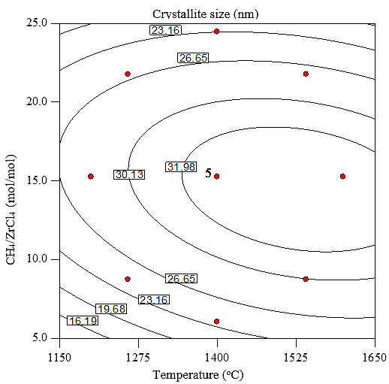

**Figure 3.** The effect of temperature and CH4/ZrCl4 ratio on crystallite size.

## Surface morphology

Figure 4 shows SEM micrographs of ZrC deposited at 1200 °C, 1400 °C and 1600 °C. The CH4/ZrCl4 ratio was maintained at 15.23 during deposition. ZrC deposited at 1200 °C shows ball-shaped particles clustering together to form a cauliflower-like shape. Several pores surrounded the cauliflower-like shapes. At 1400 °C the ball-like shapes became bigger and the openings reduce significantly. This might be an indication of small particles agglomerating to form much bigger particles during deposition. When the temperature was increased to 1600 °C, the ball-like shapes became even much bigger that those at 1400 °C. At this point the openings are no longer visible leaving the bottom of the surface looking somehow flat. Some regions of the surface have the particles stacking on top of each like islands. No cracks were visible in all the deposited ZrC. It is therefore clear that the substrate temperature influenced the morphology and the surface uniformity of the ZrC coatings.

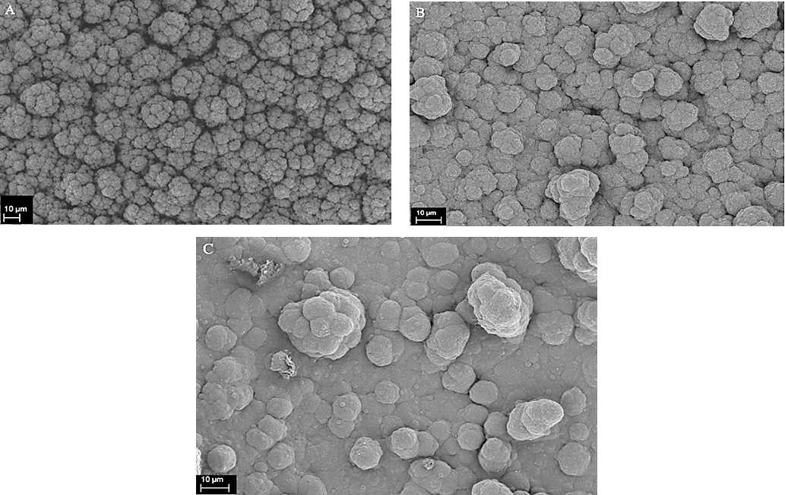

**Figure 4.**SEM image of the surface morphology of ZrC layers deposited at CH4/ZrCl4 ratio of 15.23 and at A-1200 oC, B-1400 oC and C-1600 oC.

1. Conclusion

ZrC coatings were deposited on graphite substrates at atmospheric pressure using an in-house built vertical CVD system. The experimental raw results were analysed using response surface methodology (RSM) to give a correlation between the crystallite sizes and, substrate temperature and CH4/ZrCl4 ratio. Mathematical regression representations were obtained and are useful in predicting the values of the independent variables for the preparation of ZrC layers with desired average crystallite sizes. The graphical representation further displays the patterns and trends of their behaviour. SEM results showed that particle size and coating uniformity increase with increasing temperature in the range of 1200–1600°C. This means that to deposit a relatively thick coating high temperatures are required.

1. References

[1] Malherbe J B 2013 Diffusion of fission products and radiation damage in SiC *J. Phys. D. Appl. Phys.* **46** 473001

[2] Sawa K and Ueta S 2004 Research and development on HTGR fuel in the HTTR project *Nucl. Eng. Des.* **233** 163–72

[3] Katoh Y, Vasudevamurthy G, Nozawa T and Snead L L 2013 Properties of zirconium carbide for nuclear fuel applications *J. Nucl. Mater.* **441** 718–42

[4] Montgomery D C 2008 *Design and analysis of experiments* (John Wiley & Sons)

[5] Biira S, Crouse P L, Bissett H, Alawad B A B, Hlatshwayo T T, Nel J T, and Malherbe J B 2017 Optimisation of the synthesis of ZrC coatings in an RF induction-heating CVD system using surface response methodology *Thin Solid Films* **624** 61–69

[6] Stat-Ease 2005 Design expert version 7.0.0 *Stat-Ease Inc*