Supervisor/Promoter Agreement

Note: In order to improve the scientific quality and ensure credibility of published proceedings of South African Insititute of Physics (SAIP) conferences, it is essential that manuscripts be evaluated by competent individuals. Unfortunately, the physics community in South Africa is small and the onerous responsibility of reviewing manuscripts cannot be left to a few individuals. As a supervisor of a student submitting a paper, you will automatically be added as a referee for the 2016 SAIP Conference proceedings.

Paper ID | 208
Paper title | Search for a heavy scalar decaying into the Higgs boson and missing energy with the ATLAS detector
Author (Primary) Name: | Chad Pelwan
Author (Primary) Email: | Chad.pelwan@gmail.com
Supervisor Name: | Prof. Bruce Mellado
Supervisor Email: | bmellado@mail.cern.ch
Suggested reviewer #1 | Dr. Deepak Kar (dkar@cern.ch)
Suggested reviewer #2 | Dr. Yesenia Hernandez (yesenia.hernandez.jimenez@cern.ch)

For this paper, the supervisor/promotor must agree/disagree with the following statements.

 | Yes | No
I am aware that the above-mentioned paper is being submitted for possible publication in the Proceedings of the 2016 SAIP Conference and hereby give consent to the submission | x
I have proof-read the paper and I am satisfied that the presented work is that of the listed authors | x
I am satisfied that the paper is written in appropriate English and is sufficiently free of grammatical and spelling errors | x
I am familiar with the required manuscript format and I am satisfied that this paper meets the criteria | x
I am satisfied that the scientific content of this manuscript is of sufficient standard for it to be considered for publication in a reputable journal and consequently also in the Proceedings of the South African Institute of Physics Conference 2016 | x

Student: ……C. Pelwan.. Signature: …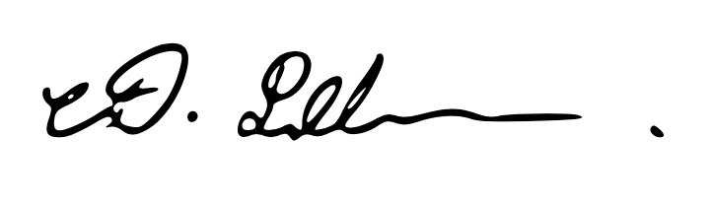 Date:14/07/2016.

Supervisor: …Prof. Bruce Mellado. Signature: ………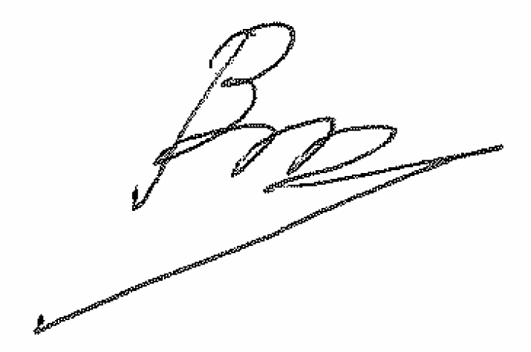 Date: 14/07/2016.

