**Synthesis and characterization of PbS nanostructures using the chemical bath deposition method**

**L.F. Koao1, F. B. Dejene1* and H.C. Swart2.**

1Department of Physics, University of the Free State (Qwaqwa Campus), Private Bag

X13, Phuthaditjhaba, 9866, South Africa

2Department of Physics, University of the Free State, P.O. Box 339, Bloemfontein,

9300,South Africa.

*Corresponding author: Tel: +27 58 718 5307; Fax: +27 58 718 5444; E-mail:

dejenebf@ufs.ac.za

**Abstract**. Crystalline lead sulfide (PbS) nanorods were synthesized by chemical bath deposition (CBD) method. The lead acetate concentrations, the pH and deposition time were varied in the deposition process to determine the effect thereof. The final yields were characterized for structural, morphology and optical properties. The X-ray diffraction (XRD) spectra of the PbS nanorods correspond to the various planes of a single phase cubic PbS. The average particle sizes calculated using the XRD spectra were found to be 14±0.5 and 16±0.5 nm for samples stirred for 10 and 5 minutes respectively. The particle size was found to be dependent on the pH and the concentration of lead acetate used. Scanning electron microscopy (SEM) micrographs depict nanorod structures for a high mol concentration of lead acetate and a spherical shape for a low mol percentage. Energy dispersive X-ray (EDS) analyses confirm the presence of all the expected elements. The solid powder nanorods show good optical properties with high absorptions in the UV and visible regions. The band gap energies were estimated to be 2.07 to 3.02 eV which are higher than the bulk PbS band gap of 0.37 eV.

1. Introduction

It is well known that the synthesis of semiconductor one-dimensional nanostructures has attracted much attention in nanotechnology for several years. Designing extremely narrow nanorods with well defined shapes and sizes in the strong confinement regime (rod radius, r<< Bohr radius, aB) remains a big challenge in nanotechnology. The need for such nanorods of different materials is increasing due to their possible application as nanoscale building blocks for different applications.The interest is particularly true for the IV-VI class of materials which can cover the technologically important wide spectral range from mid-infrared to the visible region, yet have been studied to a lesser extend compared to II-VI semiconductors [1]. Lead sulfide has a narrow and direct band gap (0.37 eV) at 300 K. PbS nanorods are potentially useful in electroluminescent devices such as light emitting diodes, high speed switching and optical sensors because of large band gap of above 2 eV [2 and 3]. The band gap energy of PbS can be widened from UV to visible region by forming nanocrystal because of their quantum size effects [4 and 5]. The chemical bath deposition (CBD) is a simple, cheap and convenient process to prepare semiconducting materials. The more recent interest in all things ‘nano’ has provided a boost for CBD, since it is a low temperature, solution (almost always aqueous) technique and crystal size is often very small. The aim of this paper is to investigate the effect of different growth parameters on the material properties of PbS.

1. Experimental

The PbS nanorods were prepared by changing different mol concentrations lead acetate and holding constant thiourea and ammonia. The preparation of PbS nanorods was carried out using the following procedure: 50 ml of X Lead acetate solutions (X is the different mol concentrations of lead acetate) were taken in a 200ml beaker. Then, 50 ml of thiourea solution was added in the reaction bath and the mixture was stirred for few minutes, Following that 50 ml of ammonia solution was added slowly into the mixture, while continuing stirring for different times (for few minutes or immediate after the precipitates has formed, 5 and 10 minutes). The temperature of the bath was then allowed to increase up to 80oC. After the precipitates were formed the pH was measured and the precipitates were filtered and washed with 50 ml of ethanol. The resulting powders were dried at ambient conditions for 3 days and ready to be characterized using various characterization technique.

1. Results and Discussion

3.1 Structural analysis and Composition analysis

Fig. 1 (a) shows xrd pattern of the PbS nanorods synthesis at constant mol concentration of lead acetate of 0.06M and different times, respectively. The four main peaks observed in the diffractogram at around 25.99°, 30.11°, 43.09° and 51.03° reveal a cubic lattice structure of PbS [6].



**Figure 1**: X-ray powder diffraction patterns for undoped PbS prepared for (a) different stirring

times at constant mol concentrations and (b) different mol concentrations of lead acetate at

constant time (10 minutes).

There were also additional peaks (*) which may be attributed to unreacted Pb (CH3COO)2.2H2O, (NH2)2CS and NH3 precursors or other impurities phases such as PbO and PbOH. The calculated value of the cell constant of 5.9597 Å matched perfectly with standard data available in JCPDS card no. (05-0592, a=5.936 Å).The average size of the as-prepared nanocrystals can be calculated from the Full Width Half Maximum (FWHM) of the diffraction peaks using the Debye-Scherrer formula [7]:

(1)



where *t* is the particle diameter of nanocrystallites, λ is the X-ray wavelength (0.154 nm), β is the diffracted full-width at half maximum (in radian) caused by the crystallites and 𝜃 is the Bragg angle. All major diffraction peaks for all samples are chosen to estimate the average size of the nanocrystals by least square method. The average particle size of the PbS synthesized using a 0.06M lead acetate for 1, 5 and 10 min are estimated to be 16±0.2, 15±0.4 and 14±0.5 nm, respectively. The values increased to 18±0.7, 17±0.5 and 16±0.1 nm, after the lead acetate concentration increased to 0.13M. The sizes of the products are affected by the precursor concentration in the solution and stirring time. In Fig. 1 (b) for the sample stirred for 10 minutes the only difference is that at high mol concentration of 0.36M of lead acetate the are many peaks that may be due to the clustered lead acetate (*) but at low mol concentrations of lead acetate many peaks diminishes and the other peaks are clearly distinguishable which shows the PbS (+) and the line width broadens.

In Fig. 1 (c) for the 0.04M, 0.06M, 0.09M and 0.13M of different mol concentrations of lead acetate all stirred for 10 minutes respectively, it is clearly that the average crystallite size increases as the mol concentration of lead acetate increase. It was also observed that the estimated average particle size decreases with an increase in the pH(SeeFig 1(d)).



**Figure 1**: The graph of average crystallite sizes dependence on the (c) mol concentrations and (d)

pH all samples stirred for 10 minutes and dried at room temperature.

3.2 Surface morphological analysis

Fig. 2 (a) and (b) show SEM images of the as prepared PbS nanocrystals, composed of nanorods and spherical particles respectively.

(a)

(b)

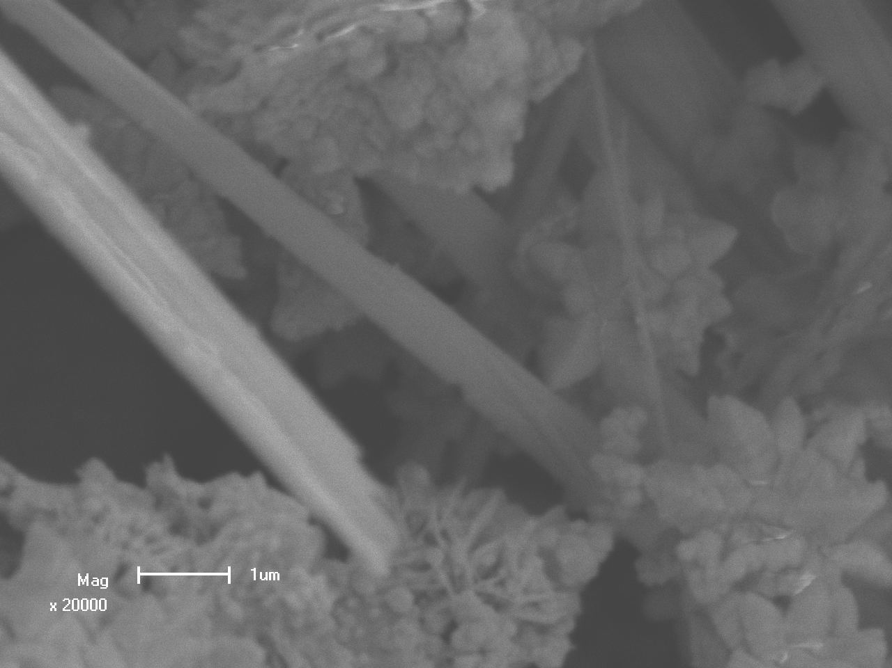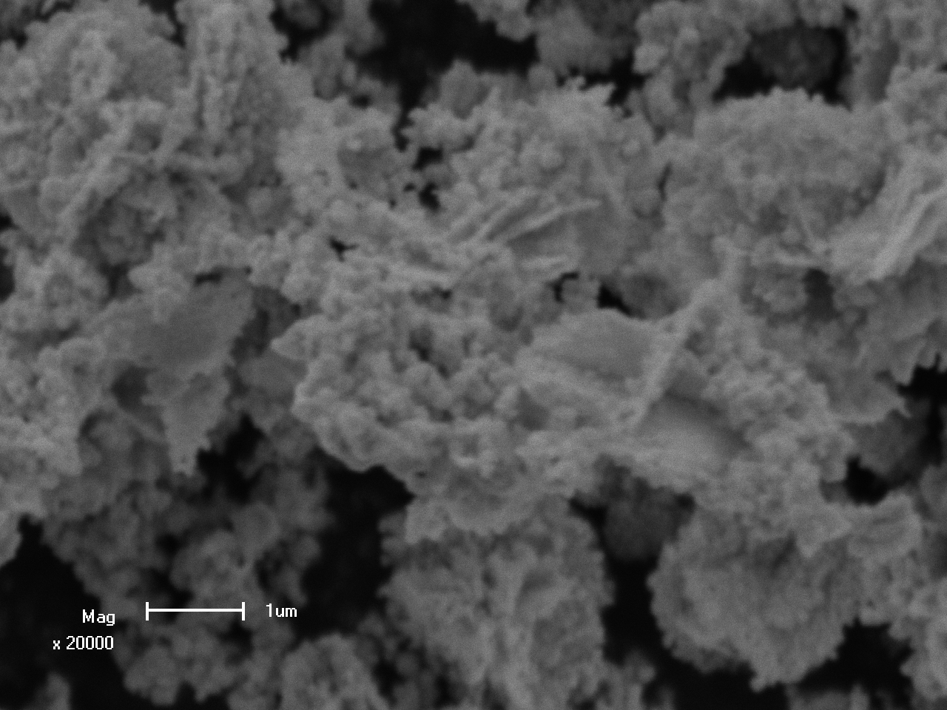

**Figure 2**: SEM images of PbS nanostructures prepared using (a) 0.46M and (b) 0.04M lead acetate both stirred for 5 minutes.



**Figure 2:** (c) A representative EDX spectrums of the undoped PbS nanocrystals.

From the micrographs, it is clear that the use of low concentration of lead acetate resulted into clustered composed of nearly spherical morphology, while high concentration resulted into nanorods with different diameter and length. The EDS spectrum in Fig. 2(c) shows the presence of Pb and S, with slight excess of sulphur for all the samples. The existence of O and C impurities is believed to have originated from the surface contamination in the atmosphere and also the double sided carbon tape.

* 1. Optical analysis

Fig. 3(a) shows the typical variation of absorbance with wavelength for the PbS prepared at different mol concentration of lead acetate but synthesized at constant time, respectively. At low mol concentrations of 0.04M and 0.13M of lead acetate the UV-visible spectrum shows the absorption bands with λmax at 247 and 565 nm, 247 and 573 nm, respectively. This implies the presence of anisotropic nanoparticles like PbS spherical particles. λmax at 247 nm may be due to the impurities such as PbOH and PbO. At high mol concentrations of 0.36M of lead acetate the UV-visible spectrum shows one broad absorption band with λmax at 412 nm indicates the presence of PbS particles with the wide distribution of size or anisotropic PbS nanorods. The energy band gap of these materials was estimated using the following equation [8],

EgN = (2)



where EgN (energy gap of nanoparticles and nanorods) is the separation between the valence and the conduction bands, 𝒉 is the Plank constant, 𝑐 is the velocity of light in vacuum and λmax is the wavelength at the maximum absorption. The value of the optical band gap energy of the PbS nanorods and nanoparticles synthesized with 0.04M, 0.13M and 0.36M lead acetate have been estimated to be 2.20 eV, 2.17 eV and 3.02 eV, respectively, as calculated using Eq.(2). It is found that the band gap energy of the resulting nanoparticles and nanorods shows marked increment as compared with that of PbS bulk materials (0.37 eV). The band gap energy of the PbS nanorods is bigger than the one of the nearly spherical PbS nanoparticles. Fig. 3(b) shows the typical variation of absorbance with wavelength for the PbS prepared at different synthesizing times but at constant mol concentration of lead acetate of 0.06M, respectively. At low mol concentrations of 0.06M of lead acetate for (i) 1 minute, (ii) 5 minutes and (iii) 10 minutes the UV-visible spectrum shows the absorption bands with λmax at 244 and 559 nm, 244 and 573 nm, 244 and 584 nm, respectively. This implies the presence of anisotropic particles like PbS spherical nanoparticles and nanorods. Their estimated band gap energy values are 2.22 eV, 2.14 eV and 2.07 eV.



**Figure 3**: The absorbance spectra of PbS nanorods, prepared at (a) different mol concentration of lead acetate but synthesized at constant time and (b) constant mol concentration of lead acetate but synthesized at different times.

1. Conclusion

The PbS nanostructures have been successfully synthesized by the chemical bath deposition technique at 80°C. XRD showed that the structure of material is a single cubic phase. UV showed that the band gap energy of the nanostructures depend on the mol concentration of lead acetate. It was observed that the nanorods structure have bigger than the band gap energy than nearly spherical nanoparticles.

**Acknowledgement**

The author would like to acknowledge the National Research Foundation and Department of science and technology and the University of the Free State for financial support. We are also grateful to people currently of Centre for Microscopy at UFS for EDS, SEM and X-ray diffraction measurements.

**Reference**

[1]Acharya S, Gautam U K, Sasaki T, Bando Y, Golan Y, Ariga K 2008*J. AM. CHEM.*

*SOC*, **130** 4595.

[2] Jing S, Xing S,Wang Y, Hu H, Zhao B, Zhao C 2008 *Mater. Lett.* **62** 977.

[3] Wu M, Zhong H, Jiao Z, Li Z, Sun Y 2008 *Colloids Surf. A: Physicochem. Eng. Aspects* **35**

313-314.

[4] Chestnoy N, Hull R, Brus LE 1986 *J. Chem. Phys.* **85** 2237.

[5] Wang Y, Suna A, Mahler W, Kawoski R 1987 *J. Chem. Phys.* **8** 7315.

[6] Wang Z, Zhao B, Zhang F, Mao W, Qian G, Fan X 2007 *Materials Letters.* **61** 3733–

3735.

[7] Cullity BD 1978, 1956 *Elements of X-ray Diffraction (2nd Ed)*, (Addison Wesley) p

285-284.

[8] Khiewa PS, Radimana S, Huanga NM, Soot Ahmada Md, Nadarajahb K *2005Materials*

*Letters.* **59** 989–993.