Enhancement of hydrogen production using biomass gasification process
A. I. Mabuda, N. S. Mamphweli and E. L. Meyer
University of Fort Hare, Institute of Technology
Private bagx1314, Alice, 5700, South Africa

E-mail: amabuda@ufh.ac.za

Abstract. Hydrogen production from biomass holds the greatest promise, since biomass is abundantly available everywhere in the world. However, hydrogen from biomass has major challenges. The yield of hydrogen is low from biomass since the hydrogen content in biomass is low to begin with (approximately 6%) and the energy content is low due to the 40% oxygen content of biomass. A novel gasification method for hydrogen production from carbonaceous materials using a CO₂ sorbent has been widely used. It mainly uses steam as gasification agent. For this study the above method has been adopted to test if it will work for air-blown biomass gasifiers. The main purpose of this project is to enhance the yield of hydrogen from air-blown biomass gasification process. The produced hydrogen will be further separated and purified for fuel cell application. Ultimate and proximate analyses of the biomass material were conducted and the obtained results were used for the simulations in order to determine the efficiency of the gasifier with biomass and biomass/sorbent blends. It was found that the biomass/sorbent blends increase the yield of not only H₂ but also other syngas constituents such as CO leading to enhancement of the gasifier efficiency since it is dependent on the volume of combustible gases.

- Introduction

Hydrogen production has required much attention in recent years due to its environmental friendly as an energy carrier. It is produced via steam methane reforming (SMR), coal gasification, oil reforming, and electrolysis. Fossil fuel sources amount to 96% [1] of total H₂ production. Therefore, clean and renewable resources and sustainable pathways are necessary if H₂ is to become a fundamental energy resource for the future [2]. The sources of hydrogen should be renewable and sustainable, efficient and cost effective, convenient and safe. Hydrogen production based on renewable energy sources such as biomass is of great interest since biomass is carbon-neutral. However, biomass has, on average, only 6 wt % of hydrogen, which would make it, in principle, of not much interest for H₂ production [3].
Some additional H₂ can come from the cracking of H₂O if the biomass is also used as a fuel to supply the high amount of heat needed to crack the molecule of H₂O [3]. Since this raw gasification gas contains some CH₄, tar, and light hydrocarbons, when a bed of calcined dolomite (CaO.MgO), limestone (CaO), and/or magnesite (MgO) can be used downstream from the gasifier, the H₂ content in the gasification gas was increased [4].The use of CaO sorbent for enhancing hydrogen yield could be applied to any carbonaceous material such as coal, hydrocarbon or biomass. The product gas through rich hydrogen also contains other gases such as CO, CH₄, CO and some hydrocarbons [5]. The following reaction takes place when calcium oxide has been employed:

CaO + CO₂ → CaCO₃ (1)

The mixture of biomass with CaO sorbent loaded to the gasifier absorb the released CO₂ to enhance the water gas water gas shift reaction towards hydrogen production.

CO + H₂O → CO₂ + H₂ (2)

It also provides the necessary energy for the endothermic gasification through the carbonation reaction (equation 1)) releasing heat. This paper presents an adopted method above using air as a gasification agent instead of steam; the steam in this case comes from the vaporization of moisture in the feedstock. It is necessary to get rid of as much of this moisture as possible to avoid the production of condensates inside the gasifier during operation and after shut down.

- Research methods
Various blends of Calcium oxide and pinewood as well as magnesium oxide and pinewood were prepared. A CHNS analyzer was used to determine the elemental composition of the various blends for the purpose of gasification simulation in order to predict the mass and energy balance of the gasifier when fuelled with the various blends. A cone calorimeter (CAL2K model) was used to determine the calorific value of the various blends. A thermogravimetric (TGA) analyzer was used to establish the reaction temperature of the various blends in order to establish a suitable gasification temperature and the thermal stability of the materials. The moisture, ash as well as fixed carbon content of the material was determined from the TGA data. A downdraft gasifier modeling program developed by T.H. Jayah was used to undertake gasification simulation.
- Results and discussions

  - Ultimate and proximate analysis

Figure 1 shows the composition of carbon, hydrogen, nitrogen and oxygen of biomass and biomass/sorbents materials. The results presented in figure 1 were obtained using the Carbon Hydrogen Nitrogen and Sulphur (CHNS) analyser; the oxygen was obtained by difference. The Sulphur content is not presented in the figure because it is of insignificant impact on gasification.

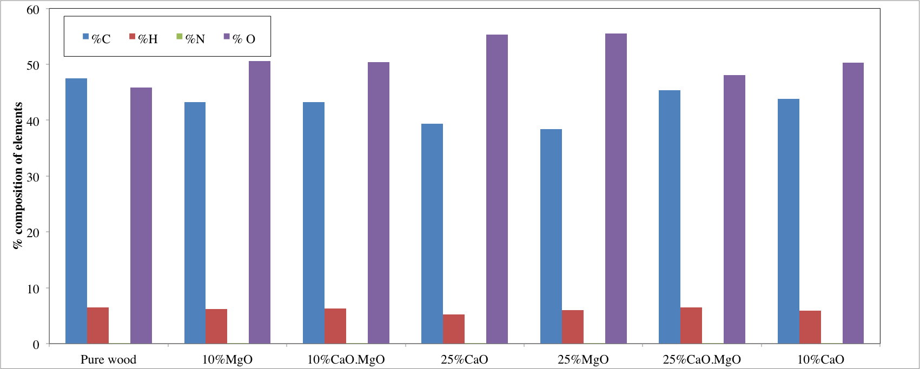
Figure 1. The composition of carbon, hydrogen, nitrogen and oxygen of biomass and biomass/sorbents materials.

It can be observed from figure 1 that the carbon and nitrogen contents form the major part of the elements in the blends as well as the pure wood (pine wood). The addition of the sorbents did not have a significant impact on the elemental structure of the pinewood. A 5-8% decrease in carbon content for the blends as compared to the pure wood can be seen in figure 1 with a corresponding increase in oxygen content for the blends. The hydrogen content however remained fairly constant in both pure wood and the blends, this should not be confused with the impact of these blends on hydrogen production because the production of hydrogen during gasification is enhanced by chemical reactions as discussed in section 1.
  - Reaction kinetics
Figure 2 shows the rate of thermal degradation of the various wood/sorbents blends. Figure 3 shows the rate of thermal degradation for a blend of 25% MgO and 75% pinewood. The two graphs were obtained using TGA after calculation of the derivatives.

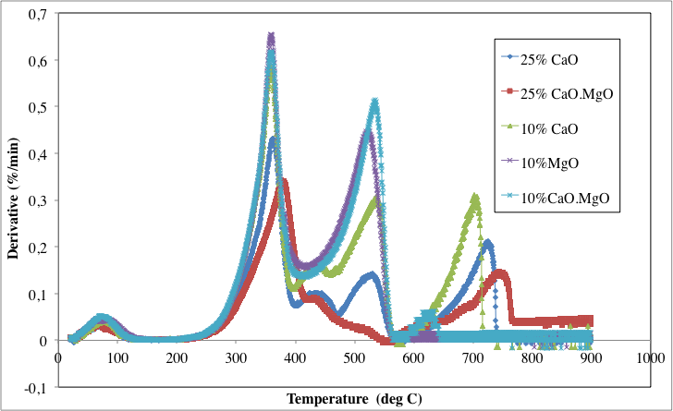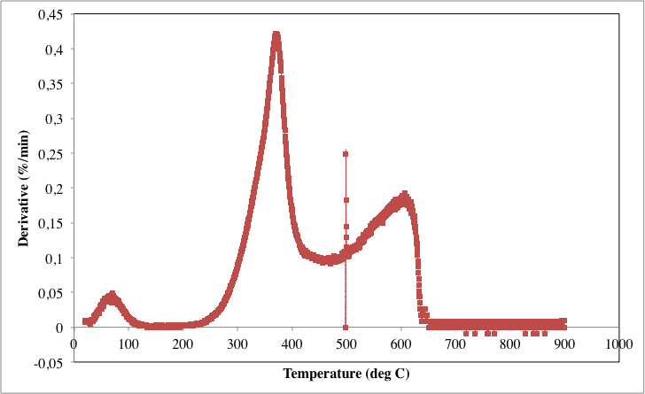
Figure 2. The rate of degradation for various sorbents/wood blends.
Figure 3. The rate of thermal degradation for 25% MgO and 75% wood blend.
The initial stage of degradation in both figure 2 and 3 involves the vaporization of water at around 100ºC. Then the reaction rate picks up at around 250ºC when carbonization or devolatization of the material starts to take place resulting in the formation of charcoal. The rate is faster between 300ºC and 600ºC for most of the materials and it slows down at higher temperatures above 600ºC. This is basically because at that point the remaining charcoal is converted to gas and ash. The charcoal consists of the major part of the carbon and therefore requires more energy to break down over time hence the reaction rate slows down. The carbon content is almost the same for both 25% MgO and 25% CaO blends hence the reaction rates at lower temperature resembles the same pattern. However there is a significant difference in the reaction rates for the two blends at higher temperatures (above 600ºC). The main cause of this is still under investigation. It is clear from figures 2 and 3 that the addition of the sorbents results in lower reaction rates, the high concentration of MgO for instance lowered the reaction rate from approximately 0.6%/min to approximately 0.4%/min. This is because of the low volatile matter content in the sorbents as compared to the pinewood.
Figure 4 and 5 show the volume of hydrogen obtained during computer simulation of the gasification of the various sorbents/wood blends, and the possible conversion efficiency that could be achieved when gasifying the various blends. The figures were generated using a downdraft gasifier modelling program mentioned in the methodology section. The input parameters were obtained from the proximate and ultimate analysis of the various blends. The simulations were undertaken assuming the same gasifier operating conditions.

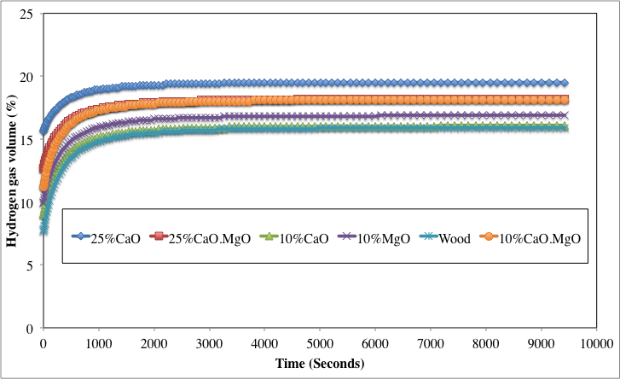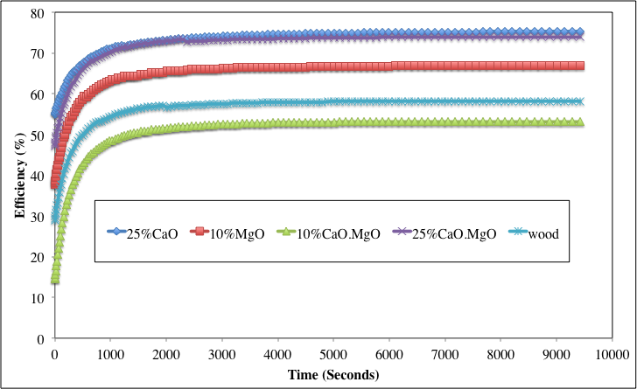
It can be observed that the highest hydrogen content was obtained from a blend with 25% MgO and 75% pinewood followed by the blend with a mixture of 50% CaO and MgO constituting 25% of the CaO/MgO/pinewood blend as well as the blend with a mixture of 50% CaO and 50% MgO constituting 10% of the CaO/MgO/pinewood blend. The 25% CaO blend also resulted in hogher gasifier conversion efficiency followed by the blend with a mixture of 50% CaO and MgO constituting 25% of the CaO/MgO/pinewood. This is because of the higher hydrogen content produced by the two blends respectively as indicated in figure 1. The efficiency of the gasifier is dependent on the volume of combustible gases, which are hydrogen, methane and carbon monoxide.
Figure 3. The hydrogen gas volume obtained during computer simulation.
Figure 4. The simulated possible efficiency achieved when gasifying the various blends.

- Conclusions
The paper presented ways in which hydrogen production from an air-blown fixed bed downdraft gasifier can be enhanced without using steam as a gasification agent. It demonstrated the possibility of taking advantage of the steam produced during the drying of the feedstock and converts it to useful hydrogen through the water-gas-shift reaction enhanced by the addition of sorbents into the process. Computer simulation results suggested that a blend of 25%CaO/75% pinewood results in higher hydrogen content produced during gasification and enhanced gasification efficiency.

- References

[1] Ewan B C, Allen R W K 2005 Int. J. Hydrogen Energy 30 809 – 819.
[2] Florin N H, Harris A T 2008 Chem. Eng. Sc 63 287–316.
[3] Aznar M P, Caballero M A, Corella J, Molina G, and Toledo J M 2006 Energy & Fuels 20 1305-1309.
[4] Delgado J and Aznar M P 1997 Ind. Eng. Chem. Res. 36 1535-1543.
[5] Madhukar R M, Goswami D Y 2007 Int. J. Hydrogen Energy 32 2803 – 2808.

