**Structural features of the Cu-In-Ga-Se precursors for formation of Cu(In,Ga)Se2 thin films by thermal reaction of InSe/Cu/GaSe alloys to elemental Se vapour.**

**F B Dejene**

Department of Physics, University of the Free State,

Private Bag X13, Code 9866, Phuthaditjhaba, South Africa.

*Corresponding author: dejenebf@qwa.ufs.ac.za

**Abstract**. A novel partway for the fabrication of copper-indium (gallium) diselenide has been developed. This two-stage process consists of the formation of Cu-In-(Ga)-Se precursors and subsequent selenization to form CuIn(Ga)Se2. In this work, the possible interactions in Cu-In-Ga-Se systems were investigated and compared using sequentially stacked precursors, in order to modify the diffusion behavior of gallium and to get a better understanding of the Cu(In,Ga)Se2 thin film formation. Morphology differences were observed between the different sequences, but the XRD analysis revealed the presence of graded CuIn1-xGaxSe2 structure irrespective of the stacking order during the precursor formation step.

1. Introduction

The Photovoltaic industry has shown robust growth during recent years. Copper indium gallium diselenide Cu(In,Ga)Se2 (CIGS) is one of a few candidate thin film materials presently being evaluated as the absorber layer in polycrystalline solar cell devices. Chalcopyrite thin films based on Cu-In-Se and related materials like Cu-In-Ga-Se2 have demonstrated considerable potential in high efficient thin film solar cells [1]. The thin film solar cells using Cu-In-Ga-Se2 absorber layers have recently reached the 19.2% efficiency on a small area [2]. The commonly used techniques for absorber formation are, namely, co-deposition of elements (evaporation or sputtering) [3] and two-step growth process [4]. The co-evaporation method provides full flexibility for device optimization, and solar cells with high efficiency of 19.2% have been demonstrated by small area absorbers [5]. However, several problems are encountered in scaling up this method due to the difficult in controlling the overall sequences in a large area. In general, two-stage processing techniques are relatively easy to scale up in order to produce uniform coatings of thin films on large area substrates. In classical two-step growth processes, Cu-In-Ga metallic precursors are selenized in elemental Se vapor or a H2Se/Ar gas mixture to form Cu(In,Ga)Se2. A seemingly insurmountable disadvantage of these processes is that the resultant semiconductor absorber films are heterogeneous. Due to the difference in the reaction rates between the binary selenides, the bulk of the material contains discrete CuInSe2 and CuGaSe2 phases [6]. Alternatively, graded film structures are obtained with most of the gallium located at the back of the film. This implies that the gallium does not increase the band gap of the absorber in the active region of the solar cell, and complete devices are therefore limited to relatively low open-circuit voltages. In order to investigate and ultimately to solve these reported growth-related problems, selenium-containing Cu-In-Ga-Se precursors were used compared to the metallic Cu-In-Ga films used in standard two-step growth processes. Various precursor structures were investigated so as to modify the diffusion behavior of gallium in the final compound semiconductor films.

1. Experimental

The CuIn1-xGaxSe2 thin films studied in the present work were deposited on Mo coated soda lime glass substrates. The sequentially stacked precursors were prepared by thermal evaporation of Cu, InSe and GaSe compounds at 200°C [3]. These specific layer thicknesses were selected in order to produce (Cu/In+Ga=0.9) absorber layers. For the purpose of comparison, the sequentially deposited precursors were reacted with elemental Se vapor in vacuum (approx 10-6 mbar) continuously supplied from stainless steel effusion cell. In all cases the samples were heated for 10 min to the reaction temperature, while the reaction period for all selenization process was maintained at 60 min. The reaction temperature was kept constant at 550°C. The crystalline properties of the films were evaluated by x-ray diffraction, the surface morphology of the films by scanning electron microscope (SEM) and the chemical composition of the films was carried out using X-ray fluorescence (XRF).

1. Results and Discussion
   1. Morphology and structure

The phase Figures 1 (a) to (f) depict SEM micrographs of the surface morphologies of sequentially deposited Cu-In-Ga-Se precursor films on molybdenum coated soda lime glass substrate. The respective layers in the precursor structures were deposited at 200°C, under the conditions described in the experimental procedure. Irrespective of the order of deposition, the thicknesses of the respective layers in the stack (200 nm Cu, 200 nm GaSe and 1500 nm InSe) were maintained constant. Fig. 1(a) represents the typical morphological features of a Mo/Cu/InSe/GaSe precursor film. These films were relatively dense and consisted of large (0.5–1 μm) spherical grains, but exhibited poor adhesion properties. The Mo/InSe/Cu/GaSe precursor structures (see Fig. 1(b)) were also dominated by the presence of a high density of mostly rounded grains with typical sizes between 0.2-0.8 μm. However, in these cases the films adhere well to the Mo/glass substrates. Fig. 1(c) is a representative SEM micrograph of a typical Mo/GaSe/Cu/InSe precursor. A comparison between this micrograph and the previous micrographs clearly revealed a significant increase in the average grain size of the film when the GaSe was deposited directly onto Mo. Typically, these films had grain sizes between 2 and 3 μm. The Mo/Cu/GaSe/InSe structures (Fig. 1 (d)) had a weakly defined grain structure with a “cauliflower” appearance. Figure 1 (e) is a SEM micrograph of a typical Mo/InSe/GaSe/Cu precursor, in which the GaSe layer was sandwiched between the InSe and Cu layers. Visually these films were extremely smooth and SEM studies revealed a layered structure. These specific structural features were retained in the case of Mo/GaSe/InSe/Cu precursors (Fig. 1 (f)). However, detailed SEM analysis revealed the presence of worm-like features superimposed on the smooth densely packed plate-like background material. Compositional analysis indicated that this worm-like structures were more Cu-rich compared to the background material. The typical crystalline features of a gallium-containing precursor, deposited at 200°C onto Mo-coated glass substrates, are depicted in Figure 2(a). The partial formation of CuInSe2 was reflected by the presence of the characteristic [112] diffraction peak of the chalcopyrite lattice at 26.75°. The expected binary phases (i.e. CuSe, InSe and GaSe) were also clearly visible in the depicted XRD spectrum, which confirmed the fact that the inter-diffusion process between the individual layers in the precursor stack was incomplete at this stage of processing. It is also important to mention that the order of deposition of the layers in the precursor stack had marginal influences on the crystalline quality of the precursor films. The relative intensities of the binary phases were for obvious reasons influenced by the order of deposition, but the specific binary phases shown in Fig. 2 were detected in all the films.

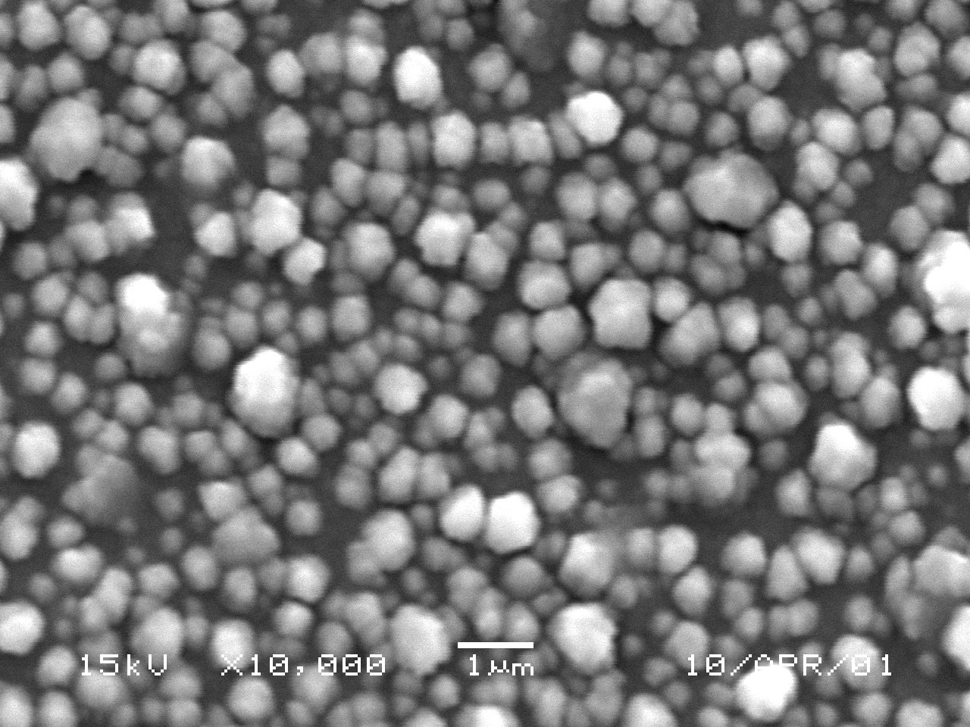

(b)

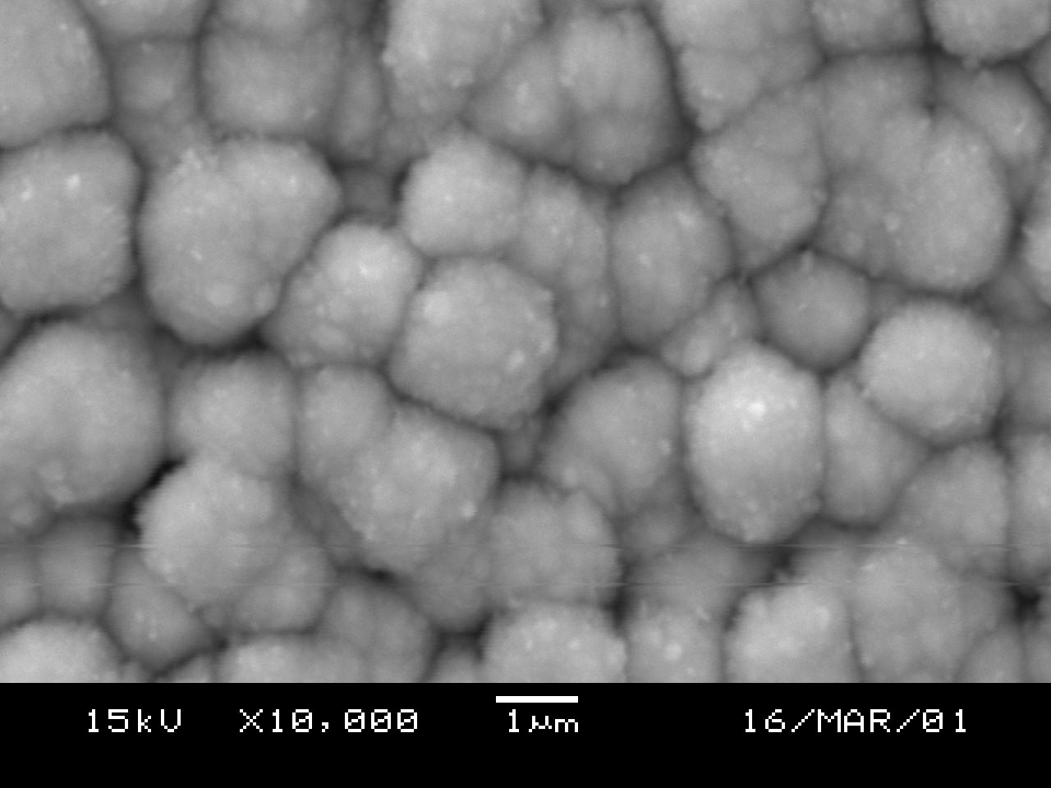

(c)

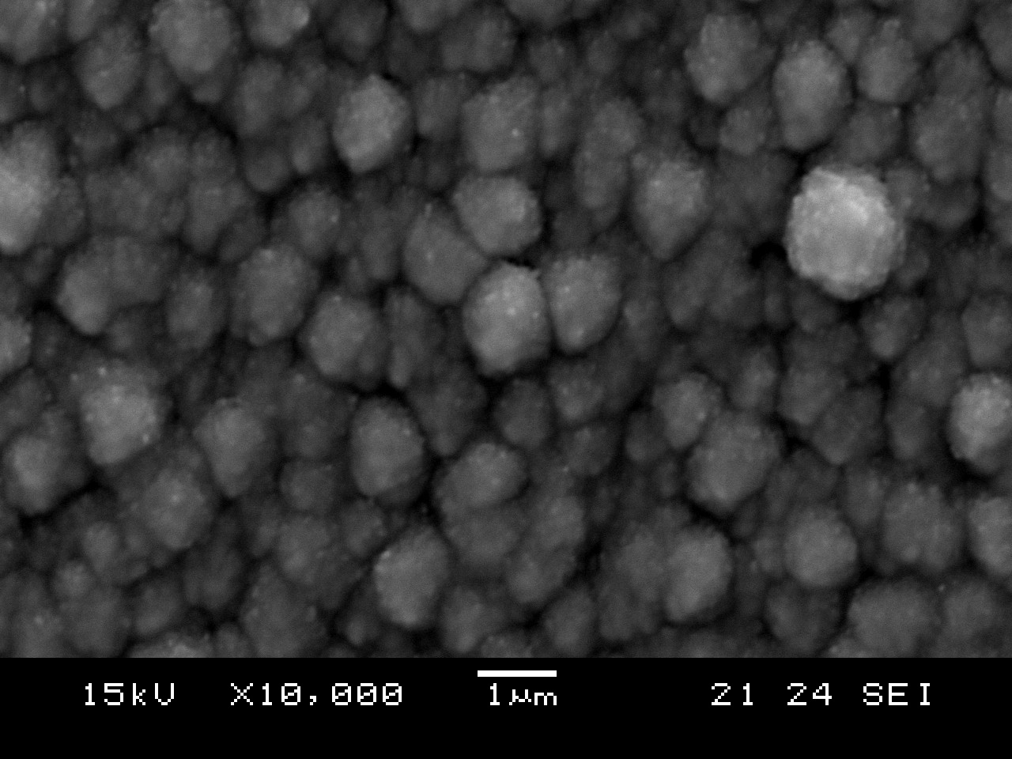

(d)

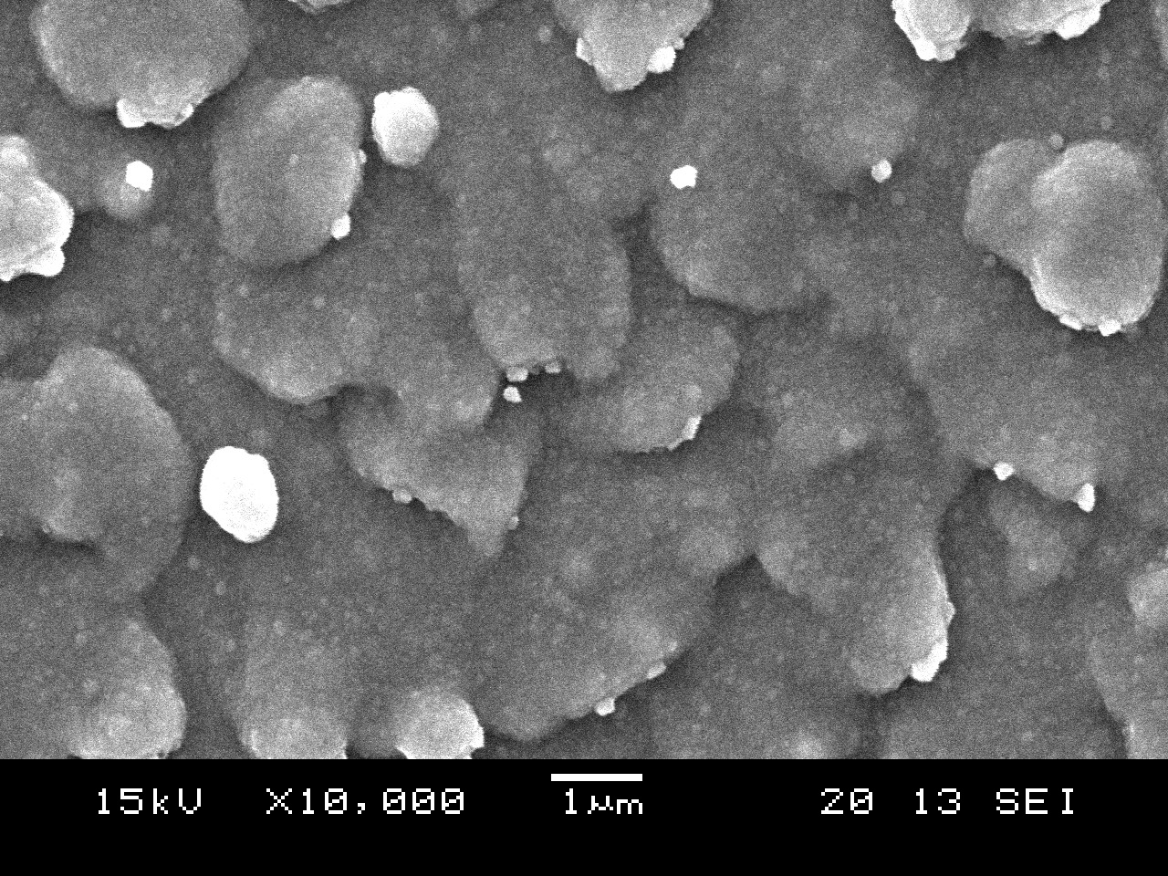

(e)

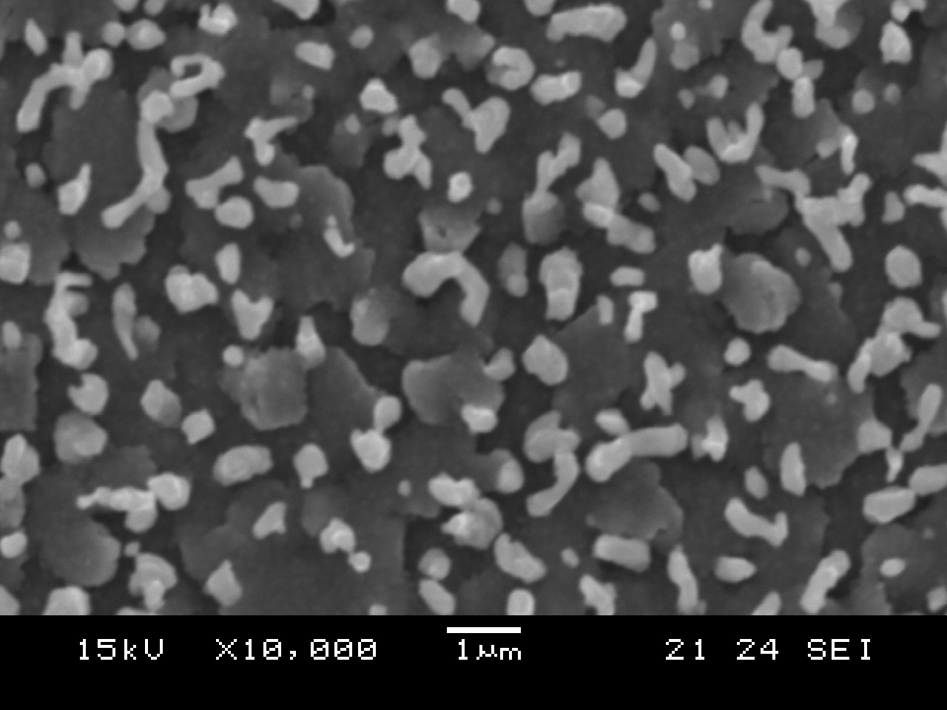

(f)

(a)

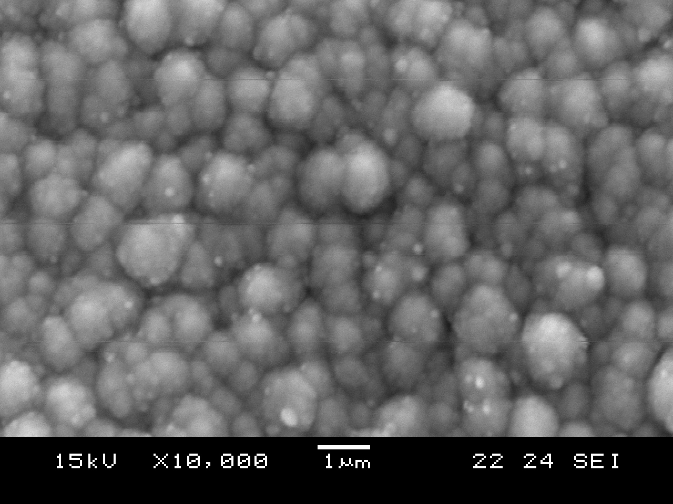

**Figure 1**: Surface morphologies of sequentially deposited (a) Cu/InSe/GaSe (b) InSe/Cu/GaSe (c) GaSe/Cu/InSe (d) Cu/GaSe/InSe (e) InSe/GaSe/Cu and (f) GaSe/InSe/Cu precursors onto Mo/glass substrates. These films were deposited at a substrate temperature close to 200°C.



(a)



(b)

**Figure 2**: XRD pattern of a typical (a) sequentially deposited Cu-In-Ga-Se precursor structure on Mo/glass at 200°C.(b)Cu(In,Ga)Se2 films shown in Fig. 3. The respective precursor structures were deposited at 200°C on glass/Mo, followed by reaction to elemental Se vapour at 550°C for 60 minutes.

* 1. Relationship between precursor structure and material properties of the CuIn1-xGaxSe2 thin films

The precursor structures, discussed in the previous section, were subsequently exposed to elemental Se vapour in vacuum. It is important to mention that the thicknesses of the individual layers in the precursor stacks (200 nm Cu, 200 nm GaSe and 1500 nm InSe) were kept constant and that all these layers were deposited at a substrate temperature of 200°C. Assuming a homogeneous quaternary alloy, these thickness values should translate in absorber films with Cu/(In+Ga)- and Ga/(In+Ga)- atomic ratios of 0.85 and 0.25 respectively. It is also important to realize that the selenization temperature critically influence the formation kinetics of the chalcopyrite absorber films. For the purpose of comparison, the precursors were therefore selenized under identical experimental conditions in elemental Se vapour, as outlined in experimental procedure. In order to ensure complete reaction, selenization studies were conducted at a temperature close to 550°C for 60 minutes. Selenization of the Mo/InSe/GaSe/Cu and Mo/GaSe/InSe/Cu structures (see Figs. 1 (e) and (f)) resulted in CuIn1-xGaxSe2 films with poor structural features (i.e. non-uniform morphologies and/or adhesion failure). As a result, these specific films were not considered during further investigations. Figures 3 (a) to (d) depict the typical morphological features of Cu(In,Ga)Se2 films, produced after the precursors in Figs. 1 (a) to (d) were reacted to elemental Se vapour under the experimental conditions discussed above. A comparison of these SEM micrographs clearly revealed that the structure of the precursor films prior to selenization significantly influenced the surface morphologies and hence surface roughness of the resulting Cu(In,Ga)Se2 absorber films. In this regard, it is important to keep in mind that the structural features of the absorber films directly influence the conversion efficiencies of photovoltaic devices. In general, smooth and uniform absorber films are required to optimize the absorber/CdS/ZnO heterojunction properties [4]. The structural features of the selenized Mo/Cu/InSe/GaSe precursors (see Fig. 3 (a)) were dominated by the presence of nodular grain structures with typical sizes between 0.5 and 1 μm. An exchange of the Cu and InSe layers in the precursor stack (i.e. Mo/InSe/Cu/GaSe) resulted in Cu(In,Ga)Se2 absorber films with improved structural properties.

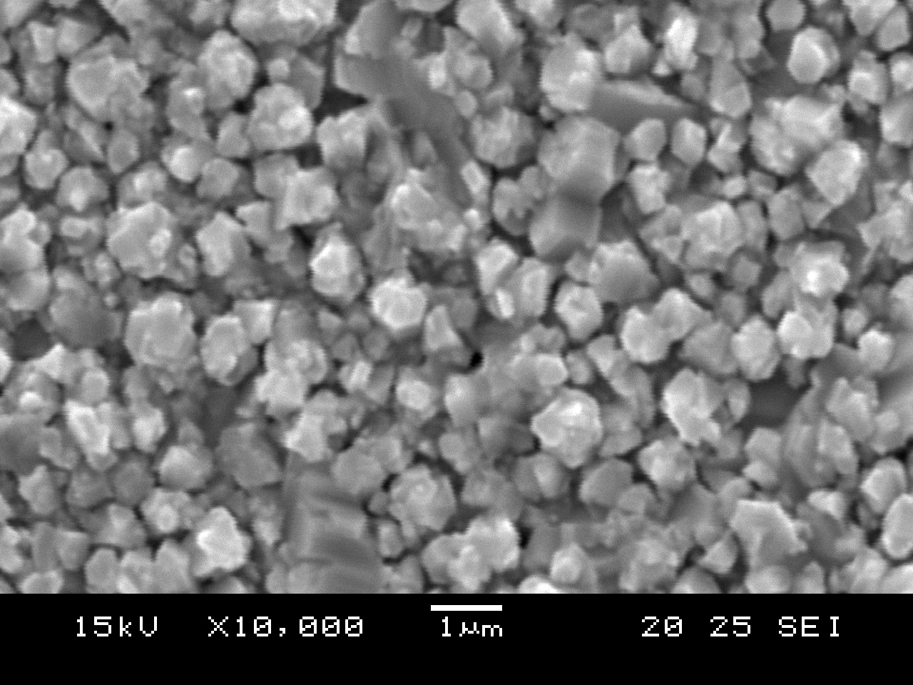

(a)

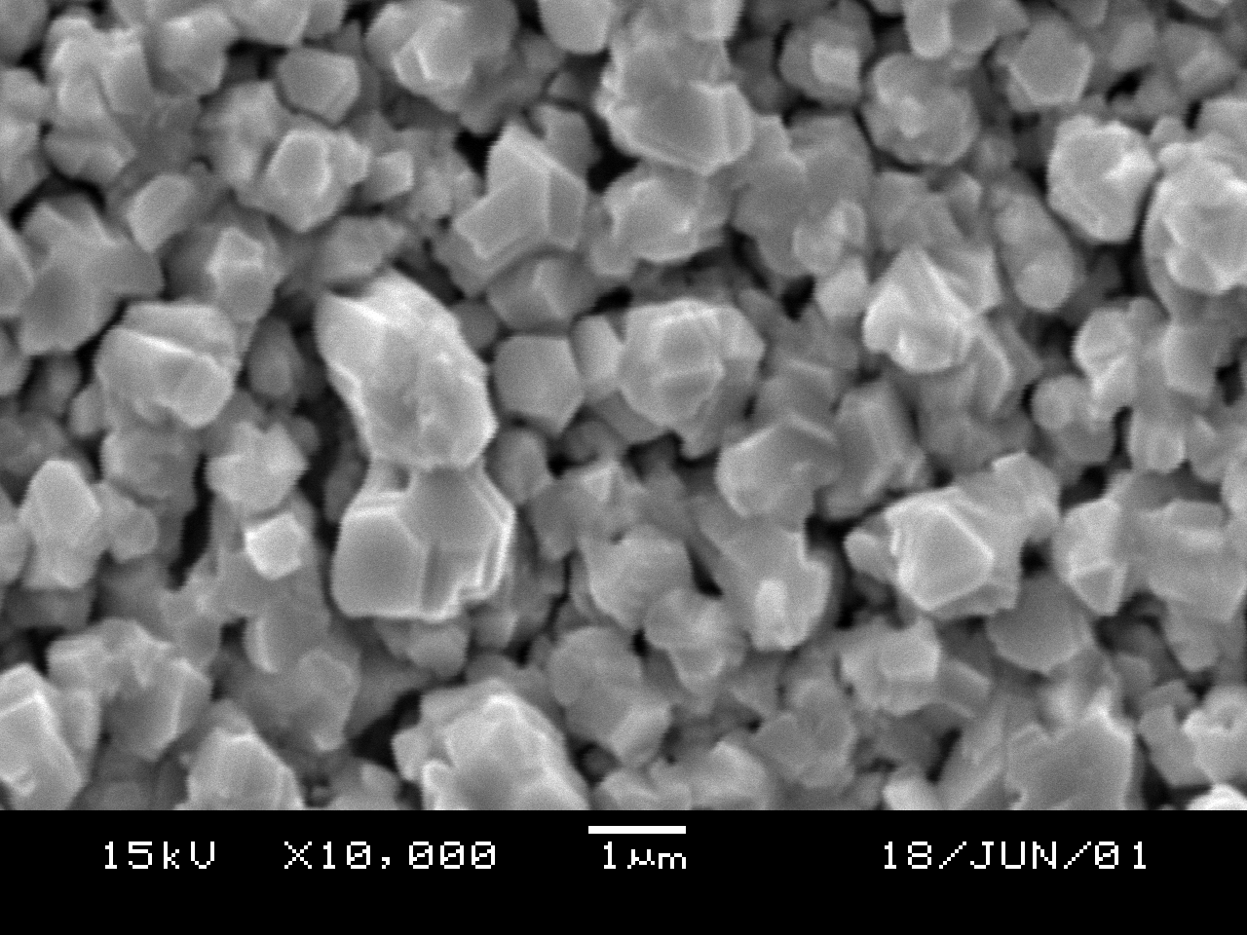

(b)

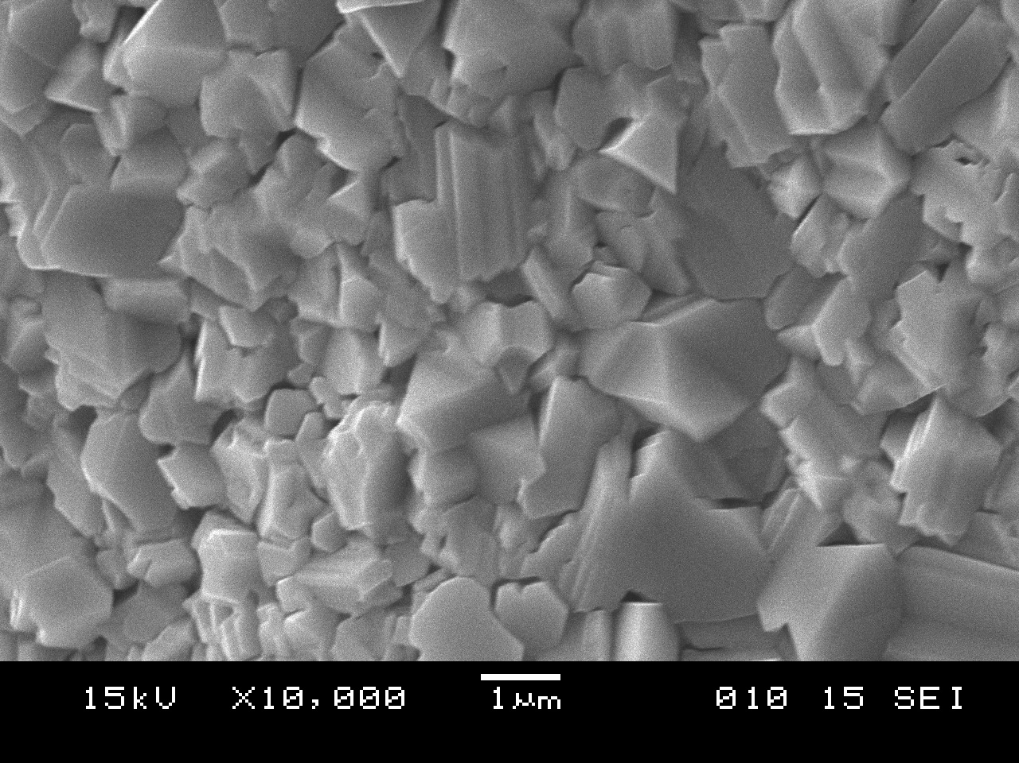

(c)

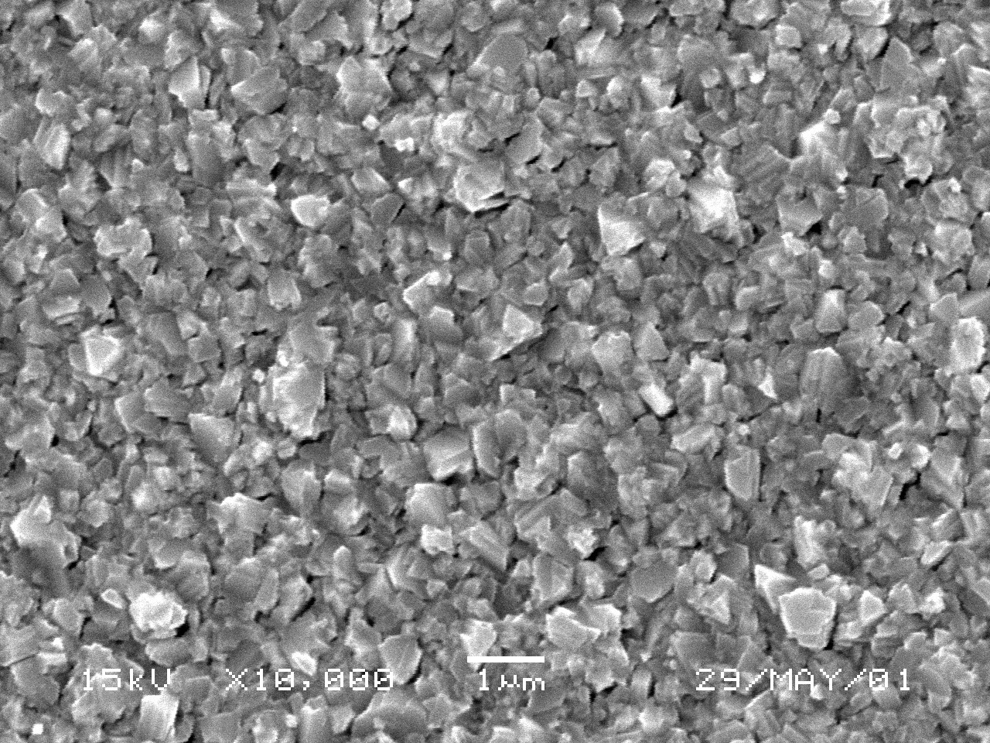

(d)

**Figure 3**: Surface morphologies of Cu(In,Ga)Se2 thin films produced by selenization of (a) Cu/InSe/GaSe (b) InSe/Cu/GaSe (c) GaSe/Cu/InSe (d) Cu/GaSe/InSe precursor structures under identical experimental conditions in elemental Se vapour at 550°C for 60 minutes.

As indicated in Figure 3 (b), these films were characterized by the presence of densely packed columnar grain structures with average grain sizes around 1 μm. In cases where growth was initiated with a GaSe layer and terminated with a InSe layer (see Fig. 3 (c)), Cu(In,Ga)Se2 films exhibited large smooth faced crystallites with typical sizes between 2 and 5μm. This large variation in grain size implied that these specific films were non-uniform with a relatively high level of surface roughness. Figure 3 (d) is SEM micrograph of a quaternary alloy, which resulted after a Cu/GaSe/InSe precursor was annealed in elemental Se vapour at 550°C for 60 minutes. This stacking order resulted in a dramatic reduction in the average grain size of the chalcopyrite alloy with typical grain size well below 1μm. As a result, these films were dense and smooth compared to the other structures. However, the high density of sub-micron grains corresponds to a significant increase in the grain boundary density in the thin film. This, in turn, may result in deterioration in the opto-electrical behavior of the solar cell device. Figure 2(b) is a representative XRD patterns from the Cu(In,Ga)Se2 samples shown in Figure 3. Irrespective of the stacking order during the precursor formation step, XRD analyses revealed the presence of a graded CuIn1-xGaxSe structure. This phenomenon is represented by the asymmetric broadening of the characteristic [112], [220/204] and [312/116] diffraction peaks. In this regard, it is important to note that the position of the [112] diffraction peak close to 26.65° represents the lattice parameter of pure CuInSe2, while the tail due to increasing amounts of gallium extends all the way to the peak position of CuGaSe2. It is therefore reasonable to assume that the surface of the absorber film contains pure CuInSe2 and that the gallium increases continuously towards the Mo back contact. These observations are in good agreement with other related studies and are attributed to the difference in the formation kinetics of the two ternary phases [5,7,8].

3.3 Chemical properties

As can be observed in Table 1, the atomic ratio of Cu/In+Ga (~0.9) and Ga/In+Ga (~0.25) done by XRF operated at 60 KeV, virtually remained unchanged through out all films irrespective of sequential stacks.

Table 1: XRF (60KeV) of Cu(In,Ga)Se2 with identical amount of Cu/(In+Ga) ratio for selenized samples of various precursor stacks.

|  |  |  |  |  |  |
| --- | --- | --- | --- | --- | --- |
| Precursor Stacks | Element concentration (at. %)Cu( In Ga Se | | | | Atomic Ratio  [Cu]/[In+Ga] |
| InSe/Cu/GaSe | 24.50 | 19.95 | 6.65 | 48.90 | 0.92 |
| InSe/GaSe/Cu | 24.10 | 19.80 | 6.60 | 49.50 | 0.93 |
| GaSe/InSe/Cu | 24.20 | 19.90 | 6.63 | 49.30 | 0.91 |
| GaSe/Cu/InSe | 24.60 | 21.00 | 7.00 | 47.20 | 0.88 |
| Cu/InSe/GaSe | 24.40 | 20.10 | 6.70 | 48.80 | 0.91 |
| Cu/GaSe/InSe | 24.70 | 21.30 | 7.10 | 46.90 | 0.87 |

It is well known that the final surface morphology and structure is significantly influenced by the overall bulk composition of the film. Therefore for the purpose of comparison the films had similar bulk compositional properties and the observed variation in structural features is directly related to different type of stacks. The slight difference of Cu/In+Ga ratios observed during selenization process is common for selenization processes due to volatile In2Se species, especially for stacks with InSe layers at the top. It is interesting to note that the Se concentration remained below 50% for different stacks when Se vapour treatment was at 550°C. This phenomenon can be explained by the possible depletion of the Se source (i.e. lack of sufficient Se over pressure) at high temperatures during the completion of the selenization process.

1. Conclusion

In an attempt to produce homogenous CIGS thin films, a variety of gallium-containing precursors (e.g. Cu/InSe/GaSe, InSe/Cu/GaSe, GaSe/Cu/InSe, Cu/GaSe/InSe, InSe/GaSe/Cu and GaSe/InSe/Cu) were thermally evaporated onto Mo/Glass substrates at substrate temperature close to 200 °C. SEM and XRD studies revealed that the morphological properties of these films were significantly influenced by the precursor stacking order. XRD studies revealed the partial formation of CIS as well as the expected binary phases (i.e CuSe, InSe and GaSe) at this stage of processing. The precursor structures were subsequently exposed to elemental Se at 550°C for 60 minutes. Comparative SEM studies indicated that the surface roughness of the resulting CIGS absorber films were significantly influenced by the structures of the precursor films prior to selenization. In fact, in most cases the morphological features of the precursors were retained in the final fully reacted films. In addition, the adhesion properties of the films were also critically influenced by the experimental conditions followed during the precursor formation step. However, irrespective of the stacking order during the precursor formation step, XRD analyses revealed the presence of a graded CIGS structure. This phenomenon was represented by the asymmetric broadening of the characteristic [112], [220/204] and [312/316] diffraction peaks. Even more significantly, careful analysis indicated virtually no shift in the position of the characteristic peaks to a higher diffraction angles (i.e. corresponding to a reduction in lattice spacing due to the incorporation of Ga). These results therefore suggested that the top surface region of the CIGS absorbers films contained almost pure CIS and that gallium increases continuously towards the Mo back contact.

**Acknowledgement**

The authors send gratitude to the National Research Foundation (NRF) for funding the project and the University of Free State Physics (Physics department, Center for microscopy and Geology department) for the research techniques used in this study.

**Reference**

[1]Ramanathan K, Contreras M A, Hasoon F S, Keane J, Young D, Romero M, Metzger W, Noufi R, Ward J and Duda A, *Prog. Photovolt Res. Appl*. **11** p. 225 (2003).

[2] Hagiwara Y, Nakada T and Kunioka A, Sol. Energy Mater. Sol. Cells **67,** p. 267 (2001).

[3] A Goetzberger, C Hebling, H W Shock, *Mater. Sci. Enf. Res*. **40**, p. 1 (2003).

[4] R Caballero, C Guillen, *Sol. Energy Mater. Sol.* Cells, **86**, p. 1 (2005).

[5] K Ramanathan, M A Contreras, C L Perkinds, S Asher, F S Hasoon, J Keane, D Young, M Romero, W Metzger, R Noufi, J Ward and A Duda, *Prog. Photovolt. Res. Appl*. **11**, 225 (2003).

[6] Arya R, Lommasson T, Wied Man S, Russell L, Skubo S and Fogleboch J, IEEEC pp. 516 – 520 (1993).

[7] Dejene F B and Alberts V, Materials in electronics **14,** p. 89 (2003).

[8] Marudachalan M., Birkmire R., Hichri., Schultz J. M., Swartzlander A., and AL-Jassim M., M., J. Appl. Phys. **82** (6) p. 2896, (1997).