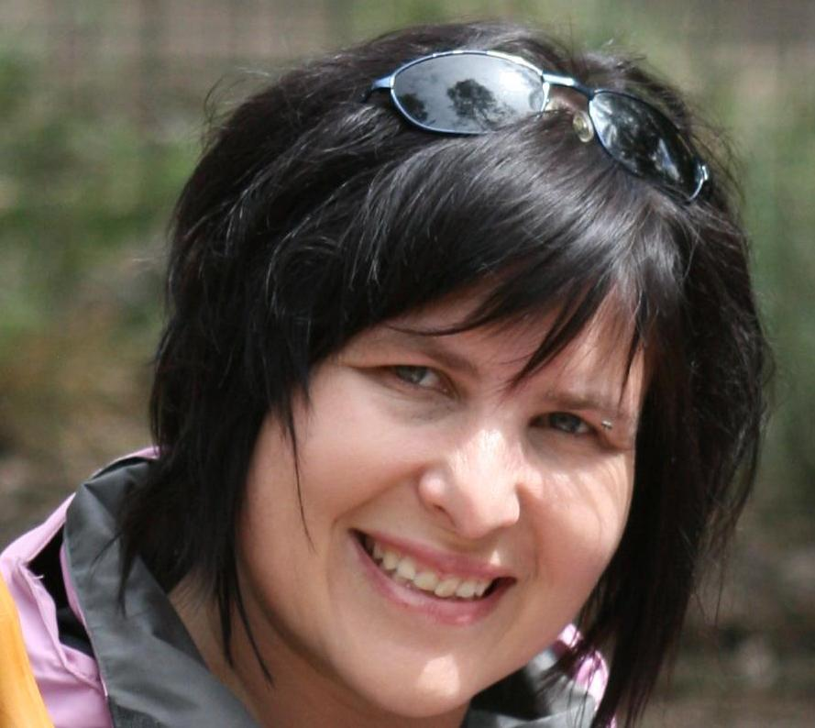 | Van Tonder, Danel^{1,2} received her MSc in Geology from the University of Pretoria, South Africa, in 2010. She is currently a lecturer in the Geology Department at the North West University (NWU) in Potchefstroom. Her doctorate research interests are geared towards Environmental Geology with a strong focus on alternative energy in South Africa. She is currently involved with the development of a solar desalination plant for water purification, groundwater applications and water pollution remediation.  .¹Department ofEnvironment, water and Earth Sciences, Faculty of Science, Tshwane University of Technology – Pretoria, SA  ²Geology Department, North West University, Potechefstroom, South Africa  Email: dvtonder@gmail.com

