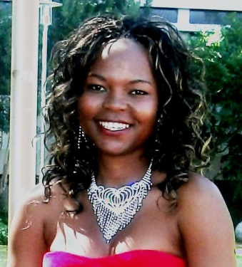
Makhokha Dakalo received her BSc Geology and BSc Geohydrology honours from the University of the Free State, in 2012 and 2013 respectively. She is currently studying towards her MSc degree in Geohydrology specializing in Groundwater Geophysics. Her research topic is “A systematic approach to the interpretation of conductivity anomalies recorded with the Geonics EM34-3 electromagnetic instrument across intrusive dolerite dykes and sills in the Karoo Supergroup”

¹Institute for Groundwater Studies, University of the Free State - Bloemfontein, SA
Email: 2008071603@ufs4life.ac.za / makhokhajoy@gmail.com / Mobile +27 782121152
Supervisor : Fourie,Francois, Dr / fouriefd@ufs.ac.za

