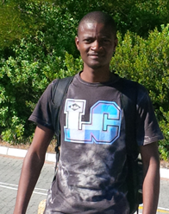 | Mandende, H.¹ received his Bachelor of Science degree (BSc.) in Geology from the University of the Western Cape in 2011. He obtained his Honors (Applied Geology) in 2012 from the University of the Western Cape, South Africa (UWC). Mandende is currently doing his second year MSc programme in Applied Geology at UWC where his research interest is geared towards “Exploration techniques in metasomatised rocks of the Platreef, Akanani prospect area”. Field studies entailed core logging and studies on the local geology at the Northern Limb of the Bushveld Complex, Akanani(South Africa). His MSc. Research is titled “Geochemical and Petrographic characterization of the Platreef Pyroxenite Package P1, P2, P3 and P4 units at the Akanani Prospect Area, Bushveld Complex, South Africa” where he goes a long way to unravel the mineralogical and geochemical character of the Platreef at the Akanani prospect area. Hakundwi is a registerd MSc student for the academic year 2014.  .¹Department of Earth Sciences, University of the Western Cape - Cape Town, SA  Sub-Project No … / Dr. Abdi Siad … + e.mail address:amsiad@myuwc.ac.za  Email: 2933981@myuwc.ac.za / private e.mail address: hakaymanday@gmail,com / Mobile +27 (0) 79 785 8160

