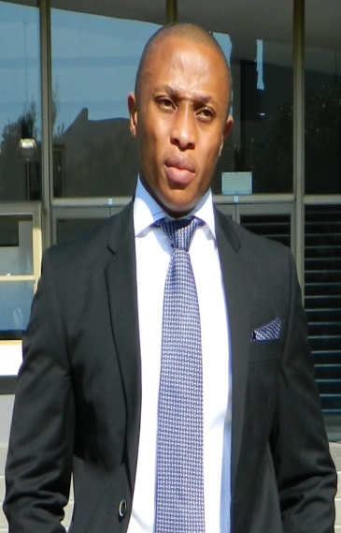 | Pule P Molokoane¹ holds an MSc degree in Inorganic Chemistry with the title “Catalytic Oxidation Processes Using Functionalized O,O’-Bidentate Ligand Copper Complexes”. Mr Molokoane is currently a doctoral candidate at the University of the Free State in pursuit of a PhD in Inorganic Chemistry. He accepted a position at the University of the Free State as a Senior Research Assistant in the Department of Chemistry. Mr Molokoane is also a Junior Lecture/Facilitator presenting first year modules in chemistry with his ongoing research. His research interests are currently centered on the synthesis and characterisation of maltol-based organometallics as well as homogeneous catalysis (oxidation, coupling reactions and hydroformylation), reaction mechanisms via kinetics of applied processes and general coordination chemistry. Typical characterisation techniques include; Single crystal XRD, stopped flow (ambient, cryo and high pressure), multi-nuclear NMR and infrared.  .¹Department of Chemistry, University of the Free State - Bloemfontein, SA  Email: molokoanep@ufs.ac.za / e.mail address (private): 2006037416@ufs4life.ac.za / Mobile +27 782313068  Supervisors : Steyl, Gideon, Prof, steylg@ufs.ac.za; Roodt, Andreas, Prof, roodta@ufs.ac.za

