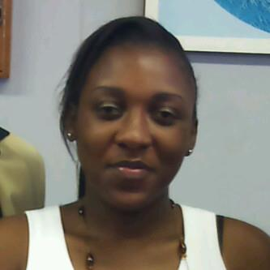 | Nkosi, Nokwazi P.¹ received her BSc in Land Surveying from the University of KwaZulu-Natal in 2011. During this time, she undertook undergraduate research on using GIS as a disaster management tool towards evacuation planning of the Durban coastal region. After receiving her BSc, she registered under the South African Council for Professional and Technical Surveyors as a candidate Professional Land Surveyor. Nokwazi is currently doing her MSc under the Inkaba yeAfrica programme towards characterization of a Cassegrain telescope and development of a laser beam coudé path for Lunar Laser Ranging.  ¹Programme of Land Surveying (Geomatics), School of Engineering, University of KwaZulu-Natal, Durban, South Africa  Email: Nokwazi@hartrao.ac.za / email address (private):Nokwazi.purity@gmail.com / Mobile +27 79 459 1071  Supervisor : Combrinck, L. Prof / email address: ludwig@hartrao.ac.za
Short Bio & Picture

