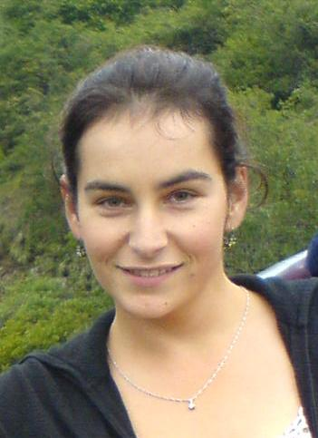 | Allison C.¹ received her BSc in Geology from the University of Kwa-Zulu Natal, South Africa in 2004. She obtained her Honours degree in Geology from the University of Cape Town, South Africa in 2005 and is currently studying an MSc degree at the Nelson Mandela Metropolitan University, South Africa entitled “Study of geo-contamination related to acid mine drainage in the West Rand, Witwatersrand, and a quantification of the costs related to environmental degradation as a result of South Africa’s gold mining industry”. Chazanne has been working since 2006 as a consulting geologist with applications in the fields of environmental science, geotechnical engineering and mineralogy. She is also a member of a number of professional societies and sits on the organizing committee for IMA2014.  ¹Department of Geosciences, Nelson Mandela Metropolitan University –Port Elizabeth, SA Email: chazanne_a@hotmail.com

