Energy transfer and photoluminescence properties of Ce³⁺ or/and Tb³⁺-doped PbS nanorods
Dejene BF, Koao LF
Department of Physics, University of the Free State (Qwaqwa), Private Bag x 13, Phuthaditjhaba, 9866
dejenebf@qwa.ufs.ac.za
Abstract. A series of luminescent PbS:Ce³⁺;Tb³⁺ material phosphors have been synthesized by low temperature chemical bath deposition (CBD) method. The X-ray diffraction (XRD) spectra of the PbS nanorods correspond to the various planes of a single cubic PbS phase. The PL spectrum monitored at 452 nm exhibits two overlapping excitation bands at 276 and 282 nm, which is assigned to the 4d-5f transitions of Ce³⁺. Under excitation (λ_{Exc}= 282 nm), the PL spectrum exhibits two luminescence bands with the maximum wavelengths at 452 and 486 nm in the visible region. The two transitions ascribed to a direct band to band and the sulphur vacancies transitions in the nanocrystalline PbS. Upon the excitation at 276 nm, the PbS:Ce³⁺;Tb³⁺ phosphor shows intense UV emissions located at 334 and 380 nm assigned to the transitions from the lowest 5d₁ crystal field component (²D_{3/2}) to the two compounds (²F_{5/2} and ²F_{7/2}) of the 4f ground state, and weak emissions at around 700 nm due to the transitions of PbS deep levels defects. The photoluminescence (PL) intensity of Ce³⁺ increases with an increasing Tb³⁺ concentration up to an optimum value of Tb²⁺:Ce³⁺ of 2, indicating the effective energy transfer (ET) occurred from Tb³⁺ to Ce³⁺ in PbS:Ce³⁺;Tb³⁺.
- Introduction
PbS belong to a class of IV-VI nanocrystals with narrow energy gaps of relevance for optical applications in the near-IR region of the electromagnetic spectrum such as long wavelength (1.3 and 1.55 µm) telecommunications [1], photovoltaics [2] and bio-imaging in the spectroscopic window of low absorption of biological systems (1-1.2 µm) [3]. Bulk lead sulfide (PbS) has a small hole mass, which is almost equal to the mass of the electron. This leads to a large exciton Bohr radius R_{ex} ~20 nm. Owing to these properties, electrons and holes, and hence the exciton, can be strongly confined. This is not always feasible in other semiconductors because of the different electron and hole effective masses [4]. Thus this system provides an ideal platform to investigate the exciton in the strong confinement regime. The ability to tune the photon emission of PbS nanostructures in the near infrared region of the electromagnetic spectrum makes this type of nanostructures suitable for several applications. The investigation of materials at the nano-scale has gained a great deal of interest as it fills the gap between bulk and atoms or molecules, thus improving our understanding of fundamental properties and providing new physical effects. This has been one of the hottest areas of research in the last twenty years [1, 5], fueled by the shrinking approach in device fabrication for optoelectronics and electronics. Up to date, due to a joint effort of physicists, chemists, biologists and material scientists, many achievements have been reported in this field. By controlling their size/shape and/or their chemical compositions, the electronic and optical properties of semiconductor nanostructures, can be manipulated [1, 6]. In particular, the confinement of the electron and hole in all spatial directions is responsible for atomic-like energy levels and physical properties. Nanostructures can be produced by different synthesis methods. Wet chemistry process provides an attractive method of synthesizing high quality nanocrystals. Being not attached to any surface, nanostructures are promising candidates to be used as building blocks for ordered structures [6, 7]. In this study we present an experimental investigation of the structural and optical properties of undoped, singly and doubly doped PbS nanostructure synthesized in aqueous solution with different do-pants. The photoluminescence emission and the effect of Tb³⁺ or/and Ce³⁺ doping concentration are investigated in detail.
- Experimental
The preparation of PbS powders were carried out using the following procedure: The PbS precursors were prepared by dissolving 0.13 M of lead acetate, 0.18 M of thiourea and 98.8 mL of ammonia in 400 mL of deionised water, separately. The chemical bath solution was prepared as follows: 60 mL of a lead acetate, thiourea and ammonia solutions as a complexing agent were mixed. The amount of solutions of lead acetate, thiourea and ammonia was held constant at ratio of 1:1:1. The amounts of do-pants and/or co-dopants were varied from 0 to 2.0. Each mixture was continuous stirred for 10 minutes while the synthesis temperature was maintained at 65 ºC. The PbS particles were washed with 60 mL of acetone and ethanol in that order. The precipitates formed were left overnight and then filtered. The obtained particles were dried at ambient conditions for a weeek and ready to be characterized. The particle size, phase and crystallinity were investigated by powder X-ray diffraction (XRD) using a Bruker D8 (Bruker Co., Germany) X-ray diffractometer with CuK_{α} (λ= 1.5406 Å). The PL excitation and emission spectra was measured using a Cary Eclipse fluorescence spectrophotometer equipped with a monochromatic xenon lamp.

- Results and discussion
3.1 Structure properties
Figure 1 shows XRD profiles of PbS, Pb_{0.99}S:Ce_{0.01}, Pb_{0.99}S:Tb_{0.01} and Pb_{0.98}S:Ce_{0.01}Tb_{0.01} samples. All the peaks observed in the diffractogram at around 2θ = 25.99, 30.11, 43.09 and 51.03º for these four samples belonging to cubic phase of PbS matched well with the standard JCPDS card no. (05-0592, a= 5.936 Å). According to XRD profiles for Pb_{1-x-y}S;Ce_{x};Tb_{y} samples with various Ce³⁺ and Tb³⁺ concentrations (not shown), single phase with cubic-type structure is obtained in the ranges of 0 ≤ x ≤ 0.20 and 0 ≤ y ≤ 0.20. The estimated average value of the cell constant a is 5.934 Å which match perfectly with the standard data.

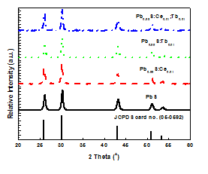

Figure 1: XRD patterns of undoped, Ce-doped, Tb-doped and Ce;Tb co-doped PbS nanostructures depict cubic structure.

No significant changes were observed for lattice parameter with the type of dopants. However, the widths of the diffraction lines are broadened because of the small size of the crystallites. The average crystalline size of the prepared PbS nanostructures calculated from the Scherer equation is between 25 and 40 nm. It was observed that low doping concentration have no significant effect on the size of the nanostructures.

3.2 Photoluminescence characteristics
In order to study the energy transfer between host, Ce³⁺ and Tb³⁺ ions, the emission spectra of PbS:Ce³⁺/Tb³⁺ nanocrystals were measured under different excitation wavelengths. The PL emission spectra were measured at the excitation wavelengths of 276 and 282 nm. Fig. 2(a) shows the room-temperature photoluminescence emission spectra of undoped, doped and co-doped PbS nanostructures after drying in air at 60 ºC for 2hr measured under 282 nm excitation wavelengths. The spectrum in Fig. 2(a) shows that the two broad luminescence peaks in visible and IR region ascribed to the nanocrystalline PbS nanostructutes sample are not symmetrical, but has a tail towards longer wavelengths. To investigate this, the spectrum excited at 280 nm was fitted with multiple Gaussian profiles.

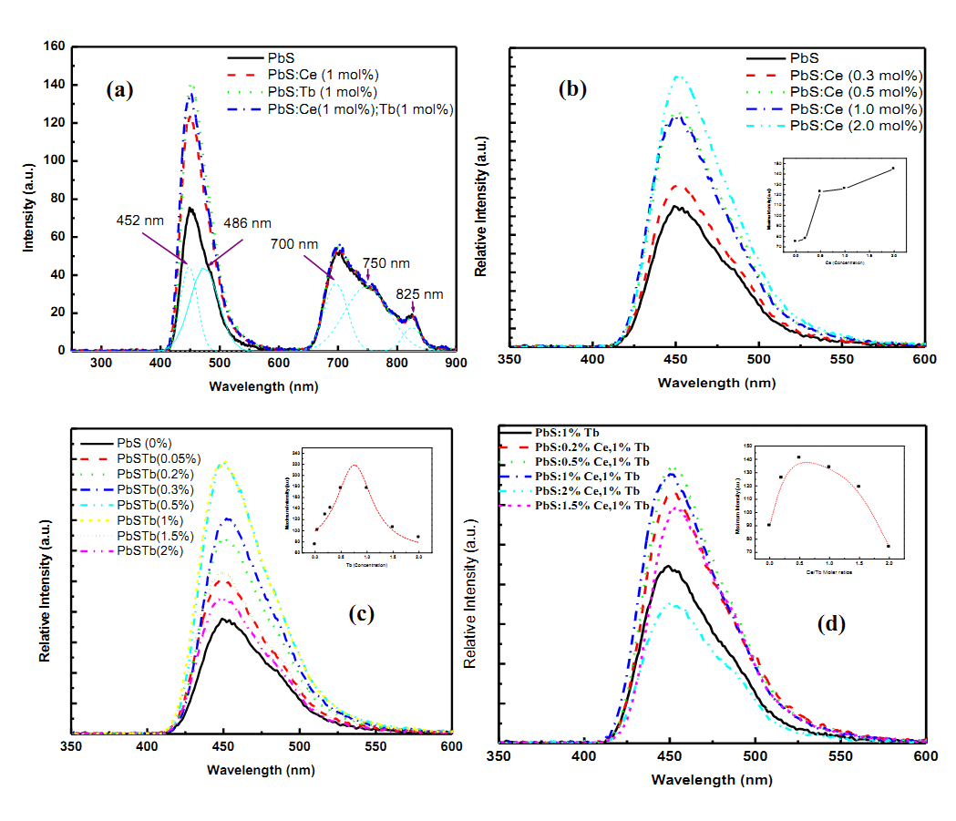
Figure 2: The effects of (a) types of dopants (b) the concentration of Ce³⁺ ions (c) the concentration of Tb³⁺ ions and (d) the molar ratios of Tb³⁺:Ce³⁺ on the emission spectra of PbS nanostructures under 282 nm excitation wavelengths.

Fig. 2(a) shows that five Gaussian peaks are necessary to provide an acceptable fit, with peak wavelengths of 452 nm, 486 nm in the visible region and broad band with peak intensities at 700, 750 and 825 nm in the IR region. From the first two wavelengths, the shorter wavelength 452 nm is ascribed to a direct band to band transition of nanocrystalline PbS and the second peak centered at 486 nm is attributed to the presence of sulphur vacancies in the lattice [9]. This emission results from the recombination of photo generated charge carriers in shallow traps [10, 11]. The remaining three peaks centred at longer wavelengths 700, 750 and 825 nm are due to the deep level transitions in nanocrystalline PbS. The shorter wavelength emission is ascribed to a direct recombination and the longer wavelength to a recombination through shallow surface states [12 - 15]. The PL emission spectra from PbS:Ce³⁺ is very similar to that of undoped PbS but with enhanced luminescence in the visible region without any significant shift in peak positions while no changes are observed in IR region emission. Increase in Ce concentration increases the intensity of PbS emissions in the visible regions. This implies that there is the possibility of the absorbing centre Ce³⁺ transfers energy to the host PbS in contrast. The dependence of the luminescence spectra of PbS: Ce on the Ce concentration is illustrated in the inset to Fig. 2(b). The emission intensity is related to the concentration of the Ce³⁺ activator ions. With the increase of the concentration of the activator ion, the energy transferring centres increases and the emission intensity is enhanced for the range of Ce dopants investigated. Accordingly, we can find substantial emission differences between Tb³⁺ or Ce³⁺ singly doped samples. For Tb³⁺-doped samples, with the increase of the concentration of the rare earth ion, the energy transfer centers increases and the emission intensity is enhanced. The highest luminescent intensity yield of the samples was obtained at a terbium concentration of 0.8% and lower or higher terbium content results in a substantial decrease in emission intensity in contrast to Ce doping. In order to further investigate the energy transfer process between the host, Ce³⁺ and Tb³⁺ ions in the PbS lattice, a series of co-doped samples were prepared. The concentration of Tb³⁺ was fixed at the optimal value x = 0.01 and the content of Ce³⁺ was varied in the range of 0 − 0.2.
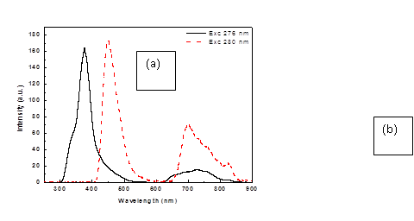

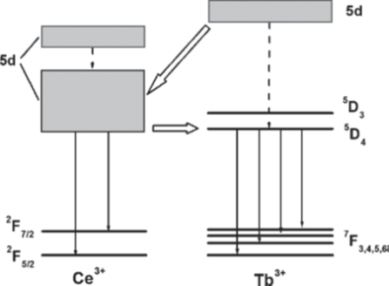

Figure 3: (a) Emission spectra of TbS:Ce³⁺(1%)/Tb³⁺(1%) nanostructures under different excitation wavelengths and (b) Schematic for the energy transfer and luminescence processes in Ce³⁺/Tb³⁺-codoped PbS nanocrystals [19].

The highest luminescent intensity yield of the particles was obtained at Tb³⁺: Ce³⁺ molar ratio of 2.0 and lower or higher molar ratios results in a substantial decrease in emission intensity. The PL emission spectra of PbS:Ce³⁺(1%)/Tb³⁺(1%) nanostructures under 276 nm excitation show peaks at 334 and 380 nm possibly be due to transition in and Ce³⁺ emitting centres. A broad peak is also observed in the IR region, but with lower intensity and blue shifted to lower wavelengths. This implies that there is the possibility of host PbS/Tb³⁺ transfers energy to the emitting centre Ce³⁺ just like in the commercially used ZnS:Ag⁺, in which the sulphide host transfers energy to Ag⁺. The existence of several peaks in the visible can be attributed to the non‐equivalence of the Ce ions (e.g. coordination number changing with the surrounding ligands from one side to another). These luminescence bands are characteristic emissions of 4f¹→5d¹ transitions of triply charged cerium ions [16, 17, 18], commonly in either in the ultraviolet or visible region (blue) spectral region and it consists typically of two bands, which corresponds to the transitions from the lowest 5d₁ crystal field component (²D_{3/2}) to the two compounds (²F_{5/2} and ²F_{7/2}) of the 4f ground state [20]. When excited at 276 nm the spectra exhibit the emissions of Ce³⁺, indicating that energy transfer could only take place from Tb³⁺ to Ce³⁺ ions but not Ce³⁺ to Tb³⁺. The emissions from Ce³⁺ are dominant under 276 nm excitation, while the emission from PbS is dominant under 280 nm excitation. The schematics of the energy transfer and luminescent processes in PbS:Ce³⁺/Tb³⁺ nanocrystals are shown in Fig. 3(b). In luminescent materials, energy transfer mechanisms between ions of the same or different types and between the host and the activator are well known [20, 21, 22, 23, 24]. They are either due to resonance or exchange interactions or multipolar interactions between the ions of the same or different types and depend on the critical energy transfer distance (Rc) between the absorbing groups in the crystal lattice [21, 22]. In addition, the lifetime of the excited state of the sensitizer ion also plays a major role, and both radiative and nonradiative processes of energy transfer can occur.

4. Conclusion
In summary, we have synthesized single crystalline PbS nanostructures by a chemical bath deposition method using easily available reactants. The product also showed a photoluminescence peak at 452, 486, 700, 750 and 825 nm due to radiative recombination from the surface states. These PbS crystals may find potential applications in fundamental studies of nanostructure as well as for the fabrication of semiconductor devices based on these structures.

Acknowledgment
The authors send gratitude to the National Research Foundation (NRF) for funding the project and the University of Free State Physics (Physics department) for the research techniques used in this study.

References
[1] Rogach A L, Eychmuller A, Hickey S G, and Kershaw S V Small 3(4), 536–557 (2007).
[2] McDonald S A, Konstantatos G, Zhang S G, Cyr P W, Klem E J D, Levina L, Sargent E H Nature Materials 4(2), 138–U14 (2005).
[3] Hyun B-R, Chen H, Rey D A, Wise F W, Batt C A Journal of Physical Chemistry B 111(20), 5726–5730 (2007).
[4] Zhao X S, Gorelikov I, Musikhin S, Cauchi S, Sukhovatkin V, Sargent E H, Kumacheva E Langmuir 21(3), 1086–1090 (2005).
[5] Alivisatos A P Science 271(5251), 933–937 (1996).
[6] Hollingsworth J, Klimov V Semiconductor and Metal Nanocrystals: synthesis and Electronic and Optical properties, chapter ’Soft’ Chemical Synthesis and Manipulation of Semiconductor Nanocrystals, 1–64. New York: Marcel Dekker, Inc. (2004).
[7] Zrenner A Journal of Chemical Physics 112(18), 7790–7798 (2000).
[8] Dhas N A, Zaban N A, Gedanken A, Chem. mater 11, 806 (1999).
[9] Sooklal K, Cullum B S, Angel S M, Mur C J J. Phys. Chem.100, 4551 (1996).
[10] Becker W G, Bard A J, J. Phys. Chem 87, 4888 (1983).
[11] Fernee M J, Watt A, Warner J, Cooper S, Heckenberg N Rubinsztein-Dunlop H, Nanotechnology 14(9), 991–997 (2004).
[12] Fernee M J, Watt A, Warner J, Cooper S, Heckenberg N Rubinsztein-Dunlop H Nanotechnology 15(9), 1328–1337 (2004).
[13] Capoena B, Martuccib A, Turrellb S Bouazaoui M, J. Mol. Struct. 651, 467–473 (2003).
[14] Fernee M J, Watt A, Warner J, Heckenberg N Rubinsztein-Dunlop H Nanotechnology 15(9), 1351–1355 (2004).
[15] Patra A, Ganguli D, J. Non‐Cryst. Solids 144, 111 (1992).
[16] Turos‐Matysiak R, Gryk W, Grinberg M, Lin Y S, Liu R S J. Phys. Condens. Matter. 18, 10531(2006).
[17] Reisfeld R, Patra A, Panczer G, et al., Opt. Mater. 13, 81 (1999).
[18]Wang G, Qin W, Zhang D, Wei G, Zheng K, Wang L, Ding F, J. Nanosci. Nanotechnol 10, 1939–1942, 2010
[19] Blasse G, Grabmaier E C Luminescent Materials, Springer-Verlag, Berlin (1994).
[20] Smets B M J, Mater. Chem. Phys., 16, 283 (1987).
[21] Fouassier C, Curr. Opin. Solid State Mater. Sci., 2, 231 (1997).
[22] Ronda C R, Justel T, Nikol H J. Alloys Compd., 275-277, 669 (1998).
[23] Ronda C, Angew. Chem. Int. Ed. 37, 3084 (1998).
[24] Shea L E, Datta R K, Brown J J Jr. J. Electrochem. Soc., 141, 1950 (1994).

