Effects of different TiO₂ phases on the luminescence of CaTiO₃:Pr³⁺
Noto LL*, Pitale SS, Ntwaeaborwa OM, Terblans JJ, Yagoub MYA and Swart HC*
Physics Department, University of the Free State, P. O. Box 339, Bloemfontein, 9300, South Africa
*Corresponding author: NotoLL@ufs.ac.za or SwartHC@ufs.ac.za

Abstract. CaTiO₃ is widely used in the ceramic industry, and when it is doped with Pr³⁺ it glows with a single red emission at a wavelength of 613 nm. The red emission is attributed to the ¹D₂ →³H₄ radiative transition of Pr³⁺ upon ultraviolet (UV) or electron beam irradiation. The compound was prepared by using rutile and anatase polymorphs of TiO₂ to investigate their effects on the luminescence properties. X-ray diffraction patterns of CaTiO₃:Pr³⁺ phosphor prepared with rutile polymorph show that the phosphor was successfully synthesized without any additional phases, whereas the patterns for the phosphor prepared with anatase polymorph show unreacted TiO₂ phases. The unreacted phases resulted in lowered luminescence intensity of the phosphor prepared with the anatase TiO₂. The chemical stability of the phosphor was also investigated by exposing it to a prolonged electron beam irradiation.
Keywords:CaTiO₃: Pr³⁺ red emission, long afterglow phosphor
- Introduction
The intentervalence charge transfer mechanism is known to be the reason behind the single red emission of Pr³⁺ doped CaTiO₃ at room temperature. The phenomenon is attributed to complete depopulation of the ³P₀ level carriers by populating the ¹D₂ state. However so, the intensity of the single red emission peak from ¹D₂ → ³H₄ transition is highly dependent on energy transfer from the host to the luminescent centers of Pr³⁺[1,2]. CaTiO₃, which is an orthorhombic perovskite, is known to exhibit good dielectric properties. The symmetry of this compound is temperature dependant and it changes from orthorhombic to tetragonal under different temperature exposure [3,4,5,6]. Solid state reaction is the main route to prepare this compound by directly firing the TiO₂ and CaCO₃/CaO as initial reagents at temperatures above 1000 ºC [6]. The final compound can have different quantities of the different types of defects such as line defects, point defects, and vacancies. These are a result of slight changes in the preparation procedures such as heating rate, cooling rate and the rate of the chemical reaction. Different chemical reaction rates may also be introduced by different reagent phases. All these parameters may influence the properties of the final compound, which may in return affect energy transfer from the host to the luminescent centers of Pr³⁺ because of many non-radiative centers that may be introduced in the material [7,8,9]. TiO₂ that is used as a reagent to fabricate CaTiO₃ itself exists in different modifications, such as the rutile, anatase and the brookite polymorphs [10,11]. The three polymorphs have similar crystal structures made of TiO₆ octahedrons that differ from each other with size and distortion at different temperatures and pressure [10]. The octahedrons link to each other through corners and edges, and there are two links for rutile, three links for brookite and four links for anatase [10]. The increase in the number of links has an effect of increased distortion and reduced volume to the octahedrons. At higher temperatures the factor of distortion increases the most for anatase and remains unchanged for rutile. This leads to rutile being the most chemically and physically stable polymorph of TiO₂ [10]]. The paper presents the effects of preparing CaTiO₃:Pr³⁺ phosphor using rutile and anatase polymorphs of TiO₂, to the luminescence intensity at different temperatures. The chemical stability of the phosphor is also investigated by probing its surface with a prolonged electron beam, and the effects to Cathodoluminescence (CL) emission were monitored.

- Experimental
CaTiO₃ compound doped with 0.2 mol % of Pr³⁺ was prepared by stochiometrically reacting CaCO₃ with TiO₂ rutile and TiO₂ anatase in separate experimental setups. PrCl₃ was also stochiometrically incorporated into each of the two prepared CaTiO₃ products to introduce Pr³⁺ ions as activator ions for luminescence. Solid state chemical reaction was used to prepare these materials at different temperatures (1100 to 1500°C). The phosphors were analyzed using X-ray diffraction (XRD) (Bruker Advance D8) to identity the phases that are present in each compound, and scanning electron microscopy (SEM) (Shimadzu SSX-550, Kyoto, Japan) for the surface morphology. Photoluminescence (PL) spectroscopy (Varian – Carry Eclipse fluorescence spectrometer) was used to identify the absorption regions from the excitation spectra and luminescence from the emission spectra of the CaTiO₃:Pr³⁺ phosphor. The electron beam of an AES PHI 549 with 2 keV energy and 10 µA current was used to probe the surface of the phosphor and the cathodoluminescence (CL) spectrometer (Ocean optics inc. PC2000) was used to monitor the CL emission.

- Results
CaTiO₃:Pr³⁺ XRD patterns are presented for compounds prepared by using rutile (figure 1(a)) and anatase (figure 1(b)) TiO₂polymorphs, which were sintered at different temperatures as indicated. TheXRD pattern of CaTiO₃ prepared with the rutile TiO₂ shows single phase formation when compared to the standard (JCPDS card no. 22-0153). On the contrary the XRD pattern of CaTiO₃ prepared with the anatase TiO₂ shows additional phases (marked by *) when compared to the standard (JCPDS card no. 22-0153), which match with those of TiO₂. The presence of the additional phases is attributed to the unreacted TiO₂. The peaks of the phosphor prepared using rutile polymorph are broader than those of the phosphor prepared using anatase polymorph, and this is correlated with the size effect. The effect may be attributed to particles of the phosphor of the sample prepared by the earlier polymorph being smaller than the latter polymorph of TiO₂[12]. The existence of TiO₂ in different polymorphs, rutile, anatase and brookite, gives it the unique ability to react with a particular material to fabricate a product with different properties. The properties referred to are: different quantities of Ti³⁺ and Ti⁴⁺ point defects, oxygen vacancies, line defects, different electronic structures, and different chemical and physical stability [8,13,14,16].Anatase TiO₂ has a greater quantity of point defects and oxygen vacancies compared to the rutile TiO₂ due to its much more distorted nature, and this leads to it forming products that have much more point defects [10,14,16].The greater chemical stability of the rutile polymorph allows it to react more effectively than the anatase, and form products with a greater chemical stability [14,15]. Hence CaTiO₃ prepared using a rutile TiO₂ exists as a single phase as opposed to that prepared using anatase TiO₂, which has additional phases (figure 1(b)).
The surface morphology of the two CaTiO₃ phases prepared at 1300 ºC using rutile TiO₂ phase (figure 2(a)) and anatase TiO₂ phase (figure 2(b)) showed approximately the same crystal shapes. They both had particles of different sizes and shapes. The particles for both SEM images are agglomerated because the high temperature (1300 ºC) involved for the preparation of CaTiO₃ compounds.
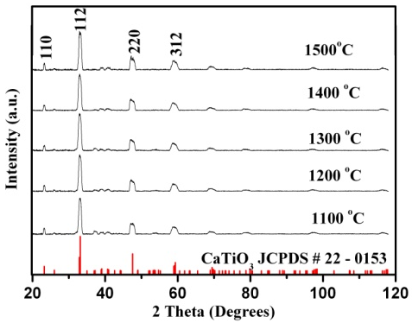
(a)
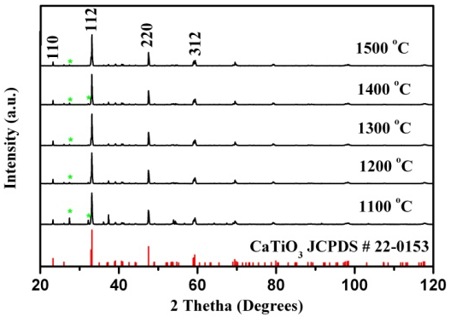
(b)
Figure 1: The XRD patterns of CaTiO₃ compounds prepared using different TiO₂ phases; rutile (a) and anatase (b) phases.

(b)
(a)

Figure 2: SEM images showing the surface morphology of CaTiO₃ prepared using rutile (a) and anatase (b) TiO₂ phases.
Perovskite materials are reported to be stable at temperatures above 1000 ºC, and solid state reaction has so far been the famous route to prepare these materials [6]. However, recent reports have also shown chemical routes for their preparation [4,16]. The spectra in figure 3(a) show the PL excitation and emission of the CaTiO₃:Pr³⁺(0.2 mol %) prepared by anatase and rutile TiO₂ polymorphs at 1200 ºC. According to the excitation spectra, the two compounds can best be excited using a 330 nm wavelength source to excite electrons from the valence band to the conduction band, or excite them from the 4f level to the 4f5d level. The intensity of the ¹D₂ – ³H₄ emission of CaTiO₃ prepared using rutile TiO₂ is more intense than that of the one prepared using the anatase TiO₂ phase. This outcome is attributed to the difference in phase purity of the two CaTiO₃ compounds, as evidenced in their XRD patterns (figure 1). The additional phases present in the CaTiO₃:Pr³⁺ phosphor prepared with anatase TiO₂ introduce luminescent quenching centers that promote non-radiative relaxation to the excited carriers [17]. Figure 3(b) presents the comparison of the PL intensity of CaTiO₃:Pr³⁺(0.2 mol %) phosphor at different preparation temperatures. PL intensity increases as a result of improved crystallinity of the material and it is at its maximum for the sample prepared at 1200 ºC for the anatase prepared phosphor and 1300 ºC for the rutile prepared phosphor. The decrement is attributed to increased point defects that act a quenching centers with an increase in temperature [17,18,19]. The energy required to produce defects in the material, is proportional to the temperature as modeled using the Arrhenius equation. This leads to the concentration of the defects to increase exponentially as temperature is increased [20].
The chemical stability of the compounds was investigated by probing the surface of the phosphor with a prolonged electron beam of 2 keV energy and 10 µA current in-situ. From the spectra, the CL emission of the CaTiO₃:Pr³⁺ phosphor prepared using the rutile TiO₂ phase is stable compared to that prepared using the anatase phase. The CL emission of the anatase TiO₂ phase dropped with 60 %, until 2000 C.cm⁻² electron doses, before it stabilized.

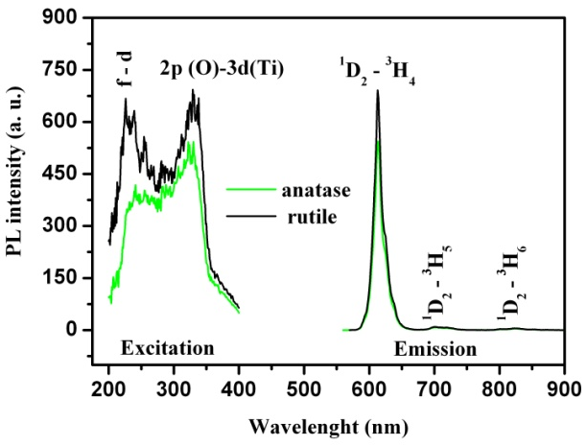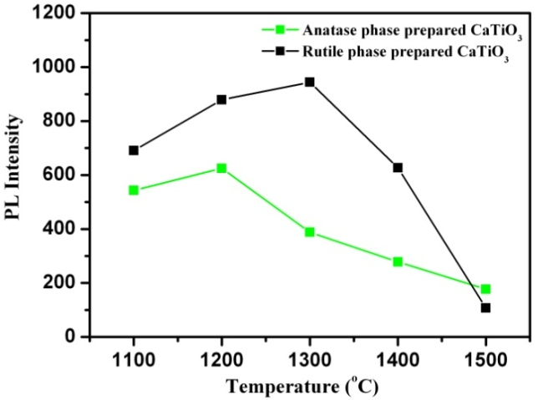
(b)
(a)
Figure 3: The excitation and PL emission spectra of CaTiO₃ at 1200 ºC and the maximum PL intensity at different temperatures (b).

Oxide phosphors are known to be chemically stable materials, and are good candidates for fabricating television screens. This is because of their CL intensity that resists degradation under prolonged electron beam irradiation [21,22]. According to the ESSCR mechanism, CL degradation is a result of surface chemical changes which occur to non-chemically stable surfaces [23]. The CL intensity of CaTiO₃:Pr³⁺ (0.2 mol %) prepared using the rutile TiO₂ shows stability against prolonged electron beam, as opposed to that prepared by the anatase phase. This may be attributed to the CaTiO₃ prepared using the rutile TiO₂ being more chemically stable compared to that prepared using the anatase TiO₂ [11]. The surface of the compound with a higher chemical stability tends to resist dissociation by an electron beam more than the compound with a lesser chemical stability [22]. The surface dissociation follows the ESSCR mechanism proposed by Swart et al [23]. A 4 eV shift in the AES spectra (not shown) was, however, measured during the degradation of the anatase phase leading to band bending in which the excited electrons and holes are separated before recombination leading to a lower CL intensity. Similar surface charging occurs during electron bombardment of aged ZnS:Ag,Cl phosphor due to the formation of a non-conductive ZnO surface layer [24]. Noto et al. [25] also measured the formation of CaO and CaO_{x} as well as TiO₂/Ti₂O₃ non-luminescent species on the surface of (anatase phase) CaTiO₃:Pr³⁺.

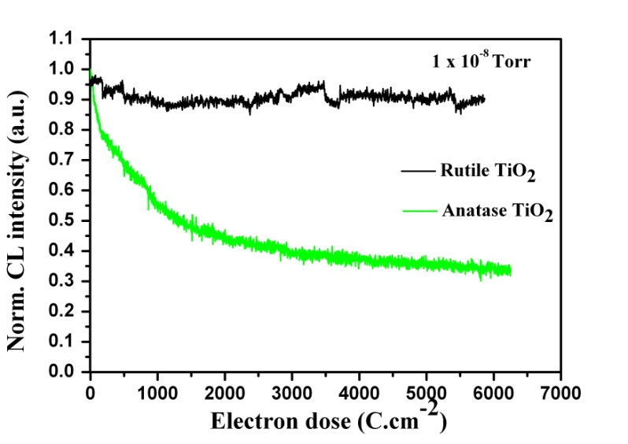
Figure 4: Cathodoluminescence of CaTiO₃:Pr³⁺ under prolonged electron exposure.

- Conclusion
CaTiO₃:Pr³⁺ (0.2 mol %) was prepared using two different polymorphs of TiO₂, the anatase and the rutile that is more chemically and physically stable. The phosphor glowed with a single red emission of 613 nm wavelength from the ¹D₂ →³H₄ radiative transition at room temperature, due to complete quenching of the blue emission by the intervalence charge transfer. The rutile TiO₂ was effective in preparing phase pure CaTiO₃:Pr³⁺ (0.2 mol %) phosphor at different temperatures as evidenced from the XRD. This effect led to samples prepared with rutile at different temperatures to have higher luminescence intensity. The surface of the phosphor prepared with the rutile TiO₂ was discovered to be more stable against prolonged electron beam irradiation.

Acknowledgement
This work is based on the research supported by the South African Research Chairs Initiative of the Department of Science and Technology and National Research Foundation of South Africa, and the University of Free State Cluster program for financial support.

References
- Boutinaud P, Sarakha L, Cavalli E, Bettinelli M, Dorenbos P and Mahiou R, 2009 J.Phys. D: Appl. Phys. 42 045106.
- Diallo PT, Jeanlouis K, Boutinaud P, Mahiou R and Cousseins JC, 2001 J. Alloys and Compd. 218 323.
- Cockayne E and Burton BP, 2000 Phys. Rev. B 63 3735.
- Chen SYD and Tang W, 2007 J. Alloys and Compd. 441 327.
- Johnson M and Lemmens P, 2008 J. Phys. Condens. Matter 20 264001.
- Steele B, Burns AD, Chernatynskiy A, Grimes RW and Phillpot SR, 2010 J. Mater. Sci. 45 168.
- Tang W and Chen D, 2009 Mater. Res. Bull. 44 836.
- Zhang X, Zhang J, Chen X, Lu S and Wong XJ, 2007 J. Lumin. 122 958.
- Boutinaud P, Pinel E, Dubois M, Vink AP and Mahiou R, 2005 J. Lumin. 111 69.
- Meagher EP and Lager GA, 1979 Can. Mineral. 17 77.
- Weber J, Lavrov E and Herklotz F, 2012 Physica B 407 1456.
- Mohd RJ, Kok SW, Norliza H, Nurul AKA, 2012 Int. J. Electrochem. Sci. 7 4942
- Ricci PC, Casu A, Salis M, Corpino R and Anedda A, 2010 J. Phys. Chem. C 114 14441.
- Cho E, Han S, Ahn HS, Lee KR, Kim SK and Hwang CS, 2006 Phys. Rev. B 73 193202.
- Scepanovicy M, Grujic-Brojcin M, Miric M, Dohcevic-Mitrovic Z and Popovic ZV, 2009 Acta Phys. Pol. A 116 603.
- Park KH and Kim HG, 2011 J. Korean Phys. Soc. 56(2) 648.
- Deren PJ, Pazik R, Strek W, Boutinaud P, Mahiou R, 2008 J. Alloys and Compd. 451 595.
- Erdei S, Rodriguez NM, White FW, Ravichandran D and Cross LE, 1998 J. Mater. Chem. 8(1) 99.
- Zhang J, Liang H and Su Q, 2009 J. Phys. D: Appl. Phys. 42 105110.
- Askeland DR, Fulay PP, Wright VJ, The science and engineering of materials, 2010, 6th ed., Cengage learning Inc. USA, p115.
- Pitale SS, Kumar V, Nagpure IM, Ntwaeaborwa OM, Coetzee E and Swart HC, 2011 J. Appl. Phys. 109 013105.
- Kumar V, Mishra V, Pitale SS, Nagpure IM, Coetzee E, Ntwaeaborwa OM, Terblans JJ and Swart HC, 2010 J. Appl. Phys. 107 123533.
- Swart HC, Sebastian JS, Trottier TA, Jones SL and Holloway PH, 1996 J. Vac. Sci. Technol. 14(3) 1697.
- Swart HC, Greeff AP, Holloway PH and Berning GLP, 1999 Appl. Surf. Sci. 140 63.
- Noto LL, Pitale SS, Terblans JJ, Ntwaeaborwa OM and Swart HC, 2012 Physica B: Physics of Condensed Matter 407(10) 1517.

