**Structural, electronic and mechanical stability of olivine LiMPO4 (M: Mn, Fe, Co)**

**NL Lethole, HR Chauke and PE Ngoepe**

Materials Modeling Centre, University of Limpopo, Private Bag X1106, Sovenga, 0727, South Africa

E-mail: [Lesley.lethole@ul.ac.za](mailto:Lesley.lethole@ul.ac.za)

**Abstract**. First-principles calculations used to investigate the structural, thermodynamic, electronic and mechanical stabilities of LiMPO4 crystal structures have been performed. The structural lattice parameters are in good agreement with the available experimental data to within 3 %. The independent elastic constants suggested mechanical stability of LiMPO4 crystal structures. Lastly, the electronic density of states suggested that considered LiMPO4 systems are metallic.

1. **Introduction**

Previous studies have shown that olivine lithium iron phosphate, LiFePO4 is a promising cathode material for new generation of lithium rechargeable batteries. The following characteristics: low cost, non-toxicity, remarkable thermal stability, good electrochemical properties and environmental benign make this material a competitive candidate [1, 2]. Consequently, attention has also been shifted to the other olivine lithium transition metal phosphates such as LiMnPO4 and LiCoPO4. It is known that LiFePO4 has an operating voltage of 3.45 V which is twice more than that of standard AA alkaline battery. Moreover, its theoretical capacity is relatively high (170 mAh/g) [2]. On the other hand LiMnPO4 and LiCoPO4 show operating voltages of 4.1 V and 4.5 V, and theoretical capacities of 171 mAh/g and 70 mAh/g, respectively [3, 4, 5].

LiMPO4 (M: Mn, Fe, Co) is an ordered olivine orthorhombic system with space group *Pnma* where M and P atoms occupy half of the octahedral sites and quota of the tetrahedral sites in a hexagonal close-packed array of oxygen atoms, respectively (Figure 1). In this work, we present first-principles stability study on LiMPO4 structures, particularly the thermodynamic, electronic and mechanical stability. The equilibrium lattice parameters, heats of formation, densities of states, phonon dispersion curves and elastic properties will be investigated to mimic the stability trend between LiMPO4 structures.

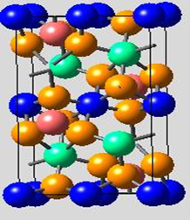

Li

M

P

O

Figure 1: Schematic representation of olivine LiMPO4 structure.

1. **Methodology**

First-principles calculations were performed using the density functional theory (DFT) method as implemented in the Vienna ab initio simulation package (VASP) [6]. The projector augmented wave (PAW) potential sets were used with the exchange and correlation energies approximation in the local density approximation with the Hubbard parameter correction (LDA+*U*) following the rotationally invariant. A plane wave basis set cut-off of 500 eV and k-mash of 4x6x6 were chosen since they were found to be sufficient to converge the total energy of the systems. Optimisation of structural parameters was achieved by minimisation of forces and stress tensors. Finally, the densities of states (DOS) were calculated using a smearing width of 0.05 eV using a Methfessel-Paxton smearing approach [7].

1. **Results and discussion**

Table 1. Structural lattice parameters, cell volumes, heats of formation, elastic constants andmoduli of LiMPO4 polymorphs; the experimental data are in parenthesis.

|  |  |  |  |
| --- | --- | --- | --- |
| Structure | LiMnPO4 | LiFePO4 | LiCoPO4 |
| a (Å)  b (Å)  c (Å)  V (Å3) | 10.52 (10.40)a  6.12 (6.09)a  4.78 (4.74)a  307.74 (300.21)a | 10.38 (10.30)b  6.06 (5.99)b  4.71 (4.69)b  296.27 (289.36)b | 10.42 (10.20)c  5.89 (5.92)c  4.73 (4.69)c  290.29 (283.20)c |
| Hf (kJ/mol) | -1340.45 | -1184.49 | -1097.25 |
| C11  C12  C13  C22  C23  C33  C44  C55  C66 | 167.61  82.33  79.07  199.84  63.41  200.78  49.99  62.56  54.79 | 209.56  117.29  99.83  270.49  80.53  249.58  56.89  72.27  62.10 | 152.17  68.83  61.75  192.50  51.42  199.33  47.67  59.67  58.33 |
| BH | 113.00 | 146.80 | 100.53 |
| GH | 55.77 | 65.97 | 56.53 |
| EH | 143.67 | 172.13 | 142.83 |

[8]a [9]b [10]c

* 1. *Structural and thermodynamic properties*

Presented in Table 1 are the structural lattice parameters, cell volumes, formation energies and elastic properties which have been calculated by performing full geometric optimization and are presented in table 1. We note that our calculated lattice parameters and cell volumes are in good agreement with the experimental values to within 3% which is reasonable for DFT transition metal phosphates calculations [11]. It is also observed that our calculated values slightly overestimate the experimental data except for the LiCoPO4 lattice parameter b; however, the volume is overestimated as expected from DFT+*U* calculations. The heats of formation were calculated using expression 1.

 (1)

According to this expression, it was found that the LiMPO4 structures show relatively low formation energy values, with the LiMnPO4 (-1340.45 kJ/mol) displaying the lowest value. This suggests that the structure is the most stable over LiFePO4 (-1184.49 kJ/mol) and LiCoPO4 (-1097.25 kJ/mol), respectively.

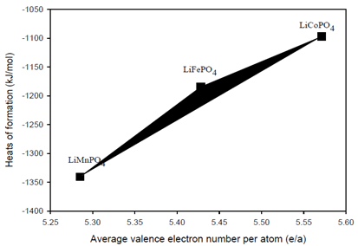

Figure 2 Heats of formation for LiMPO4 structures as a function of the average number of valence electrons per atom (*e*/*a*).

The heat of formation for LiMPO4 structures as a function of the average number of valence electrons per atom (*e*/*a*) is shown in Figure 2. It is clear from this figure that LiMnPO4 has the lowest heat of formation as compared to LiFePO4 and LiCoPO4. This indicates highest stability for LiMnPO4 structure over LiFePO4 and LiCoPO4, respectively. The observed linear trend predicts that the average number of valence electrons per atom increases with the heats of formation across the transition metal element (Mn, Fe and Co).

* 1. *Electronic properties*

The total densities of states of LiMPO4 structures were calculated using the spin polarised DFT+*U* approach and presented in Figure 3.

 (2)

Thus  represents the number of states between  and .

It was observed that all structures show relatively wide band gaps around the Fermi level. However, the Fermi level falls with the 3*d* M band suggesting the metallic behaviour characteristic of the LiMPO4 systems, particularly for LiMnPO4 and LiFePO4. On the other hand the partial densities of states show that states around the Fermi level are mainly due to contribution from transition metal, M 3*d* electrons.

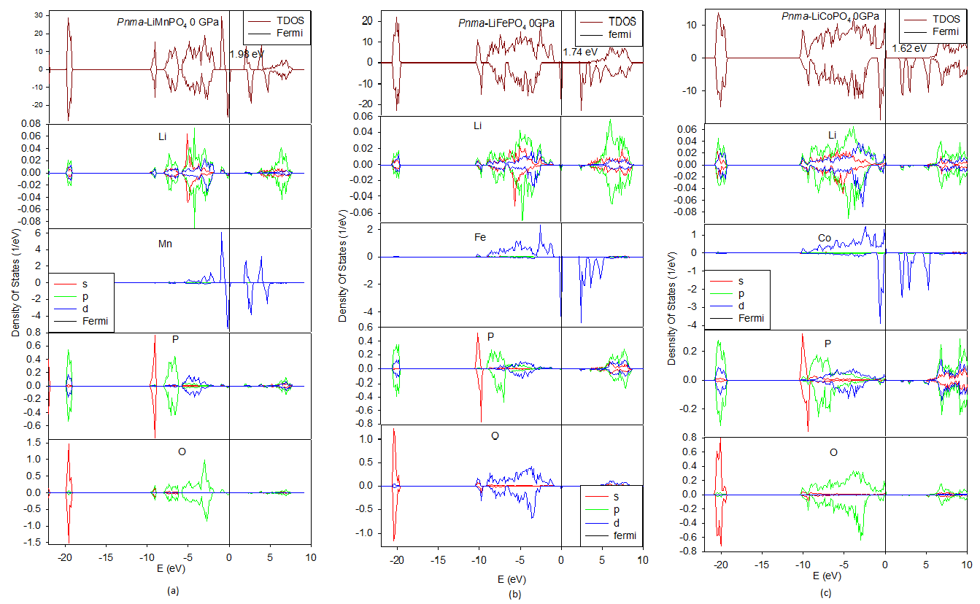

Figure 3. Total and partial densities of states of LiMPO4 structures: (a) LiMnPO4, (b) LiFePO4 and (c) LiCoPO4

* 1. *Elastic properties*

Elastic constants were calculated by means of Taylor expansion of the total energy as follows:

 (3)

where is the unstrained system energy, V0 is the equilibrium volume while  and  are elements in the stress tensor and factor to take of Voigt index, respectively. The orthorhombic LiMPO4 crystals have nine (C11, C12, C13, C22, C23, C33, C44, C55, C66) independent elastic constants [12] as listed in Table 1. The necessary mechanical stability conditions for orthorhombic systems are given as follows:

, , , , , , , , , 

It is clear from Table 1 that all the independent elastic moduli (Cij) are positive satisfying all the stability conditions; this suggests that all LiMPO4 structures are elastically stable. Their resultant bulk modulus B, shear modulus G and Young’s modulus E were also obtained from the calculated elastic constants using the Hill method [13].

 (4)

 (5)

 (6)

where V (upper limit), R (lower limit) and H (average) are Voigt, Reus and Hill, respectively.

The highest values of B, G and E are obtained for LiFePO4, while LiMnPO4 and LiCoPO4 are comparable. The B and E values suggest hardness and Stiffness, respectively of materials. Furthermore, we note that G is less than B for all structures, implying that the Shear modulus is the limiting parameter for stability [14].

1. **Conclusion**

First-principles calculations on thermodynamic, structural, electronic and mechanical properties of LiMPO4 crystals have been performed using DFT+*U* approach. From the calculated properties, the stability trend within LiMnPO4, LiFePO4 and LiCoPO4 has also been determined. The calculated structural lattice parameters and equilibrium cell volume are in good agreement with the experimental data to within 3 %. The predicted heats of formation suggest that LiMnPO4 is the most stable structure over LiFePO4 and LiCoPO4, respectively. Moreover, the independent elastic properties have shown that LiMPO4 crystals are mechanically stable. There is a good agreement between the heats of formation and the electronic densities of states which are consistent with elastic stability.

**Acknowledgements**

This work has been done at the Materials Modelling Centre, University of Limpopo, supported by the National Research Foundation.

1. **References**

[1] Amine K, Yashuda H and Yamachi M 2000 *Electrochem. and Solid-State Lett.* **3** 178

[2] Padhi AK, Nanjundaswamy K and Goodenough JB 1997 *J. Electrochem. Soc*. **144** 1188

[3] Zhang Y, Sun C.S and Zhou Z 2009 *Electrochem. Commun.* **11** 1183

[4] Nakayama M, Goto S, Uchimoto Y, Wakihara M and Kitajima Y 2004 *Chem. Mat.* **16** 3399

[5] Wang L, Sun W, He X, Li J and Jiang C 2011 *Int. J. Electrochem. Sci.* **6** 2022

[6] Kresse G and Furthmüller J 1996 *Phys. Rev. B* **54** 1169

[7] Methfessel M and Paxton A 1989 *Phys. Rev. B* **40** 616

[8] Osorio-Guille´n JM, Holma B, Ahuja R and Johansson B 2004 *Solid State Ionics* **167** 221

[9] Sanchez MAE, Brito GES, Fantini MCA, Goya GF and Matos JR 2006 *Solid State Ionics* **177** 497

[10] Kubel F 1994 *Zeitschrift fuer Kristallographi* **209** 755

[11] Li G, Azuma H and Tohda M 2002 *Electrochem. Solid-State Lett.* **5** A135

[12] Patil SKZ, Khare SV, Tuttle BR, Bording JK and Kodambaka S 2006 Phys. Rev. B **73** 104118

[13] Hill R 1952 *Proc. Phys. Soc. A* **65** 349

[14] Shein IR and Ivanovskii AL 2008 *J. Phys. Conden. Mat.* **20** 415218