Structural, electronic and mechanical stability study of olivine

LiMPO4 (M: Mn, Fe, Co)

NL Lethole, HR Chauke and PE Ngoepe

Materials Modelling Centre, University of Limpopo, Private Bag x1106, Sovenga, 0727, South Africa

E-mail: Lesley.lethole@ul.ac.za

Abstract. First-principle calculations to investigate the structural, thermodynamic, electronic and mechanical stabilities of LiMPO4 crystal structures have been performed. The structural lattice parameters are in good agreement with the available experimental data within 3%. The independent elastic properties suggested mechanical stability of LiMPO4 crystal structures. Lastly, the electronic density of states suggests that LiMPO4 crystal structures are metallic.

1. Introduction
Previous studies have shown that olivine lithium iron phosphate, LiFePO4 is a promising cathode material candidate for new generation of lithium rechargeable batteries. The following characteristics: low cost, non-toxicity, remarkable thermal stability, good electrochemical properties and environmental benign make this material a competitive candidate [1,2]. Consequently, attention has
also been shifted to other olivine lithium transition metal phosphates such as LiMnPO4 and LiCoPO4. It is known that LiFePO4 has an operating voltage of 3.45 V which is twice more that of a standard AA alkaline battery. Moreover, its theoretical capacity is relatively high (170 mAh/g) [2]. On the other hand LiMnPO4 and LiCoPO4 show an operating voltage of 4.1 V and 4.5 V, and theoretical capacity of
171 mAh/g and 70 mAh/ respectively [3,4,5].

LiMPO4 (M: Mn, Fe, Co) is an ordered olivine orthorhombic system with space group Pnma where M and P atoms occupy half of octahedral sites and quota of the tetrahedral sites in a hexagonal close- packed array of oxygen atoms, respectively (fig. 1). In this work, we present first principles stability study on LiMPO4 structures, particularly the thermodynamic, electronic and mechanical stability. The equilibrium lattice parameters, heats of formation, phonon dispersion curves and elastic properties will be investigated to mimic the stability trends between LiMPO4 structures.

Li Fe P
O

Figure 1: Schematic representation of olivine LiMPO4 structure.

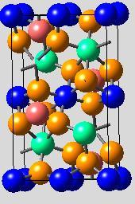
2. Methodology
We have performed first-principle calculations using the density functional theory (DFT+U) method
as implemented in the Vienna ab initio simulation package (VASP) [6]. The Projector augmented wave (PAW) potential sets were used with the exchange and correlation energies approximated in the local density approximation with the Hubbard parameter correction (LDA+U) following the rotationally invariant. A plane wave basis set cut-off of 500 eV and k-mesh of 4x6x6 was chosen since they are sufficient to converge the total energy of the systems. Optimization of structural parameters was achieved by minimization of forces and stress tensors. Finally, the densities of states (DOS) were calculated using a smearing width of 0.05 eV using a Methfessel–Paxton smearing approach [7].

3. Results and discussion
Table 1. Structural lattice parameters, cell volumes, heats of formation, elastic constants and
moduli of LiMPO4 polymorphs; the experimental data are in parenthesis.

Structure | LiMnPO4 | LiFePO4 | LiCoPO4
a (Å)  b (Å)  c (Å)  V (Å3) | 10.52 (10.4)a  6.118 (6.09)a  4.777 (4.74)a  307.3 (301.1)a | 10.38 (10.30)b  6.055 (5.99)b  4.707 (4.69)b  295.0 (289.8)b | 10.42 (10.2)c  5.886 (5.92)c  4.734 (4.69)c  290.29 (283.2)c
Hf kJ/mol) | -1340.45 | -1184.49 | -1097.25
C11  C12  C13  C22  C23  C33 | 167.61  82.33  79.07  199.84  63.41  200.78 | 209.56  117.29  99.83  270.49  80.53  249.58 | 152.17  68.83  61.75  192.50  51.42  199.33

[8]a [9]b [10]c
C44  C55  C66 | 49.99  62.56  54.79 | 56.89  72.27  62.40 | 47.67  59.67  58.33
BH | 113.00 | 146.80 | 100.53
GH | 55.77 | 65.97 | 56.53
EH | 143.67 | 172.13 | 142.83

3.1 Structural and thermodynamic properties
The structural lattice parameters, cell volumes and formation energies have been calculated by performing full geometric optimization and are presented in table 1. We note that our calculated lattice
parameters and cell volumes are in good agreement with the experimental values to within 3% which
is reasonable for DFT transition metal phosphates calculations [11]. It is also observed that our calculated values slightly overestimate the experimental data except for the LiCoPO4 lattice parameter b; however, the volume is overestimated as expected from DFT calculations.

The structural formation energies were calculated using the expression:
( ) ⁄ [ ( )] (1) According to this expression, it was found that the LiMPO4 structures show relatively low
formation energy values, with the LiMnPO4 (-1340.45 kJ/mol) displaying the lowest energy value. This suggests that the structure is the most stable over LiFePO4 (-1184.49 kJ/mol) and LiCoPO4 (-
1097.25 kJ/mol), respectively.

-1050

-1100

LiCoPO4

-1150
Heats of formation (kJ/mol)
LiFePO4

-1200

-1250

-1300

LiMnPO4

-1350

-1400
5.25 5.30 5.35 5.40 5.45 5.50 5.55 5.60

Average valence electron number per atom (e/a)

Figure 2: Heats of formation for LiMPO4 structures as a function of the average number of valence electrons per atom (e/a).

The heat of formation for LiMPO4 structures as a function of the average number of valence electrons per atom (e/a) is shown in figure 2. It is clear from this figure that LiMnPO4 has the lowest heat of formation as compared to LiFePO4 and LiCoPO4. This indicates highest stability for LiMnPO4 structure over LiFePO4 and LiCoPO4, respectively. The observed linear trend predicts that the average

number of valence electrons per atom increases with the heats of formation across the transition metal element (Mn, Fe and Co).

3.2. Electronic properties

30 TDOS
20
10
0
-10
-20

0.08
20

0

-10

-20
0.06
0.04
10

0

-10

0.06
Fermi

Li
0.06 Li
0.04
0.02
0.00
-0.02

-0.06

6
Density Of States (DOS)
Mn
4
2
0
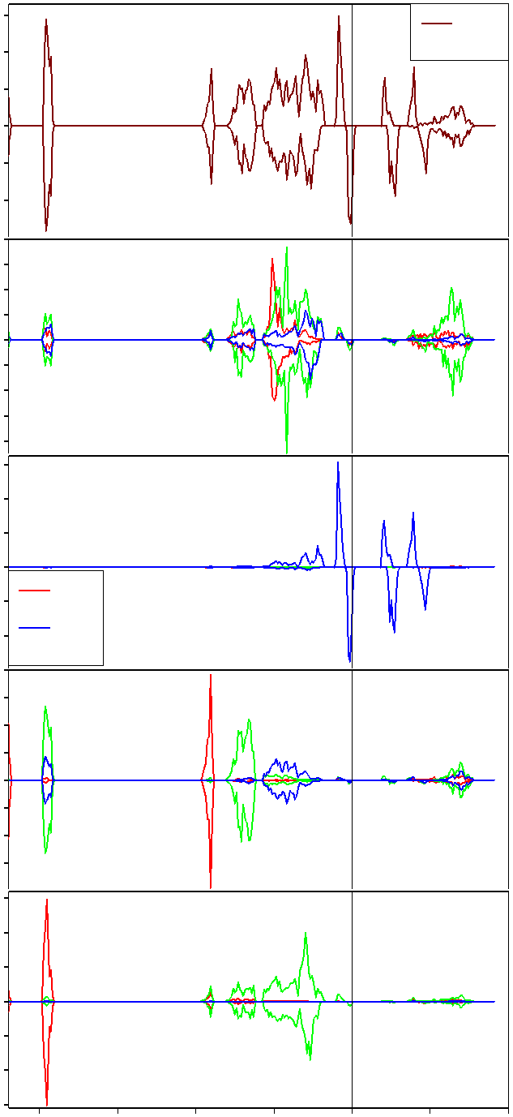
s
0.02
0.00
-0.02
-0.04
-0.06

0
0.02
0.00
-0.02
-0.04
-0.06
-0.08

1 Co
0
-1
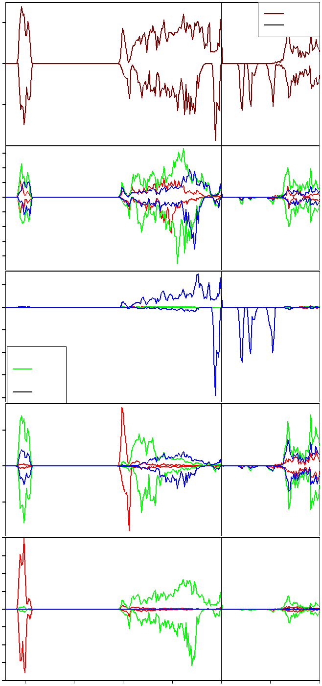
-2 s p
-2 p
-4 -3 d
-4 d
Fermi
0.8
P
0.6
0.4
0.2
0.0
-0.2
-0.4
-0.6
0.6
0.4
0.2
0.0
-0.2
-0.4
-0.6
-0.8
-4

0.2

0.0

-0.2

0.8
Fermi

P

1.0
0.5
0.0
-0.5
-1.0
-1.5

O

-20 -15 -10 -5 0 5 10
E (eV)

0.5

0.0

-0.5

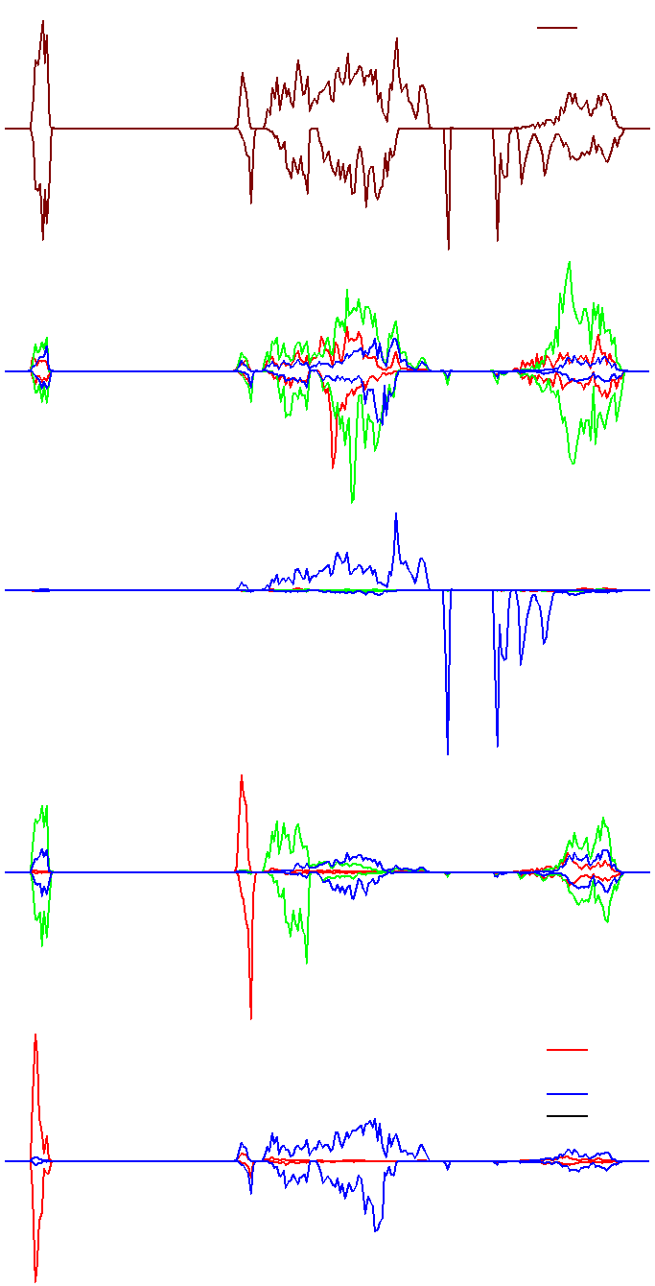
-1.0

-20 -15 -10 -5 0 5 10
TDOS
2.39 eV
Li
Fe
d fermi

E (eV)

0.4
0.2
0.0
-0.2
-0.4
-0.6
-0.8

-20 -15 -10 -5 0 5 10
E (eV)

(a)
(b)
(c)

Figure 3. Total and partial densities of states of LiMPO4 structures: (a) LiMnPO4, (b) LiFePO4 and (c) LiCoPO4

The total densities of states of LiMPO4 structures were calculated using the spin polarised DFT
approach and are presented in fig. 2.
( ) ∫ ( ) (2)

Thus
g(E)dE represents the number of states between E and dE .

We observe that all structures show relatively wide band gaps around the Fermi level. However the Fermi level falls with the 3d M band suggesting the metallic behaviour of the LiMPO4 systems, particularly for LiMnPO4 and LiFePO4. It is evident that LiMnPO4 shows more states around the Fermi level than LiFePO4 and LiCoPO4, respectively. On the other hand the partial densities of states show that states around the Fermi level are mainly due to contributions from transition metal, M 3d electrons.

3.3. Elastic properties
Elastic constants are calculated by means of a Taylor expansion of the total energy as follows:

( ) ( ) [∑ ∑ ] (3)

where U (V0 ,0) is the unstrained system energy, V0 is the equilibrium volume while τ i
and ξ i are
element in the stress tensor and factor to take of Voigt index, respectively. The orthorhombic olive LiMPO4 crystals have nine ( C11 , C12, C13 , C22 , C23 , C33 , C44 , C55 , C66 ) independent elastic constants [12] as listed in table 1. The necessary mechanical stability conditions for orthorhombic systems are given as follows:

(C11 + C22 − 2C12 ) > 0 , (C11 + C33 − 2C13 ) > 0 , (C22 + C33 − 2C23 ) > 0 ,
(C11 + C22 + C33 + 2C12 + 2C13 + 2C23 ) > 0 ,
C66 > 0
C11 > 0 ,
C22 > 0 ,
C33 > 0 ,
C44 > 0 ,
C55 > 0 ,

It is clear from table 1 that all the independent elastic moduli (Cij) are positive satisfying all the stability conditions; this suggests that all LiMPO4 crystals are elastically stable. Their resultant bulk modulus B, shear modulus G and Young’s modulus E were also obtained from the calculated elastic constants using the Hill method [13].

( ) (4)

( ) (5)

(6)

where V , R and H are Voigt, Reus and Hill, respectively.

The highest values of B, G and E, are obtained for LiFePO4, while LiMnPO4 and LiCoPO4 are comparable. The B and E values suggest hardness and stiffness, respectively of materials. Furthermore, we note that G is less than B for all structures, implying that the Shear modulus is the limiting parameter for stability [14].

4. Conclusions
First principle calculations on thermodynamic, structural, electronic and mechanical properties of
LiMPO4 crystals have been performed using the DFT approach. From the calculated properties, the stability trend within LiMnPO4, LiFePO4 and LiCoPO4 has also been determined. The calculated structural lattice parameters and equilibrium cell volume are in good agreement with the experimental data to within 3%. The predicted formation energies suggest that LiMnPO4 is the most stable structure over LiFePO4 and LiCoPO4, respectively. Moreover, the independent elastic properties have shown that LiMPO4 crystals are mechanically stable. There is a good correlation between the heats of formation and, the electronic densities of states, which are consistent with elastic stability.

Acknowledgements
This work has been done at the materials modelling centre, university of Limpopo, supported by the
national research foundation.

5. References

[1] Amine K, Yashuda H and Yamachi M 2000 Electrochem. and Solid-State Lett. 3 178

[2] Padhi AK, Nanjundaswamy K and Goodenough JB 1997 J. Electrochem. Soc. 144 1188 [3] Zhang Y, Sun C.S and Zhou Z 2009 Electrochem. Commun. 11 1183
[4] Nakayama M, Goto S, Uchimoto Y, Wakihara M and Kitajima Y 2004 Chem. Mat. 16 3399 [5] Wang L, Sun W, He X, Li J and Jiang C 2011 Int. J. Electrochem. Sci. 6 2022
[6] Kresse G and Furthmüller J 1996 Phys. Rev. B 54 11169 [7] Methfessel M and Paxton A 1989 Phys. Rev. B 40 3616
[8] Osorio-Guille´n JM, Holma B, Ahuja R and Johansson B 2004 Solid State Ionics 167 221

[9] Sanchez MAE, Brito GES, Fantini MCA, Goya GF and Matos JR 2006 Solid State Ionics 177 497 [10] Kubel F 1994 Zeitschrift fuer Kristallographi 209 755
[11] Li G, Azuma H and Tohda M 2002 Electrochem. Solid-State Lett. 5 A135

[12] Patil SKZ, Khare SV, Tuttle BR, Bording JK and Kodambaka S 2006 Phys. Rev. B 73

[13] Hill R 1952 Proc. Phys. Soc. A 65, 349

[14] Shein IR and Ivanovskii AL 2008 J. Phys. Conden. Mat. 20 415218

