Optical Properties of SiN:H thin films obtained by hydrogen dilution

S Jacobs¹, T F G Muller*, G F Malgas², and C J Arendse¹

¹Department of Physics, University of the Western Cape, Modderdam Road, Private
Bag X17, Bellville, 7535, South Africa

²CSIR National Centre for Nano-Structured Materials, P. O. Box 395, Pretoria,
0001, South Africa

E-mail: tmuller@uwc.ac.za

Abstract. Silicon Nittride (SiN) thin films were deposited on Corning 7059 glass and crystalline silicon <100> substrates. UV-VIS spectra were obtained in reflection and transmission modes on the silicon and glass substrate respectively, and the optical modelling was performed using a Bruggerman Effective Medium Approximation (EMA). Optical fits for the spectra were obtained using TFCompanion® and Scout® software. The mean square error function values for single layer homogenous materials on substrates indicate inaccurate fits and subsequent extracted optical properties of the material. Hence a virtual multi-layered approximation for a single film was adopted to describe a material that possesses dissimilar optical properties in its bulk compared to interface regions. In the EMA matrix Cauchy /OJL materials were mixed with particles required to describe SiN, and the results obtained for the different fits are contrasted in terms of their optical constants. .
Introduction
Amorphous silicon nitride (a-SiN) is a material with a high dielectric function, large tuneable band gap, and a low refractive index [1]. These properties allow SiN to be used in many industries, depending on the required structural and optical characteristics. Different deposition methods produce varying structural characteristics of the material, and in each specific system the required optical and structural properties of the thin film can be tuned and controlled through the conditions during the deposition. In Industry, the preferred method of manufacturing SiN is through the use of Plasma Enhanced Chemical Vapour Deposition (PECVD). Thin films produced by PECVD are of poor quality, and for use in industry may not be ideal. Recently an alternative method known as Hot Wire Chemical Vapour Deposition (HWCVD) has started gaining popularity [2].

Thin films deposited by PECVD as compared to those deposited by HWCVD are less dense due to the high hydrogen incorporation in the thin films [2]. Recently much focus has been placed on the manufacturing of SiN as an antireflective coating on top of microcrystalline silicon (mc-Si) solar cells. HWCVD offers high growth rates with stable, dense films exhibiting excellent optical and structural properties, in comparison to PECVD.

In this study SiN was deposited by diluting silane and ammonia with hydrogen in a HWCVD chamber. The total hydrogen content in the film influences the distribution of the Si-Si bonds [2], and in HWCVD-deposited films the atoms are tightly packed, which yields high-quality material, a consequence of the improved structural properties of thin films produced by HWCVD. For application as photovoltaic material the hydrogenated silicon nitride (SiN:H) thin films need to be optically characterised in order to determine the effects of light scattering, reflection and transmission off and through the surface and bulk of the thin film. The optical constants of the material, i.e. the refractive index (n) and extinction coefficient (k), which are related to the dielectric function (ε), can be computed over a range of wavelengths and subsequently the Tauc band gap [3] values (E_{g}) can be determined from the absorption coefficient (α). At present many mathematical models to describe the dielectric functions exist in literature and are used in experimental works to obtain the calculated optical constants. Since n and k cannot be calculated directly they are instead determined through an indirect measurement, which can be done in two ways [4]. The first method involves calculating and fitting the measured reflection and transmission ultraviolet-visible (UV-vis) spectra from the complex dielectric function of the material. The filmstack parameters are inferred from the best fit of the measured data to the data simulated/generated by using a suitable optical model of the filmstack. Another commonly used method for determining n and k of an amorphous semiconductor is through an inversion process as described by Swanepoel’s [5] envelope method.

In this work both methods are utilised and compared. Firstly, the model proposed by O’ Leary et al in 1997 [6] (OJL) is used in simulations and the results compared to those of the Cauchy [7] model for refractive index dispersion, and the Swanepoel method [5].
Experimental
The SiN thin films used in this study were produced by the thermal catalytic decomposition of silane, ammonia and hydrogen gas in a HWCVD chamber. The pressure within the chamber was set to 100 μbar for the duration of the deposition, with the tantalum (Ta) wire temperature at 1490 ⁰C. The substrate heater temperature was kept at 240 ⁰C while the source gas flow rates were kept at 20 sccm hydrogen, 5 sccm silane, and 7 sccm ammonia. The resulting thin films were deposited on both crystalline silicon <100> as well as Corning 7059 glass substrates; each used for the different characterisation techniques and reflection/transmission UV-vis geometry. The glass substrates were used for optical transmission measurements, as well as X-ray diffraction (XRD), while optical reflection measurements were performed on the silicon substrates. XRD was performed using a Panalytical X’Pert Pro system in reflection geometry utilising Copper Kα₁ radiation of wavelength 1.54 Å with a scan step-size of 2θ = 0.03°. UV-vis transmission measurements were performed on a Carey 1E UV-visible spectrophotometer over the range 400 to 850 nm while the reflection measurements were performed on a Semiconsoft MProbe Thin Film measurement system over a wavelength range of 300 to 800 nm. Surface roughness was measured with a Veeco Atomic Force Microscope (AFM) probe.
Results and Discussion

3.1 X-ray Diffraction and surface morphology
A diffraction pattern was obtained for the thin film deposited on the Corning 7059 glass substrate, and is shown in figure 1. The absence of crystalline peaks, and the presence of a broad amorphous ‘halo’ around 27°, signifies that the thin films are amorphous in nature, possessing no long range order.

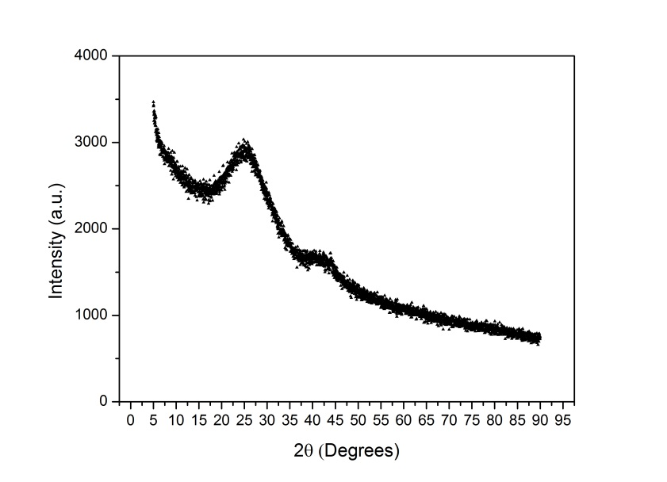
Figure 1: XRD pattern of SiN:H film on glass.
The root-mean-square surface roughness was measured using AFM and was determined to be 2 nm; this is in agreement to what was reported by Verlaan et.al [8] who reported values between 0.4 nm and 4.8 nm which can be attributed to the N/Si bonding ratios obtained by varying the deposition parameters [8].

3.2 Optical Modelling
The dielectric function of a material describes the behaviour of the material in response to an electromagnetic (EM) stimulus with certain photon energy. The dependencies of n and k on ε allow for the interpretation of the EM interaction with the material, which is normally generalised to the Cauchy dispersion model of the form $n\left(λ\right)= N_{0}+ \frac{N_{2}}{λ^{2}} + \frac{N_{4}}{λ^{4}}$. In the expression N_{0,} N₂, and N₄ are fitting parameters for a generalised dispersion relation, which holds up well in the visible region [9]. In TFCompanion® software [10] the parameters are determined by fitting a parameterised material with a known dispersion relation to the Cauchy equation. The calculation is carried out through a Marquardt-Levenberg iterative process. The calculated spectra are then fitted onto the measured spectra and a mean square error (MSE) is calculated. On the other hand the software program Scout® [11] implements the OJL-modified density of states (DOS) theoretical framework in its calculations. The DOS of a system describes the number of available sites per unit of energy at each sequential energy level that may be occupied by electrons. The OJL modelling approach in describing the dielectric functions of such materials is founded on the principals of the DOS for amorphous semiconductor materials. The OJL approach assumes that the valence and conduction DOS follows a parabolic function with the tail regions decaying exponentially into the forbidden region (band gap) [6]. It also allows for transitions between the band and the tail regions in the DOS function [6] and the extent of the tailing into the band gap region. Initial guesses for each parameter were selected and the simulation was allowed to run its course. A downhill simplex method was employed in the optical fitting regime with an automatic fitting process; this ensures that the deviation between the spectrum and the fit is kept to a minimum.

The growth of the thin film on the substrate is dependent on the substrate position relative to the hot filament; the variation in position causes inhomogeneity in the film growth. The heterogeneous nature of the thin films does not only relate to the thickness profiles of the deposited film on the substrate, but also to the material properties. Heterogeneity in the structure leads to heterogeneity in the optical spectrum and optical properties as well, and the use of a simple, single material model (Cauchy or OJL) to describe the thin film system is ineffective. Thus more complex models consisting of composite materials are needed. In this work the Bruggerman Effective Medium Approximation [12] (BEMA) is used to describe the heterogeneous thin film material. The BEMA consists of a host matrix with an embedded particle having a separate dielectric function from the host. The effective dielectric function on a macroscopic level can be used to describe the overall optical characteristics of the material. The BEMA function can be expressed mathematically as $\sum_{i}{f_{i}}\frac{ε_{i}-ε_{eff}}{ε_{i}+2ε_{eff}}=0$ where ε_{i} represents the dielectric function of the i^{th} component in the composite system and f_{i} is its respective volume fraction. The EMA can describe the layer containing varying volume fractions of the composite materials, this leads to varying optical properties throughout the thin film. A host matrix was selected, either a Cauchy amorphous semiconductor (TFCompanion®), or an OJL amorphous semiconductor (Scout®). Particles of material that could be present in the material, such as silicon crystallites, and particles of air to represent voids, could have an influence on the optical properties of the material. The dielectric functions of these materials in the Bruggeman form were incorporated in the virtual material, as well as a mixture of non-stoichiometric and stoichiometric silicon nitride.

However, the use of a single EMA is also not sufficiently mathematically complex enough to describe the complex SiN material obtained by the dilution of hydrogen in silane and ammonia, as shown in figure 2. The OJL model is able to approximate some of the interference fringes, whereas the Cauchy cannot. This necessitated the construction of a multi-layered EMA model [13] to represent one film. The optical models consisted of three layers as well as a fourth oxide surface layer, where each virtual layer represents a section of the thin film. The third layer constitutes of an intermediate layer between the substrate and the bulk of the film, where initial film growth took place. The bulk or middle layer is usually found to be the thickest layer and contributes most to the overall optical properties of the film. The first layer represents the final growth phase of the thin film, the settling of the final radicals after power has been cut to the hot filament, or the shutter controlling deposition has been inserted between the film surface and hot filament. Post deposition oxidation occurs as soon as the thin film is exposed to atmosphere. This occurs due to the structural characteristics of the thin film at the surface, and necessitates the insertion of a thin oxidation layer on the surface of the film to accurately model the real film structure, and thus realistically approximate the optical properties of the thin film. Cauchy and OJL optical models incorporating EMA particles were thus built according to the inhomogeneous virtual layer set up as described above. Figure 2 displays the resulting fits for each model type on the reflection and transmission spectrum respectively.

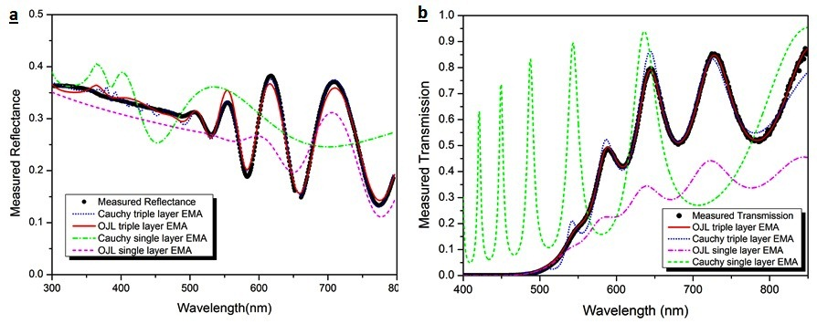

Figure 2: Measured and calculated spectra for (a) reflection and (b) transmission modes.
Excellent fits were achieved with the modelling for the OJL + EMA virtual multi-layered structure especially. The Cauchy dispersion formula is an empirical mathematical formula, and does not take into account the effects of defect states and band tailing. Its results are not consistent with the two other methods. The OJL model on the other hand describes how the dielectric function of the material is affected by the defect states, band tailing and the interaction path of the light as it travels through the material. It is hence a genuine description of a semiconductor. For this reason we favour the results obtained by OJL modelling over the application of a Cauchy type. For the virtually layered structure we now obtain the overall absorption coefficient of the thin film from Beer’s Law [14] as a weighted average of the absorption coefficient by thickness, namely$\sum_{i=1}^{n}{\frac{α_{i}X_{i}}{X_{T}}}$, where α_{i} represents the absorption coefficient of the i^{th} layer, and X_{T} the total thickness of the thin film [13].The absorption coefficient obtained from the 3-layer OJL + EMA reflection spectrum closely follows the absorption coefficient obtained from the 3-layer OJL + EMA transmittance spectrum over the energy range, whereas the absorption coefficient obtained from the Swanepoel [5] method starts to diverge at higher energies.

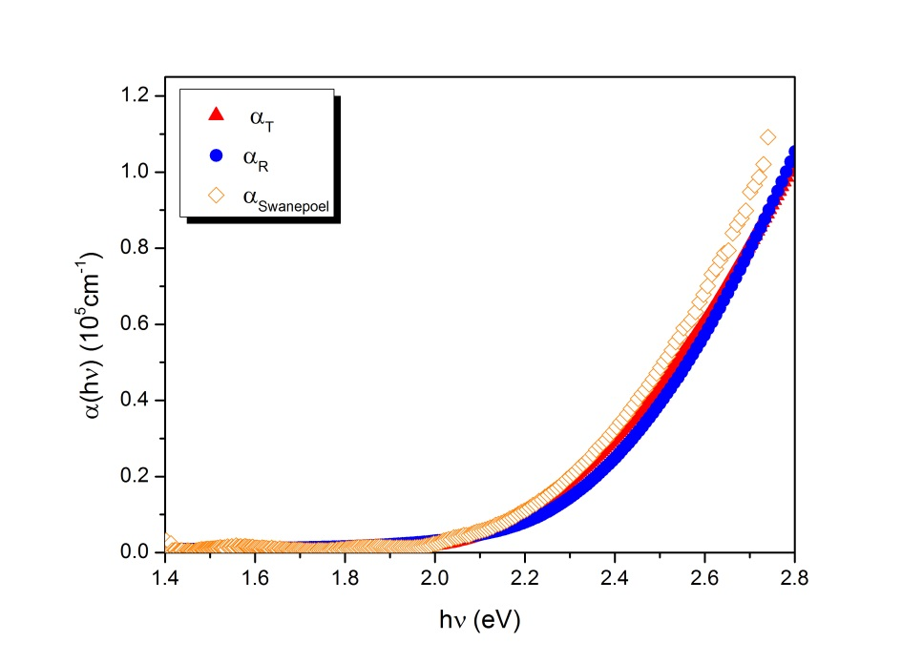

Figure 3: Plots of absorption coefficient obtained from the 3-layer OJL + EMA modelling.

For comparison we have extracted the optical constants and energy values for the material by different modelling approaches in Table 1 below. Similar values for n_{o} of the OJL model have been observed by Holt [15].

Table 1. Calculated optical constants and energies for 3 layer filmstack.

Spectra | Modelling Type | n₀ | E_{g} (eV) | E (eV) at α₁₀⁴ | X_{T} (nm) | Deviation/ MSE
Reflectance | Cauchy | 2.78 | 2.64 | 3.07 | 489 | 8.00 × 10⁻²
 | OJL | 2.53 | 2.06 | 2.25 | 642 | 6.64 × 10⁻⁴
Transmission | OJL | 2.52 | 2.00 | 2.19 | 800 | 2.25 × 10⁻⁵
 | Swanepoel | 2.51 | 2.08 | 2.19 | 805 | 1 % error
 | Cauchy | 1.03 | 1.99 | 3.20 | 1504 | 9.10 × 10⁻²

Table 1 displays the superior nature of the 3-layer OJL optical model for both the reflection and transmission results compared to the Cauchy model. The difference in thickness evident from the modelling of reflection and transmittance spectra, utilising the same 3-layer OJL model, is due to the positioning of the two substrates relative to the parallel filaments in the reaction chamber. Substrates positioned directly underneath the filament normally grow thicker films on top. The close matching of the optical functions displayed in the table above indicates that the structural properties of the thin films grown on the two substrates are the same.
Conclusion
The a-SiN:H thin films obtained by the dilution of ammonia and silane in hydrogen was found to be too complex to characterise conventionally by single layer optical models, and more thought must be given to construct a virtual analogy of the physical system under consideration. Data were extracted from the virtual multi-layered assumption for the different approaches and the values of the optical constants compared. From the results it is evident that the values obtained from the OJL modelling are fairly consistent whether the reflection or transmission spectrum is considered, and can account for effects of crystallinity in materials that show up in reflection spectra

References
[1] F. Giorgis, C. F. Pirri, E. Tresso, 1997, Thin Solid Films 307, 298.
[2] B. Stannowski, J.K. Rath, R.E.I. Schropp, 2003, J. Appl. Phys. 93, 2618.
[3] J. Tauc, 1968, Materials Research Bulletin 3, 37.
[4] A. Solieman, A.A. Abu-Sehly, 2011, Materials Chemistry and Physics 129, 1000.
[5] R. Swanepoel, 1983, J. Phys. E.: Sci. Instrum. 16, 1214.
[6] S. K. O’Leary, S.R. Johnson, P.K. Lim, 1997, J. Appl. Phys. 82, 3334.
[7] Jai Singh (ed), Optical Properties of Condensed Matter and Applications, John Wiley & Sons Ltd,
Chichester, England, 2006.
[8] V. Verlaan, ‘Silicon Nitride at high growth rates using hot wire chemical vapor deposition’, PhD Thesis,
Utrecht University, Netherlands, 2008.
[9] F. A. Jenkins, H. E. White, ‘Fundamentals of Optics, 3rd Edition’, McGraw-Hill Book Company, 1957.
[10] TFCompanion Thin Film Analysis Software (2008) manual, www.semiconsoft.com, retrieved 13 October
2011.
[11] Scout spectrum interpretation by simulation software (2008) by W.Theiss, www.mtheiss.com, retrieved 6
August 2010.
[12] D.A.G. Bruggeman, 1935, Ann. Phys. (Leipzig) 24, 636.
[13] T.F.G. Muller, C.J. Arendse, S. Halindintwali, D. Knoesen, R.E.I. Schropp, 2011, Thin Solid Films 519,
4462.
[14] K. J. Laildler, J. H. Meiser, ‘Physical Chemistry, 2nd Edition’, Houghton Mifflin Company, Boston, 1995.
[15] J. K. Holt, ‘Hot-wire Chemical Vapor Deposition of Silicon and Silicon Nitride for
Photovoltaics:Experiments, simulations, and applications’ ,PhD Thesis, California Institute of Technology,
California, U.S.A., 2003.

* To whom any correspondence should be addressed.

