Optimization of biogas by co-digestion using a field-scale bath digester

P Mukumba¹, G Makaka¹, S Mamphweli², E Meyer²
University of Fort Hare, ¹Physics Department, ²Institute of Technology, Private Bag X1314, Alice 5700.

E-mail: pmukumba@ufh.ac.za

Abstract. Biogas technology converts organic wastes into biogas, which consists of about 80% methane. The digester effluent after digestion can be used as manure. Co-digestion of organic wastes involve mixing of various substrates in varying proportions. The investigation was carried out using a field batch biogas digester. Fresh goat dung and horse dung were collected from the University of Fort Hare Honey dale farm. The latter substrates were analyzed for total solids (TS), volatile solids (VS), total alkalinity (TA) and calorific value (CV) before they were co-digested in a bath biogas digester in different mixing ratios. The biogas composition for each sample was analysed using a Non-Dispersive Infrared gas sensor, which detects methane gas up to 100% volume. The study found that a mixing ratio with 40% horse dung and 60% goat dung produced biogas with the highest methane yield. Therefore, biogas yield was influenced by variations in mixing ratios as well as waste types used.

1. Introduction
South African economy is highly dependent on fuel fuels, with coal accounting for about 90% of electricity generation. Fossil fuels have many negative impacts on the environment, which include, environmental degradation, climate change and human health problems (Elaiyaraju and Partha, 2012). After the ratification of UNFCCC and Kyoto Protocol respectively in August 1997 and July 2002, the South African government embarked upon numerous projects related to climate change, including projects that have been intended as measures to reduce greenhouse gases (Mwakasonda 2007). One measure taken by the country to reduce greenhouse gas emissions was anaerobic digestion by use of biogas digesters in rural areas. Anaerobic digestion is the production of biogas mainly methane from organic wastes in complete absence of oxygen by anaerobic aerobes such as acetogens, acidogens and methanogens.
Numerous studies have been conducted by several researchers in order to optimize biogas yield in anaerobic digestion (Iyagba et al., 2009; Li et al., 2011; Misi 2001; Mukumba et al., 2011; Uzodinma et al., 2009). These studies established that using co-substrates in anaerobic digestion system improves the biogas yield due to positive synergisms established in the digestion medium and supply of missing nutrients by the co-substrates. The co-digestion of organic wastes involves mixing of various substrates in varying proportions (Misi, 2001).
The aim of the paper is to optimize biogas production by co-digestion. The biogas digester substrates used for co-digestion were goat dung and horse dung. These wastes were co-digested at different mixing ratios.
2. Methodology
2.1. Source of substrate and mixing proportions
Fresh goat dung and horse dung were collected from University of Fort Hare Honey dale farm. The goat dung was in form of pellets. The goat dung and horse dung were mixed in different proportions. Table 1 shows the mixing proportions for horse dung and goat dung. Lime was added to each prepared sample to inhibit pH fluctuations within the biogas digester.

Table 1. Mixing proportions for horse dung and goat dung
Treatment | % of horse dung | % of goat dung
A | 0 | 100
B | 40 | 60
C | 50 | 50
D | 60 | 40
E | 75 | 25
F | 100 | 0

2.2. Substrate parameters
Before mixing the substrates, the following parameters for the substrates were determined, pH, total solids (TS), volatile solids (VS), ammonia-nitrogen (NH₄ - N), total alkalinity (TA), temperature (T) and caloric value (CV). All the analytical determinations were performed according to the standard methods for examination of water and waste water (ALPHA, 2005). The temperature of slurry was measured by type-K thermocouple, while the digital pH meter measured the influent and effluent pH.
2.3. Biogas analysis
The biogas composition was analysed by the biogas analyser. The biogas analyser consisted of Non-Dispersive Infrared sensor for sensing methane and carbon dioxide and Palladium/Nickel sensor for sensing hydrogen and hydrogen sulphide. Figure 1 shows the biogas data acquisition system that includes a biogas analyser.
CO₂ sensor
Gas pump
H₂ sensor

Hydrophobic
Filter
Flow meter
Laptop
Data logger
12V battery
H₂S sensor
CH₄ sensor
Biogas tube

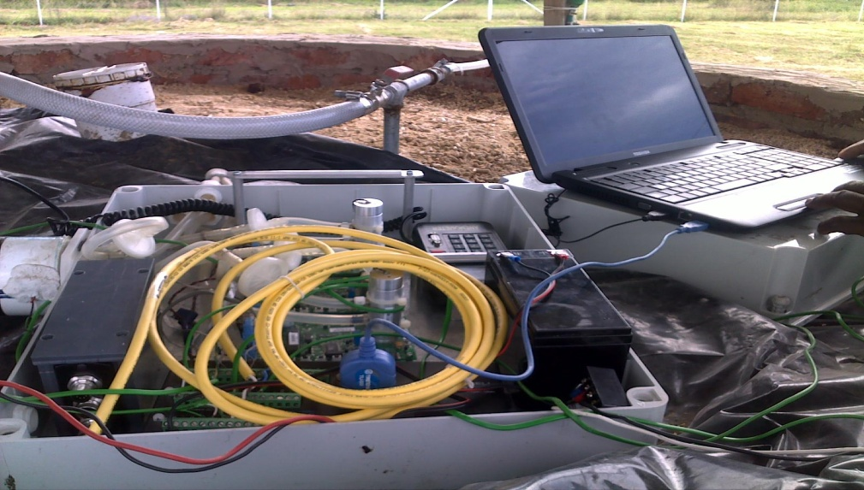
Figure 1. The data acquisition system
The data for biogas composition was recorded by a CR1000 data logger at a time interval of 2 minutes. The biogas analyser and the CR1000 data logger were powdered by a 12 V DC battery that was connected to a 20 W photovoltaic module. The biogas was carried to the flow meter where the production of the biogas was measured. A CR1000 data logger was interfaced to a laptop computer used to download data. The ambient, biogas, sawdust and slurry temperature sensors were connected to the data logger. The 12V battery was connected to the solar photovoltaic module via the battery regulator. The battery regulator prevented the 12V battery from excessive charging and discharging.
3. Results and discussions
Substrate characteristics of the horse dung and goat dung are shown in Table 2. The horse dung had less volatile solids than the goat dung. The TS/VS ratio of donkey dung was 72.11 and for goat dung was 64.16. Karim et al., 2005, found that as the TS/VS ratio is increases, the amount of methane production increases. The goat dung had a higher pH than horse dung.
Table 2. Substrate characteristics for goat and horse dung
Parameter | Goat dung | Horse dung
Total solids (mg/L) | 642796.16 | 269515.67
Total solids (%) | 64.28 | 26.95
Volatile solids (mg/L) | 463500.53 | 172934.47
Volatile solids (%) | 72.12 | 64.16
Total solids/ volatile solids (%) | 72.11 | 64.16
Total alkalinity (mg/L) | 62136-65789 | 62361-65897
pH [average] | 7.75-7.82 | 7.34-7.36
Calorific value (MJ/g) | 27.28 | 26.40
Ammonia-nitrogen (mg/L) | 175-226 | 232-250

Table 3 shows substrate parameters for horse dung and goat dung in different mixing ratios. There were variations of methane content among different treatments. Goat dung had a biogas composition with higher methane yield than horse dung. Co-digestion of goat dung and horse dung at different mixing ratios increased methane content in biogas. The 40% horse dung and 60% goat dung had the highest methane yield of 60-75%. The 50% horse dung and 50% goat dung also produced biogas of high methane yield content of 58-75%. The 75% horse dung and 25% goat dung had the lowest methane yield for all the co-substrates used between 55-65%.
Table 3. Composition of biogas for different substrates with different mixing ratios
 | 0%,horse 100%,goat dung | 40% horse,60% goat dung | 50% horse,50% goat dung | 60% horse, 40% goat dung. | 75% horse, 25% goat dung | 100% horse, 0% goat dung
CH₄% | 45-58 | 60-75 | 58-75 | 55-73 | 55-65 | 40-55
CO₂% | 30-45 | 25-35 | 30-40 | 28-40 | 30-45 | 40-50
H₂S% | trace | trace | trace | trace | trace | Trace
H₂% + other gases | 1-10 | 1-6 | 1-6 | 1-6 | 1-6 | 1-8

Biogas yields for different samples with different mixing ratios are shown in Figures 2 and 3. Figure 2 shows biogas yield for goat dung and horse dung. The biogas production started soon after seeding the biogas digester with active inoculums, and kept increasing until reaching the peak and then began to decline. The retention time was 23 days for the trials. The goat dung produced the highest biogas yield of 900 litres on day 12, while horse dung produced the highest biogas yield of 813 litres on day 13. There was difference of 87 litres between the two peaks of cow dung and horse dung. The cumulative biogas yield of cow up to the peak was 4670.19 litres. This was 63% of the total biogas yield within a hydraulic retention period of 23 days. However, cumulative biogas yield of horse dung up to the peak was 4492.52 litres. This was 63% of the total biogas yield within a hydraulic retention period. For goat dung, as from day 13, there was a decrease in biogas production until the production levels off, while for horse dung, biogas production decreased as from day 14. On average, the biogas production from goat dung was 336 L/day and for horse dung was 324 L/day. It was observed that in all trials there was very low gas production after a retention time of 20 days. This indicated that the gas content within the substrate was almost given off.
Goat dung had slightly a higher biogas yield than horse dung. This has been attributed by its high TS/VS ratio. Goat dung is easily biodegradable as compared to horse dung. Theoretically, horse dung produces more biogas than goat dung because of its carbon/nitrogen ratio of 25:1. Horse dung does not have the right bacteria in their guts to digest cellulose in plant material unlike goat dung. The dung is made of indigestible matter. The subsidiary peaks in the gas production in horse dung are a result of the presence of high lignin and cellulose in the wastes which are resistant to enzymatic degradation and hence, biogas production is low. There are more peaks for mono-digestion than when horse dung is digested with other wastes. Pre-treatment of horse dung by use of grinding would greatly increase biogas production thereby minimizing these peaks. Minor peaks are seen on mono-digestion on goat dung. Biogas production increased when goat dung and horse dung were co-digested together at different mixing ratios. This is consistent with other researches that stated that more than one kind of substrate could establish positive synergism in the biogas digester (Iyagba et al., 2009; Li et al., 2011; Misi 2001; Mukumba et al., 2011; Uzodinma et al., 2009).

Figure 2. Biogas yield for horse and goat dung

Figure 3 shows biogas production in litres for co-digestion of 40% horse dung and 60% goat dung, 50% horse dung and 50% goat dung, 60% horse dung and 40% goat dung, 75% horse dung and 25% goat dung. The highest biogas yield was made up of 40% horse dung and 60% goat dung. This was followed by the treatment made up of 50% horse dung and 50% goat dung. The mixing ratio of 75% horse dung and 25% goat dung produced the lowest biogas yield. This was attributed by an unstable pH resulting in poor buffering, thus lowering biogas production. The retention time for the co-digested trials was 23 days. The mixing ratio of 60% horse dung and 40 % goat dung produced a peak cumulative biogas yield of 64% in 11 days which was 6044 litres while the mixing ratio of 75% horse dung and 25 % goat dung, produced cumulative biogas yield of 5825 litres in 12 days. However, the mixing ratio 50% horse dung and 50% goat dung produced cumulative biogas yield within the first 11 days which was 61% of the total biogas yield which was 6498 litres. For the 40% horse dung and 60% goat dung, the maximum biogas yield was 6776 litres which was 62% of the total biogas yield attained in the first 10 days. However, for all the co-substrates used there was a decrease in biogas production until the production levels off.
The average biogas production per day, for the 60% horse dung and 40 % goat dung, for the 75% horse dung and 25 % goat dung, for the 50% horse dung and 50% goat dung and for the 40% horse dung and 60% goat were 429 litres, 401 litres, 484 litres and 500 litres respectively.

Figure 3. Biogas yield for the treatments

The co-digestion of 40% horse dung and 60% goat dung produced the highest biogas with the highest methane content. The co-digestion of 40% horse dung and 60% goat dung produced the higher yield of methane content of 60-75% than previous studies on co-digestion of horse dung with sludge that produced biogas with a methane yield of about 67% (Agayev and Egurglu 2011). Horse dung has a carbon: nitrogen ratio of 25:1 (Fulford, 2001), while goat dung has a ratio of 12:1 (Nijaguna, 2002). This means horse dung has a high carbon-nitrogen ratio than goat dung. Therefore, co-digestion of horse dung and goat dung increases biogas yield due to supply of mixing nutrients to the co-substrates.
Treatment made up of 60% horse dung and 40% donkey dung had few subsidiary peaks than the treatment made up of 75% horse dung and 25% goat dung. The peaks are an indication of high ligninostic material in horse dung that disturbed methanogenesis processes. It was observed that increase in lignin-cellulosic wastes resulted in unstable pH which is associated with poor buffering causing volatile fatty acids accumulation. Consequently, biomethation processes were affected due to the increase in acids which could not all be taken up by the methanogens. This increased acidic conditions of the methanogens. Hydrolysis and acidifying micro-organisms prefer an acid environment (pH 4.5 to 6.0). However, methanogens prefer neutral conditions with pH between 6.8 and 7.5. Most methanogens will die if pH is below 6.6. Therefore, to produce more biogas from horse dung, pretreatment techniques such as grinding of the dung to increase its biodegradability should be applied. In all digestion trials the temperature ranges between 29 - 33 °C.

4. Conclusion
There were variations in methane content for different treatments. The highest biogas yield with the highest methane content was obtained from mixing ratio 40% horse dung and 60% goat dung. However, the mixing ratio of 75% horse dung and 25% goat dung produced the lowest biogas with the lowest methane yield. It can be concluded that co-digestion horse dung and goat dung greatly increases biogas. However, for higher biogas yields, pre-treatment of horse dung is required before co-digestion. Analysis of the results reveals that biogas potential can be enhanced by addition of lime (calcium oxide) that inhibits pH fluctuations especially when horse dung is used as a co-substrate.

5. References
- Agegev E and Ugurlu A 2011 Biogas production from co-digestion of horse manure and waste sewage sludge June 13-14 technol. conf.
- American Public Health Association (ALPHA) 2005 Standard methods for Examination of Water and Waste Water (Washington DC: WEF)
- Elaiyaraju P and Partha N 2012 Biogas production from co-digestion of orange peel waste and jatropha de-oiled cake in an anaerobic batch reactor. African J. of Biotechnology 11 3339-3345
- Fulford D 2001Running a Biogas Programme (UK: ITDG Publishing)
- Han M J Behera S K and Park H S 2012 Anaerobic co-digestion of food waste leachate and piggery wastewater for methane production: Statistical optimization of key process parameters J. of Chemical Technology and Biotechnology
- Hill D T and Botte J P 2000 Methane Production from the Low Solid Concentration liquid Swine Waste using Convectional Anaerobic Fermentation Bioresource Technology 74 241
- Iyagba E l, Mangibo I A and Mohammad 2009 The study of cow dung as co-substrate with rice husk in biogas production Scientific Research and Essay 4 861-866
- Karim K, Hoffmann R, Klasson T and Al-Dahhan 2005 Anaerobic Digestion of Animal Waste, Waste strength versus impact of mixing Bioresource, Technol. 96 1771-1781
- Kshirgar M P, Arora A and Chandra H 2010 Estimation of anaerobic co-digestion potential of Agricultural waste in India and comparative financial analysis International J. of sustainable energy 31 175-188
- Li J, Jha A K, He J, Ban Q, Chang S and Wang W Assessment of dry anaerobic co-digestion of cow dung with waste water sludge on biogas yield and bio-degradability International J. of Physical Sciences 6 3679-3688
- Misi S N 2001 Anaerobic Co-digestion of Agro-industrial Wastes for Optimum Biogas Production, PhD Thesis, University of Birmingham
- Mukumba P, Makaka G and Mamphweli S 2011 Batch anaerobic co-digestion of cow dung and donkey manure Proc. of SAIP 2011 SA Institute of Phys. 701-706
- Mwakasonda S A 2007 South Africa Low Carbon Scenario Report (University of Cape Town: Energy Research Centre)
- Naomichi N and Yutaka N 2007, Recent development of anaerobic digestion processes for energy recovery from wastes J. Biosci. Bioeng 103 105-112
- Nijaguna B T 2002 Biogas Technology (New Delhi: New Age International (P) Limited, Publishers)
- Uzodinma E O, Ofoelule A U, Eze J I, Mbaaeyi I and Onwuka N D Effect of some organic wastes on biogas yield from carbonated soft drinks sludge Sci. Res. Essays 3 401-405

