Ability of a mixture of sulfonated Zinc-phthalocyanine (ZnPcSmix) to induce cellular death in human breast cancer cells (MCF-7) using laser irradiation

**I M Tynga, N N Houreld and H Abrahamse1**

Laser Research Centre, Faculty of Health Sciences, University of Johannesburg, P.O. Box 17011, Doornfontein, South Africa, 2028, Tel: 27(0)115596406

Email: [habrahamse@uj.ac.za](mailto:habrahamse@uj.ac.za)

**Abstract**. *Background:* Breast cancer is the most diagnosed and the leading cancer for women worldwide. Photodynamic therapy (PDT) is a light induced chemotherapy process; used for cancer treatment. This study aimed to determine the effects of ZnPcSmix on MCF-7cells and identify the mode of cell death induced by PDT using the optimum ZnPcSmix concentration and laser fluency. *Methods:* The ability of a mixture of sulfonated Zinc-phthalocyanine (ZnPcSmix) to induce death in MCF-7 cells was determined after the following techniques and assays were performed: subcellular localization (fluorescence microscopy), viability (trypan blue staining and adenosine triphosphate, ATP, luminescence), proliferation (alamarBlue assay) and cytotoxicity (Lactate Dehydrogenase, LDH). The mode of cell death was determined by flow cytometry (Annexin-V). *Results:* Mitochondrial, lysosomal and Golgi apparatus were the cellular primary localization sites of ZnPcSmix. The optimal parameters were identified as 0.5 μM of ZnPcSmix at 10 J/cm2 and treated cells showed a 50% decrease in cell viability, low proliferation and high cytotoxicity. More than 90% of cells were apoptotic and nuclear fragmentation occurred after treatment. *Conclusion:* The treatment is an effective method to induce cell death in MCF-7 cells and apoptosis was the main mode of cell death. ZnPcSmix mediated PDT may be considered for designing a more effective cancer treatment.

1. Introduction

Cancer refers to a genetic disorder that is the second cause of death worldwide after heart-related conditions [1]. Many types of cancer exist and cancer of the breast accounts for 23% of cancer cases. Breast cancer is the most diagnosed and the leading cause of mortality among women worldwide [2,3]. It is believed that cancer can be overcome through research, which aims to identify and develop anti-cancer means to deal with the condition.

Photodynamic therapy (PDT) is a cancer target therapy, which uses a photochemotherapeutic agent, also known as a photosensitizer (PS), in conjunction with laser irradiation to induce cancer cell death. The administration of PS and its incorporation into body tissues is done in a selective manner so that cancerous tissues are mainly affected. The activation of PS is the second step which is done through laser irradiation at a specific wavelength, which is dependent on the PS. Activated PS is excited and promoted from the ground state to a higher level of energy, known as the singlet state, which reacts with oxygen and gives rise to free radical species to destroy tissue [4,5]. Phthalocyanines are a second generation family of PSs that contain a central atom. The atom ensures not only high triplet state quantum yields but also a prolonged lifespan in this state [6,7].

In this study, the photosensitizing capabilities of ZnPcSmix were assessed and a dose dependent study on a breast cancer cell line (MCF-7) was done. The mode of cell death was also determined.

1. Methods

MCF-7 cells are derived from a human breast cancer cell line and were first isolated from a Sexagenarian lady at the Barbara Ann Karmanos Cancer Institute in Detroit. The MCF-7 breast cancer cell line (ATCC: HTB 22) is an adherent cell line and commercially available. MCF-7 cells were grown as a monolayer and attached to the bottom of cell culture flasks. Cells were grown to 85% confluence in 25 ml complete DMEM (Gibco Invitrogen Corporation, 41966). DMEM was supplemented with 10% (v/v) FBS (Gibco Invitrogen Corporation, 10106), 1% (v/v) penicillin-streptomycin (PAA Laboratories GmbH, P11-010) and 1 µg/ml Amphotericin B (PAA Laboratories GmbH, P11-001) in an 85% humidified atmosphere at 37°C and 5% CO2. The cells were incubated at 37˚C, in 5% CO2 and 85% humidity throughout the study and frequently observed to monitor cell growth. Ethics approval was obtained from the Faculty of Health Sciences Academic Ethics committee of the University of Johannesburg to perform this study (AEC58/01-2010). Cells were seeded at a concentration of 6 x 105 cells in 3 ml culture media into 3.3 cm diameter culture dishes and incubated for 4 h to allow cells to attach. Cell cultures were divided into 4 groups (G): G1 was an unirradiated control with no ZnPcSmix, G2 contained ZnPcSmix but was not irradiated and G3 was irradiated but contained no ZnPcSmix. G4 was irradiated and contained ZnPcSmix. The last group of cells (G4) were treated using one of the 4 concentrations of ZnPcSmix and one of the three laser fluences to monitor PDT. All laser irradiations were done in a dark room. A 680 nm diode laser was used with an output power of 45 mW. The laser irradiation was delivered to the cells at a distance and the irradiance spot size was 9.1 cm2 covering the exact surface of the culture dish. Cells were irradiated for 16 min 50 s, 33 min 40 s and 50 min 30 s in order to receive a fluence of 5, 10 and 15 J/cm2 respectively. All samples were incubated for 24 h and thereafter dose response was determined. *Cell viability:* All cells were stained with 0.4%trypan blue and percentage viability was determined. ATP present in each sample was quantified by recording the luminescence signal. *Cell proliferation:* Cells were treated with 10% alamarBlue and absorbances were detected at 550 nm. *Cytotoxicity:* Membrane integrity was assessed and LDH was measured at 490 nm [8]. *Fluorescence staining:* G2 cells were stained with 4',6-diamidino-2-phenylindole (DAPI) and either mitotracker or lysotracker before being examined [8]. *Cell death*: PDT cells (0.5 μM ZnPcSmix; 10 J/cm2) were treated with annexin-V and Propidium iodide (PI) before cell death was measured [9]. Significant differences were indicated as * p<0.05, ** p<0.01 and *** p<0.001 were considered at the 95th percentile.

1. Results and Discussion

*Cell Viability*: Trypan blue exclusion test was done to obtain the proportion of viable and damaged cells in different treated cell population. Laser irradiated or cells that contained ZnPcSmix alone maintain high percentage viability and do not differ much from the percentage viability of the untreated control cells. However, PDT-treated cells differ as the percentage viability significantly decreased (p< 0.1 and 0.01) when higher ZnPcSmix concentrations (0.5 and 1 µM) coupled with at least 10 J/cm2 of laser fluence were used.

ATP did not vary when compared to the untreated control and a similar observation was done for cells that contained ZnPcSmix alone or only irradiated cells as no statistically significance was seen. PDT cells treated with at least 0.1 µM concentration of ZnPcSmix, showed major ATP depletion (p<0.1; 0.01 and 0.001) in a dose dependent pattern (figure 1).

*Cell proliferation*: AlamarBlue assay was performed to determine the degree of cell proliferation. Decrease in cell proliferation was observed with all treated cells and no statistical significance was noted with cells that irradiated or contained ZnPcSmix alone. When compared to control MCF-7 cells, significant decrease (p<0.1 and 0.01) in cell proliferation was mostly observed when 0.5 and 1 µM ZnPcSmix was used in PDT treated cells (figure 2).

*Cytotoxicity*: The assay was performed and the level of LDH released into the culture media was taken into consideration to elucidate cell damage especially cell membrane damages subsequent to ZnPcSmix-mediated PDT applied to MCF-7 cells. After 24h of incubation, PDT induced an increase in cell membrane damage as a rise in the level of LDH significantly detected (p<0.1 and 0.01) in each sample when compared to the untreated MCF-7 cell control (figure 2).

*Photosensitizer localization*: Figure 3 shows successful ZnPcSmix cellular uptake, cell staining (blue DAPI, green mito- and lyso-tracker) as well as the initial subcellular localization of ZnPcSmix in MCF-7 cells after less than 1 h incubation. In the merged picture of both cases, there is an overlapping of red ZnPcSmix and green lyso-/mito-tracker colour giving rise to an intermediate yellowish tint, but no evidence of an overlapping between the red and blue DAPI colouration as both dyes are separately identified in the merged image.

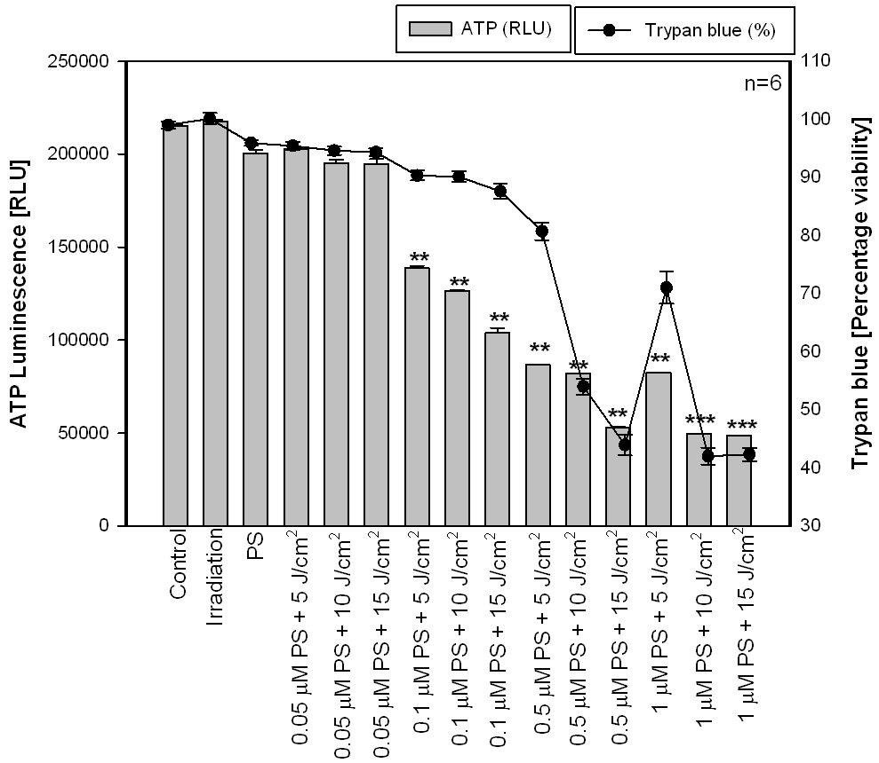

**Figure 1:** Decrease in ATP luminescence (measured in relative light units, RLU) and trypan blue percentage viability is seen with all PDT samples and no significant change was observed with irradiation- and PS-treated samples. Statistical differences were indicated as * (p<0.1),** (p<0.01) and *** (p<0.001) and compared to the reference control group.

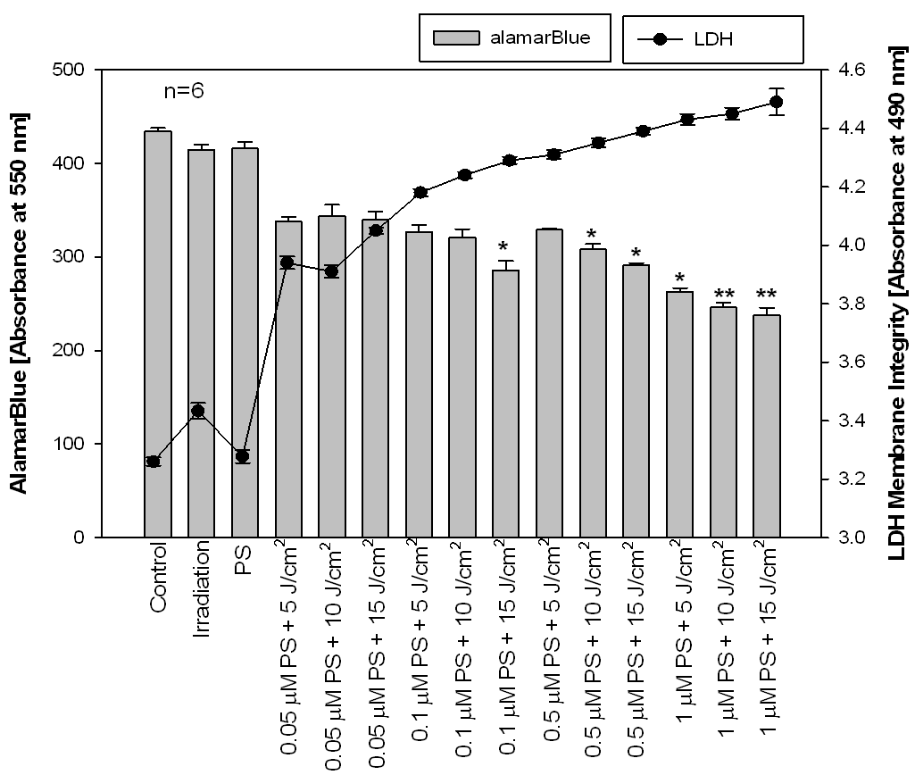

**Figure 2:** The cytodamage was significant with all PDT samples (LDH) and PDT treated cells have a slow proliferation rate (alamarBlue). Statistical significances are expressed * (p<0.1),** (p<0.01) and *** (p<0.001)and compared to the control group. No major change was identified with irradiated and PS-treated samples.

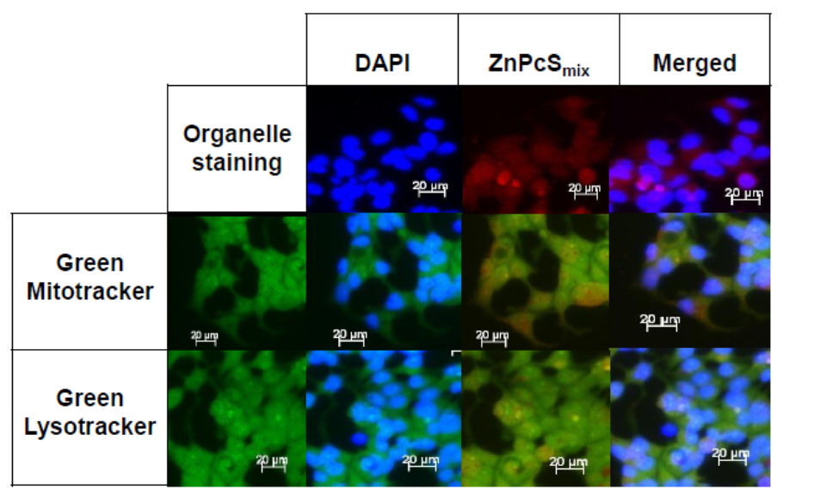

**Figure 3:** Blue DAPI is a dye that stains the nuclei, green mitotracker and green lysotracker stain mitochondria and lysosomes, respectively. Red ZnPcSmix localizes in both mitochondria and lysosomes as the intermediate yellow between green and red and not in nuclei (superimposed images). The PS localizes also in the perinuclear regions, which correspond to the golgi apparatus.



**Figure 4:** Flow cytometry analysis shows that 37% of cells were in the early apoptotic stage and 64.3% in the late apoptotic cells after PDT.

Fluorescence images reveal that ZnPcSmix localizes at perinuclear sites, which corresponds to the Golgi apparatus and this finding concurs with the work done by [10,11]. Mitochondria and lysosomes are the primary sites of ZnPcSmix, as red and green fluorescence merged to give the observed intermediate yellow fluorescence. It was shown that a similar Zinc (II) phthalocyanine localizes in the lysosomes and phthalocyanine delivery to the lysosomes is done via endocytosis [10]. Moreover, these lysosome localized-PSs accumulate in microzomes and in the mitochondria [11,12]. Mitochondria are important organelles in cellular energy metabolism and are important role-players in cell death. Under stress, release of mitochondrial proteins trigger cascades responsible for the changes to cell structure and functions resulting in apoptosis. Like any phthalocyanine, ZnPcSmix has a strong tendency to aggregate, is taken up and retained in the organelles of tumor cells, where upon light activation they induce cell death [13]. At higher concentrations, ZnPcSmix induces cell membrane damage following PDT and trypan blue dye entered cells through these damaged membranes. At the same concentration, the produced toxic derivative prevents the activities of mitochondrial energy metabolic enzymes and therefore decreases ATP levels. ZnPcSmix localized in golgi apparatus and mitochondria, might affect both protein and energy synthesis. Decreases in both percentage viability and ATP level was observed with A549 human lung cancer cells after PDT using a similar PS [8]. The drop in ATP levels correlate with the decrease in the proliferation of cancer cells. Cancer cells are high consumers of energy, less energy is available to cancer cells to perform their activities such as cell division. Wong and co-workers [14] reported a decrease in proliferation with FaDu hypopharyngeal carcinoma cells. These decreases might be due to the absence of sensitivity of PDT samples to cell stimulating factors.

This study has identified 0.5 µM ZnPcSmix and 10 J/cm2 as the PDT condition that induced approximately 50% of cell death in MCF-7 cells. The quasi totality of cells was found to be apoptotic with the majority in their late apoptotic stage. Tomecka and colleagues [15] reported that 32-65% of G361 tumor cells were undergoing apoptosis and early apoptosis occurred between 8-15 h after PDT treatment using ZnTPPS4 as a sensitizer.Chen and collaborators [16]also found out that PDT using motexafin Lutetium induces up to 35 % increase in the apoptosis of vascular cells. It was reported that the cell death is dependent on the cell line, photosensitising agent, and/or experimental conditions.

1. Conclusion

ZnPcSmix localizes in mitochondria, lysosomes and at the perinuclear sites, which correspond to the golgi apparatus and induced cytotoxic reactions leading to apoptotic like cell death responses. About 99 % of dead cells and nuclear fragmentation (not shown) were observed after ZnPcSmix mediated PDT treatment. This sensitizer at concentrations from 0.5 µM has demonstrated to be an effective inducer of cell death.

1. Acknowledgments

This work was conducted at the Laser Research Centre of the University of Johannesburg and supported by all the African Laser Centre, National Research Foundation and Medical research Council of South Africa. We thank Prof. Tebello Nyokong (Department of chemistry, Rhodes University, South Africa) for the synthesis and supply of the PS and both the National Laser Centre of the Council for Scientific and Industrial Research of South Africa is acknowledged for the supply and maintenance of lasers.

1. References

[1] Calin M A and Parasca S V 2006. *J Optoelectron Adv M* **8(3)**:1173-1179.

[2] van Zyl S, van der Merwe L J, Walsh C M, van Rooyen C and Groenewald AJ 2012 *PHCFM* **4(1)**:1-10

[3] Benn C A 2009 www.Health24.com/woman/medical accessed on 31 March 2010

[4] Castano A P, Demidora T N and Hamblin M R. 2004 *Photodiagn Photodyn* **1**:279-293.

[5] Mroz P, Szokalska A, Wu M X and Hamblin M R 2010 *J Pone* **5(12)**: 15194-15201.

[6] Ogunsipe A, Chen J Y and Nyokong T 2004 *New J Chem* **28**:822-827.

[7] Kessel D and Oleinick N L 2010*Methods Mol Biol* **635**:35-4

[8] Manoto S L and Abrahamse H 2011 *Lasers in Med Sci* **43**: 333-342.

[9] Van Engeland M, Nieland L J W, Ramaekers F C S, Schutte B and Reutelingsperger C P M 1998 *Cytometry* **31**:1–9.

[10] Wood S R, Holroyd J A and Brown S B 1997 *Photochem Photobiol B* **65(3)**:397-402

[11] Fabrics C, Valduga G, Miotto G, Borsetto L, Jori G, GarbisaI J and Reddi E 2001 *Cancer Res* **61(20)**:7495

[12] Kessel D, Luo Y, Deng Y and Chang C K 1997. Photochem and Photobiol **65(3)**: 422-426

[13] Ochsner R 1997 *J Photochem and Photobiol* **39**: 1-18

[14] Wong T W, Tracey E, Oseroff A R and Baumann H 2003 *Cancer Res* **63**:3812-3818

[15] Tomecka M, Kolarova H, Dzubak P, Bajgar R, Macecek J, Nevrelova P, Tomankova K and Strnad M 2005 *Scrita Medica* **78 (4)**: 205–210

[16] Chen Z, Woodburn KW, Shi C,   
Adelman D C, Rogers C and Simon D I 2001 *Arterioscler Thromb Vasc Biol* **21(5)**: 759–64.