Effects of annealing temperature on the optical properties of ZnO
M.A. Tshabalala², B.F. Dejene^{1*}, O.M. Ntwaeaborwa², H.C. Swart^{2*}
¹Physics Department, University of the Free State, Private Bag X13, Phuthaditjhaba, 9866, South Africa
²Physics Department, University of the Free State, P. O. Box 339, Bloemfontein, 9300, South Africa
*Corresponding author: Dejenebf@qwa.ufs.ac.za or SwartHC@ufs.ac.za
Abstract The optical properties of ZnO nanoparticles synthesised using a sol-gel method and water as a solvent are reported. The effects of annealing at different temperatures (300, 400, 500 and 600 °C) on the optical properties were investigated. The scanning electron microscopy images indicate that ZnO nanoflakes were synthesized. The X-ray diffraction (XRD) peaks were indexed as the hexagonal wurtzite structure of ZnO referenced in JCPDS 36-1451. The photoluminescent (PL) emission peaks were observed at 381, 423, 486 and 535 nm. From the UV-Vis spectra the vacancy energy level was determined and the effect of the post-preparation annealing temperature on the energy level is illustrated. The vacancy energy level of ZnO was shown to decrease from 2.63 to 2.20 eV with increasing annealing temperature.
- Introduction
Nanostructured ZnO semiconductor has drawn enormous attention due to its unique optical properties and its variety of application in, among other things, sensors, photonics and optoelectronics [1]. Different research groups worldwide are studying the optical properties of the ZnO nanostructures with different morphologies. Some properties of ZnO nanostructures change after annealing at different temperatures [2]. Different wet chemistry methods and different solvents are used to prepare ZnO with different particle morphologies. In this study, ZnO nanoparticles were synthesized using the sol-gel method and water as a solvent. Water is a dipolar, amphiprotic solvent with a high dielectric constant and, as a consequence, most salts dissolve readily in water. The zinc cation is soluble in water and growth is controlled by the diffusion of Zn²⁺ ions in the ethanol-rich layer [3]. In this report nanostructure ZnO particles were prepared by adding NaOH into the aqueous solution of Zn(CH₃COO)₂.2H₂O (zinc acetate). The aim of this work was to investigate the effect of annealing temperature on the optical properties of ZnO nanoparticles.

- Experimental
ZnO nanoparticles were prepared by dissolving 4.4g of zinc acetate [Zn (CH₃COO)₂.2H₂O] in 100 ml of water (0.2 M) using vigorous stirring until the solution turned clear (transparent) and was cooled in ice water. Then 3.2 g of NaOH was dissolved in 130 ml of water (0.8 M) in an ultrasonic bath and was also cooled in ice water. This solution was slowly added to the transparent Zn²⁺solution using vigorous stirring at room temperature for 1 hour before centrifuging. The unwanted CH₃COO⁻ and Na⁺ ions were removed by washing the precipitate repeatedly with deionised water. The precipitate was then dried at 60°C for an hour and then annealed in air at 600 °C, 500 °C, 400 °C and 300 °C for 1 hour. The X-ray diffraction (XRD) patterns were recorded using a D8 Bruker Advanced AXS GmbH X-ray diffractometer (XRD).The room temperature photoluminescence (PL) of the samples was measured using a He–Cd laser (325 nm) as excitation sources The particle morphology of was analyzed using a Shimadzu Superscan SSX-550 scanning electron microscope (SEM) operated at 20 kV and also equipped with energy dispersive X-ray spectroscopy (EDS). Optical absorption measurements were carried out using a Perkin Elmer Lamb 950 UV-visible spectrophotometer (UV).
- Results and Discussion
3.1. Structure
Figures 1 a) shows the SEM micrographs of the as prepared ZnO nanoparticles b) and c) depict the highly agglomerated ZnO nanoflakes resulting from overlapping of small particles when calcined at 300 °C and 600 °C respectively. The post-preparation annealing temperature was shown to play an important role on the surface, the growth and the shape of the ZnO nanoparticles. The XRD patterns consistent with the well-known wurtzite ZnO (JCPDS file No. 36-1451) are shown in Figure 2. The peak intensities especially the (101) diffraction increased with increasing annealing temperature. The as grown ZnO shows to be crystalline with a grain size of 33 nm. The ZnO nanoparticles become more crystalline with an increase in the annealing temperature. The strong and narrow diffraction peaks at high annealing temperature point to the crystallinity and grain sizes. The grain sizes for the annealing temperatures 300, 400, 500 and 600 °C were determined to be 38, 38, 44 and 46 nm.

Table 1. The calculated grain sizes of the ZnO nanostructure annealed at
various temperature.
Temperature (°C) | Grain size (nm)
As grown | 33
300 | 38
400 | 38
500 | 44
600 | 46

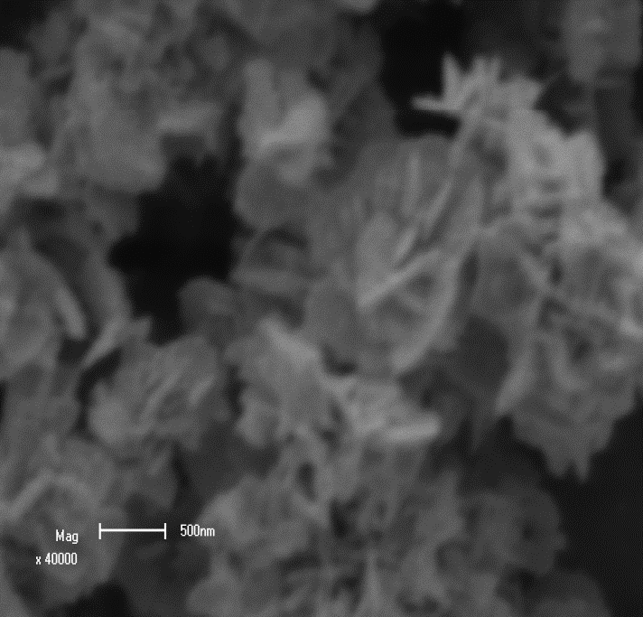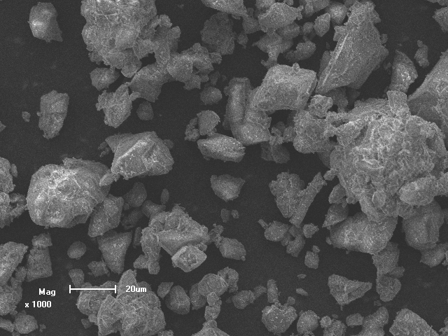
b)
a)

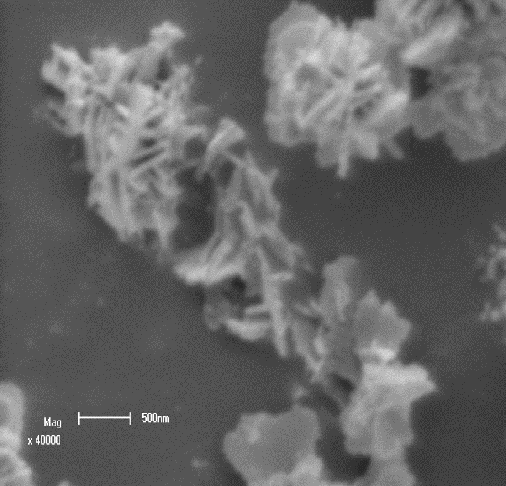
c)

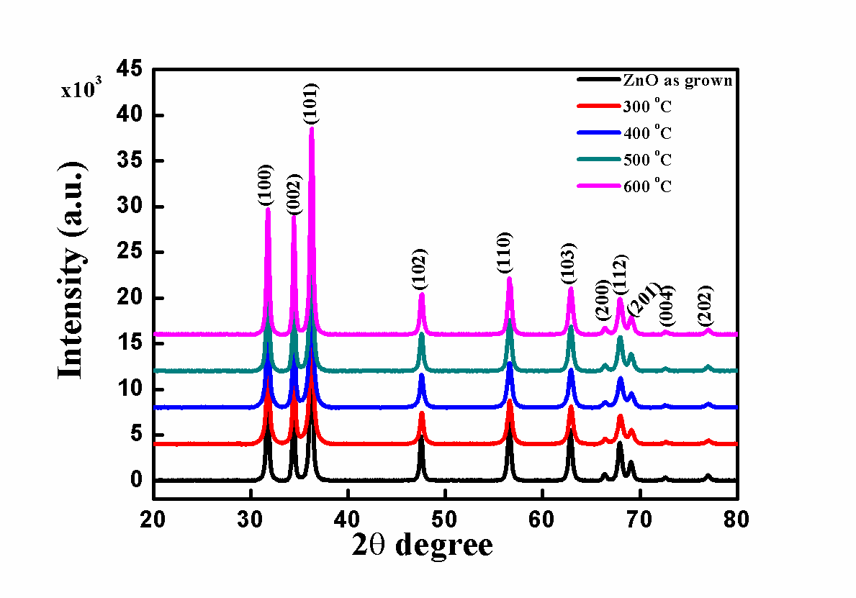 Figure 1: SEM images of ZnO nanoparticles at different temperatures of a) as prepared b) 300 °C and c) 600 °C.

Figure 2: XRD patterns of ZnO prepared at different annealing temperatures: 300, 400, 500 and 600°C.

  - Optical properties
The PL emission spectra of the ZnO nanoflakes at various annealing temperatures (300, 400, 500, 600 °C), shown in figure 3 consist of four emission peaks, these are a strong blue emission at ~423 nm, a blue-green emission at ~486 nm, and a weak green emission at 535 nm. The 423 nm peak can be attributed to the interstitial zinc or oxygen [4]. The weak green emission of the ZnO prepared presumably due to the vacancies or defects that are intrinsic to most synthesis methods, and this emission is a result of capturing of a photo-generated hole by the oxygen vacancy [5]. The presence of oxygen vacancies (V_{o}), zinc vacancies (V_{Zn}) and interstitial zinc (Zn_{i}) have been attributed to corresponding to the green emission of ZnO [6]. The spectra of ZnO annealed at 300, 400, 500 and 600 °C shows a strong emission peak at ~381 nm, it is well known that the UV emission peak (381 nm) originates from the near band-edge emission from the recombination of free excitons [7]. The weak blue-green emissions at 486 nm might be due to surface defects in the ZnO powder as in the case of ZnO nanowires reported by Wang and Gao [8]. An increase on the annealing temperature is known to move the oxygen and zinc atoms from interstitial to lattice sites [9]. The PL intensity reduction was observed in figure 3 and the nanoparticles grain size increase was detected by XRD, as shown in figure 2. The decrease in PL intensity can be attributed to the dependence of the PL spectra on the number and distribution of the defects in the grains which will change with an increase in annealing temperature and size of the nanoparticles.

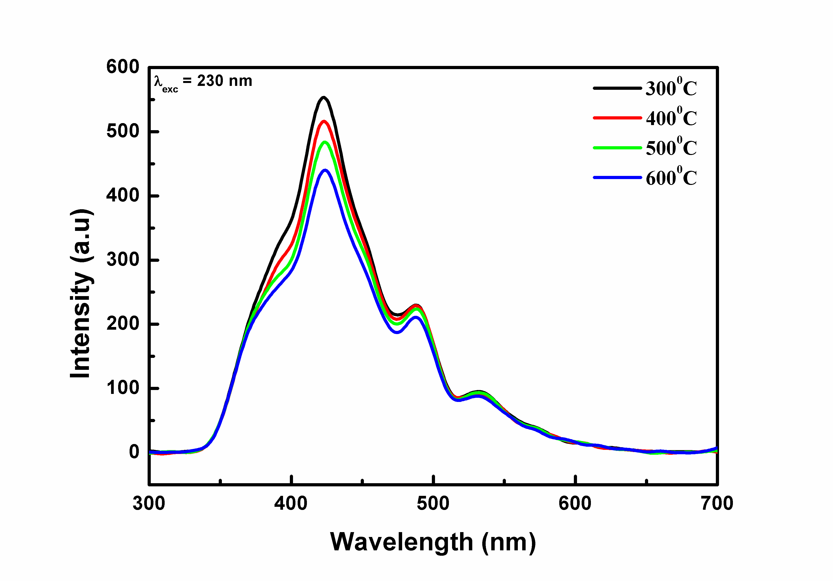
423 nm

381 nm
486 nm

535 nm

Figure 3: PL emission spectra of ZnO prepared annealed at various temperatures.

The UV absorption spectra showed the absorption peak centred at 375 nm at an annealing temperature of 300, 400, 500 and 600 °C (Figure 4). It is known that the bulk ZnO has an absorption band edge at ~3.30 eV in the UV-visible spectrum [10]. The absorption peak intensity at 375 nm decreased with increasing annealing temperature. Figure 4(b) shows the (αhv)² plots (where α is absorption coefficient and hv is the photon energy) as a function of hv. ZnO nanoflakes/flower annealed at 300 °C has an energy of 2.63 eV, annealed at 400 °C has an energy of 2.43 eV, annealed at 500 °C has an energy of 2.23 eV, and annealed at 600 °C has an energy of 2.20 eV. These values are too low to be an indication of the band gap energies but rather an indication of the vacancy/defect energy levels. This is highly speculative at this stage and need more investigation in future. This shows that an increase in the annealing temperature decreased the vacancy energy level. The decrease in the vacancy energy levels of ZnO nanoflakes as annealing temperature increases may be attributed to the defects that are in the ZnO powder. The decrease in the vacancy/defect energy levels when the temperature increased may be explained by the effects of the increase in grain size from the agglomeration of nanoparticles. This shifting of the levels may also be the effect of the lattice thermal expansion which is related to the change of electron energies with the volume. That is, the variation of Eg with temperature may be attributed to a shift in the relative positions of the valance and conduction bands due to the temperature dependence of the dilation of the lattice.

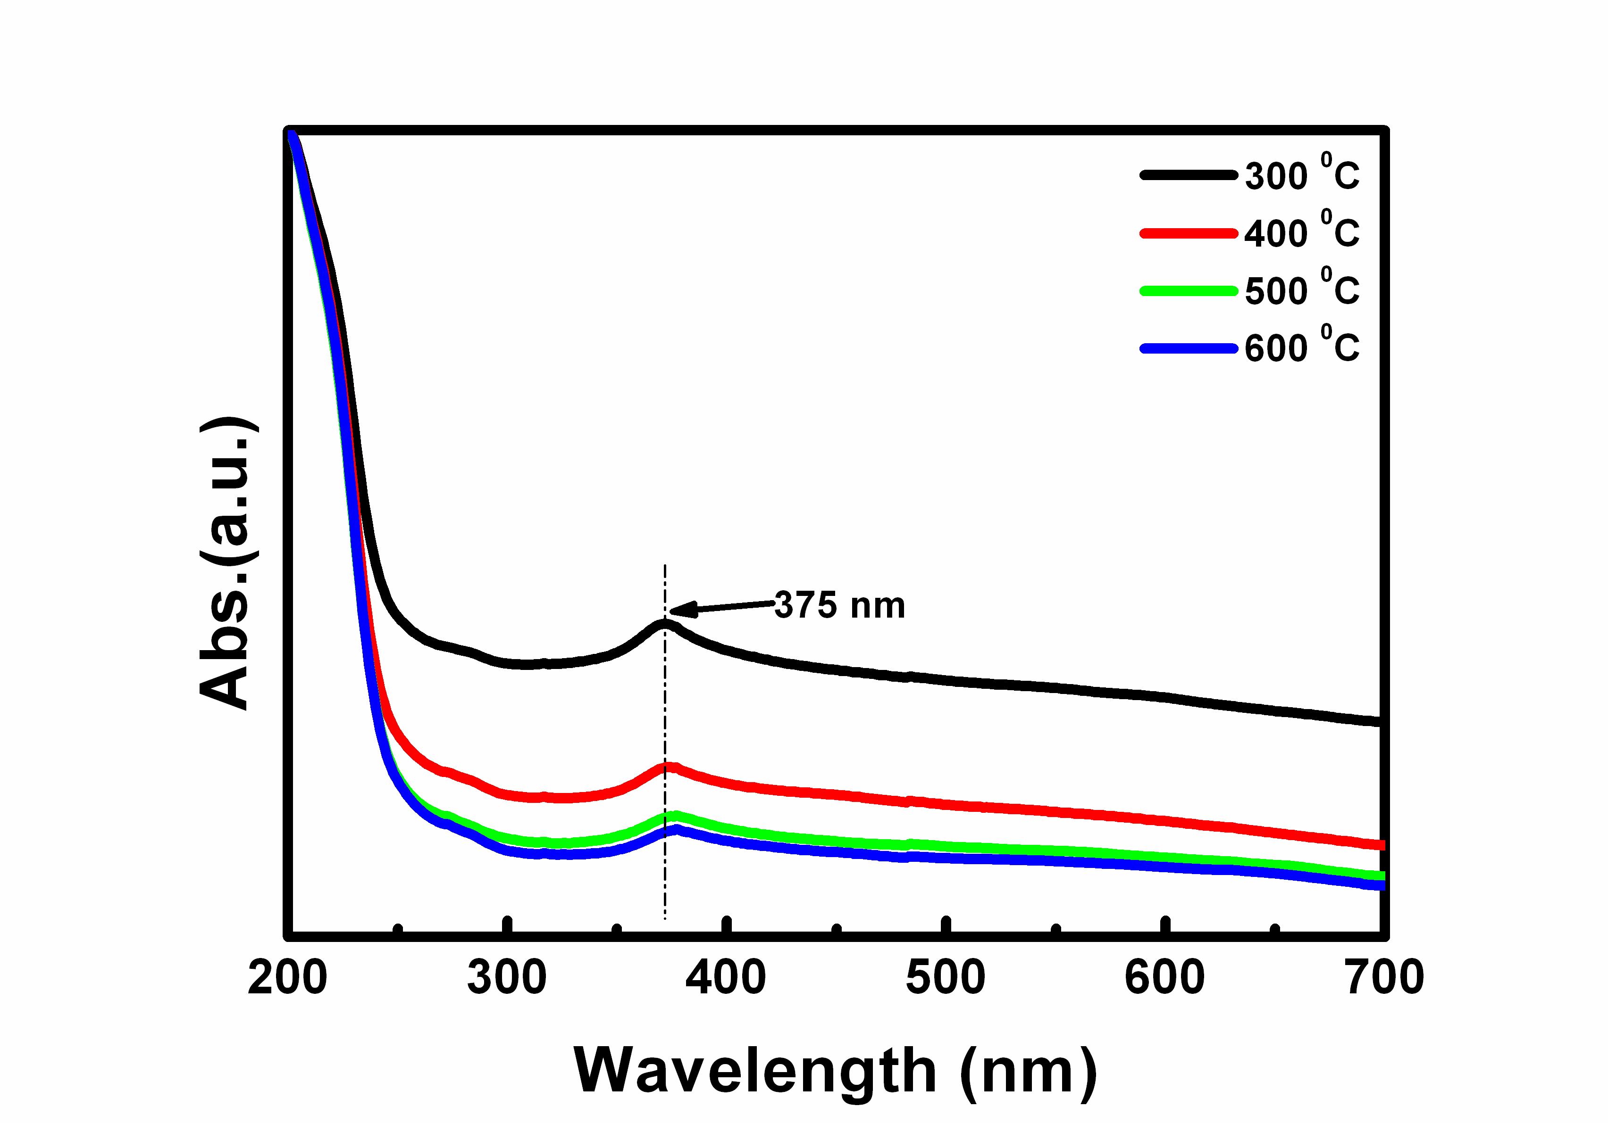
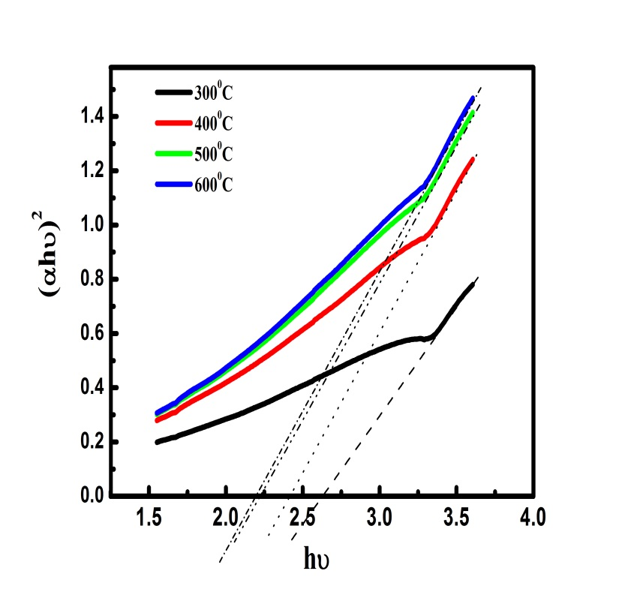
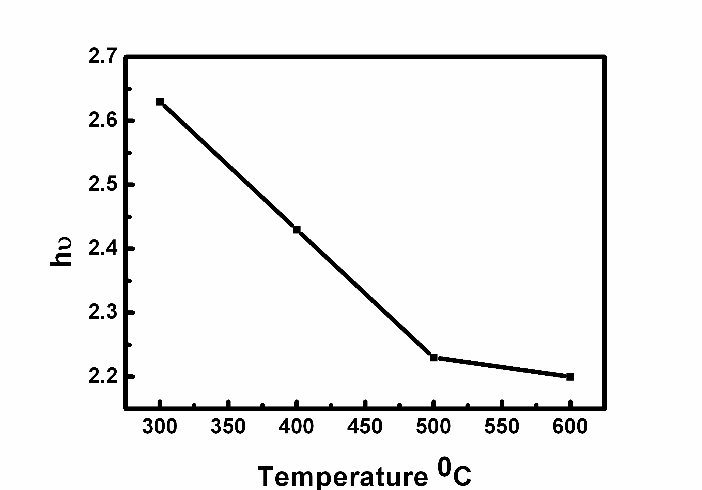

Figure 4: (a) Absorption spectra of ZnO nanoparticles prepared with water annealed at different temperatures (b) Plots of (αhν)² versus photon energy (hv) at different temperatures.

- Conclusion
ZnO nanostructures were successfully prepared using water as a solvent by a sol-gel process. The effects of annealing temperatures on the optical properties were investigated. SEM images showed that agglomerated nanoflakes/flowers of ZnO were synthesized. The photoluminescence emission intensity was influenced by various temperatures. The UV-vis absorption exhibited absorption peaks at 375 nm which was shown to decrease with an increase in annealing temperature. The vacancy energy levels of the ZnO decreased with an increase in the annealing temperatures.

Acknowledgement
The financial support of the National Research Foundation (NRF) and the University of Free State is acknowledged.
Reference
[1] Sun L, Li Y, Miyatake N, Sue H, 2007 J. Sol-Gel Sci Technol 43 237-243
[2] Yousefi R, Kamluddin B, 2012 Solid State Sciences 12 252-256
[3] Hsieh C, 2007 J. Chinese Chem. Soc. 54 31-34
[4] Choi K, Kang T, Oh S G, 2012 Materials Letters 75 240-243
[5] Maensiri S, Masingboon C, Promarak V and Seraphin S, 2007 Opt. Mat, 29 1700-1705
[6] Wang J B, Shuang D, Zhong X L, Yan H L, 2007 Materials Science in Semiconductor Processing 10 97-102
[7] Bu I Y Y, Yan C C, 2012 Superlattices and Microstructures 51745-753
[8] Wang J, Gao L, 2004 Solid State Commun. 132 269-271
[9] Vishwas N, Rao M K, Gowda K V A, Chakradhar R P S, 2010 Spectrochimica Acta Part A 77 330-333
[10] Yiamsawas D, Boonpavanitchakul K, Kangwansupamonkon W, 2009 J. Microscopy Society of Thailand 23 75-78

