Characterisation of a polycrystalline carbonado diamond sample with X-ray diffraction and scanning electron microscopy
TB Moipolai¹, AM Venter², TP Ntsoane², MAG Andreoli³ and SH Connell¹
¹ Department of Physics, University of Johannesburg, Johannesburg, South Africa
² Research and Development Division, Necsa Limited, South Africa
³ Nuclear Liability Management Department, Necsa Limited, South Africa
Corresponding author: Andrew.Venter@necsa.co.za
Abstract. This study is focused on the non-destructive investigation of a carbonado polycrystalline diamond sample in its raw as-discovered form. Investigations comprised elemental analysis using scanning electron microscopy and chemical phase identification and residual stress analysis using X-ray diffraction (XRD). Carbonado has a porous structure and quite a high content of oxygen and nitrogen is observed, however the oxide and nitride phases were not detectable with the XRD. The ratio of the gases is not similar to that at normal atmosphere. The sample structure was determined as cubic diamond. The stress values are inconclusive since a large variation is observed between the different measurement positions.
- Introduction
Diamond, the hardest of the naturally occurring materials, is an allotrope of carbon in which the carbon atoms are arranged in specific lattice symmetries, the cubic one with tetravalent covalent bonds being the one most common in nature. Carbon occurs as a native element in several polymorphs, of which the most familiar are graphite (very soft, hexagonal, black, as anisotropic sheets) and diamond (extremely hard, cubic, various colours, generally translucent). In addition there are the polycrystalline fine-grained aggregates discussed here (carbonado and related forms), and other rare polymorphs [1]. Our research interest is in the characterization of the residual stresses locked in polycrystalline diamonds from different sources as a tool to constrain their still very controversial origin [2, 3].
The typical, primary requirements for natural diamond formation are combinations of high pressures (HP) and high temperatures (HT). Possible mechanisms of formation are [4]:
- Igneous crystallisation from C-rich kimberlite melts in the mantle [HT-HP].
- Solid state conversion from graphite as a result of subduction of oceanic/continental
crust to mantle depth [HP-HT].
- Shock-metamorphism in meteorite impact processes [Ultra HT-PT].
- Presolar.
Examples of the first three mechanisms have been extensively researched, whilst the nature of the pre-solar mechanism is still much debated. The samples of our investigation, carbonados, generally are a few mm to cm size pebbles from soils/sediments, contain inclusions of foreign phases and may have been formed from any of the above mechanisms [5]. Commonly known as the "Black Diamond", carbonado is a natural polycrystalline diamond found in alluvial deposits in the Central African Republic and Brazil [6]. It is a porous aggregate of micron-sized diamond crystals. Its natural colour is black or dark grey, and it is more porous than other diamonds. It does not seem to occur with normal diamonds in kimberlite pipes, suggesting a very different mode of origin. It is postulated that the hexagonal form of diamond, called lonsdaleite, would result purely from the latter two mechanisms mentioned above [7].
We report results from non-destructive investigations on a carbonado sample originating from Brazil.
- Experimental
Since the sample is of significant scientific value, no surface preparation, apart from surface cleaning with compressed air, has been performed to remove loose deposits. Characterisation investigations have been performed with laboratory X-rays for chemical phase identification and residual stress analysis, supplemented by scanning electron microscopy (SEM) in secondary electron (SE) and backscattered electron (BSE) imaging and energy dispersive X-ray spectroscopy (EDS) have been performed for imaging of features and for elemental identification to aid in the diffraction characterization. All the investigations have been done at the Necsa facilities of the Research and Development Division.

2.1. Sample
A photograph of the carbonado sample is shown in figure 1. The sample has a distinctive irregular pebble (stone) shape of approximate dimension 13.5 x 10 x 3.5 mm³, characteristically black in colour with clear crevices and porosity visible with the naked eye. Since an essential requirement for residual stress analysis by XRD is that the surface needs to be flat to at least 20% of the penetration depth of the X-rays, four positions were selected on the sample surface that offered as-flat-as-possible surfaces for the investigations.
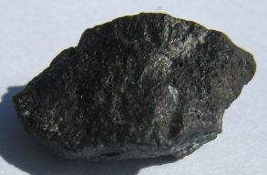

2

1

4

3

Figure 1: Photograph of the carbonado sample of this study. Investigation were performed at the 4 positions indicated which were selected to be representative of as-flat-as-possible positions on the sample surface. The irregular topography of the sample is clearly evident. Note the bubble-like void appearance covering the entire surface.

2.2 Investigations
XRD investigations were done with a Bruker D8 Discover instrument that is equipped with a 1\4 eulerian cradle goniometer stage, highly collimated Cu and Co radiations, incident beam size 0.8 mm in diameter, and an area detector system. In conjunction with the laser video alignment system on the instrument, picking of measurement positions and aligning to the instrument rotation axis was possible to within 20 μm accuracy. The beam penetration depths into diamond for Cu and Co radiation were calculated to be 240 μm and 177μm respectively. Chemical phase identification was done with respect to the International Centre for Diffraction Database(ICDD) search / match function and residual stress investigations were performed using the sin²ψ technique in side-inclination mode at rotation angles Ø = 0°, 90°, 45°,180°, 225°,270° and ψ ranging from 0° to 70° in steps of 10°. Data analysis for residual stress was done using the software package Leptos v6.The SEM investigations were done with a Quanta FEI 200 SEM/EDS instrument equipped with a silicon drift detector. The instrument parameters employed were 30 kV voltage, 0.67 nA current, working distance WD =15.00 mm and magnification 500X.
For the XRD investigations the sample was constrained in a make shift sample holder to ensure repeatable sample setup. For the SEM analyses the sample was taped to the sample stage with carbon tape to limit charging. All investigations were done at low vacuum of 0.45 Torr.

2.3 Residual stress analysis

Residual stress is the stress that remains in the material after the external force that caused the stress has been removed. Stress is defined as force per unit area. Positive values indicate tensile (expansion) stress, negative values indicate a compressive (contraction) state. The deformation per unit length is called strain [8]. The residual stress can be introduced by any mechanical, chemical or thermal process.
The X-ray diffraction method measures macroscopic strains using interplanar spacings. Residual stress investigations were done with the $\sin^{2}ψ$ side-inclination technique, shown in figure 2 that involves the measurement of the lattice plane spacings of a specific (hkl) reflection at different tilt angles ψ (inclination angles). The residual stress for a bi-axial (in-plane) condition (normally assumed with XRD due to the limited penetration depth) is deduced through the equation
$$ε_{Ø}=\frac{d_{ψ}-d_{0}}{d_{0}}=\frac{1+v}{E}\left(σ_{Ø}\sin^{2}ψ\right)-\frac{v}{E}(σ_{11}+σ_{22})$$
where E and ν are the Young’s modulus and Poisson’s ratio of the material under study, $d_{ψ}$ is the lattice spacing at each ψ, and is the value of d at ψ=0º, σ₁₁ and σ₂₂ are the in-plane principal stresses and σ₃₃ the normal. This equation gives a linear dependence of graphs of versus $\sin^{2}ψ$ with determined from the gradient of the curve as a least squares fit to the different tilt angles whilst σ₁₁+σ₂₂ are determined from the intercept. For the normal stress to be resolved, measurement needs to be performed at least 3 (azimuthal) phi rotations.
Figure 2: XRD residual stress measurement geometry [9].

- Results
Figure 3 shows SEM SE images of the sample taken at each of the measurement positions. The porosity of the sample with distinctive crevices is clearly evident, giving it a spongy appearance. The carbonado surface is quite complex: the dark areas in the SE image are carbon (does not yield electrons of sufficient energy to be detected by this equipment). Paler regions are indicative of the presence of heavier elements. It is known from the literature that minerals from the environment where the carbonado samples have been discovered and gases such as N₂ and O₂ can be entrapped in the pores. For the carbonado sample of our study, the pore sizes are estimated to be 40 - 100 μm with no visible partially closed cavities within which foreign material could be entrapped.

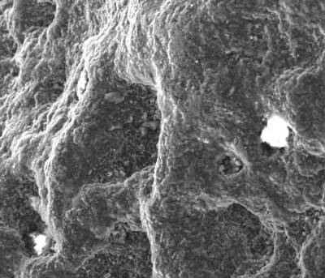
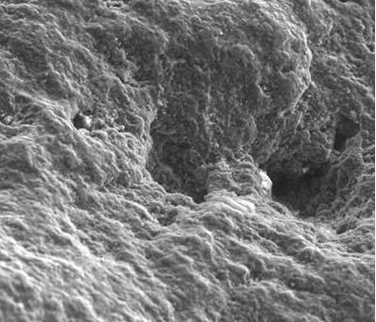
2
1

100 μm

100 μm

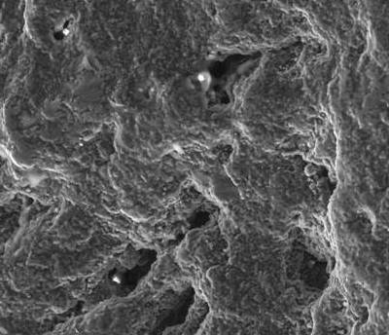
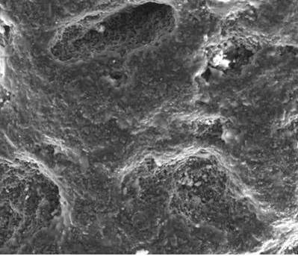
4
3

100 μm
100 μm

- (b)
Figure 3: Secondary electron images for the carbonado sample at the four positions of interest.
Results from the SEM and XRD analyses are summarized in figure 4.

The experimental results obtained at the four positions are summarized in table1.These results were extracted from figures 4 and 5.The stress analysis excluded the data points at sin²ψ=0.9 since these values were inconsistent with a linear trend. As a control a flat surface PCD also measured and the trend shown as reference. The EDS results with indicate as major element carbon, nitrogen and oxygen, with minor elements of aluminium, silicon and calcium. The XRD patterns primarily show diamond in the cubic structure with the unidentified small peak at position 4.

Table 1: Summary of experimental results taken at the four positions of this study
Measurement position | Elemental content (EDS) |  | Chemical phase content (XRD) | Stress σ₁  [MPa] | Stress σ₂  [MPa] | Stress σ₃  [MPa]
 | Major | Minor
1 | C (56%)  O (21%)  N (12%) | Si (1.5%)  Al (1.1%)  Mg (0.9%) | Diamond: Cubic | 239.3± 77 | 133.2± 84 | -61.7±53
2 | C (67%)  O (16%)  N (14%) | Si (1.2%)  Al (0.7%)  Cu (0.7%) | Diamond: Cubic | -637.9± 71 | -98.3± 70 | 59.8± 63
3 | C (67%)  O (16%)  N (14%) | Si (1.3%)  Al (0.8%) | Diamond: Cubic | -442.3± 63 | 268.3± 68 | -70.7±89
4 | C (68%)  O (16%)  N (13%) | Si (1.6%)  Al (1.2%) | Diamond: Cubic | -492.5± 82 | 217.7± 83 | -10.2±41.69
PCD | - | - | Diamond :Cubic | -835.5± 78 | -502.1± 78 | 7.2±77

Notwithstanding the literature reports of entrapments and speculation on the possible presence of the hexagonal phase of diamond, lonsdaleite, and amorphous carbon, our results do not indicate the presence of any of these. Presence of amorphous phases would manifest as a broad increase in the background of diffraction patterns at angles below 40º 2θ.The carbon versus oxygen ratio’s observed in this investigation do not correlate with the one that exists at normal atmospheric conditions. This in conjunction with the sample being under a partial vacuum during the SEM analyses indicates that these gases may be present in an entrapped form.
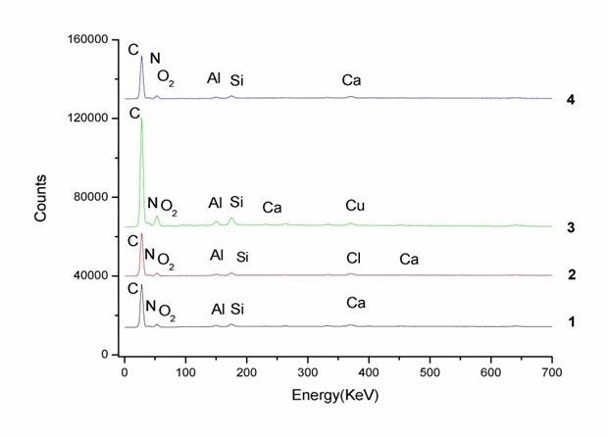
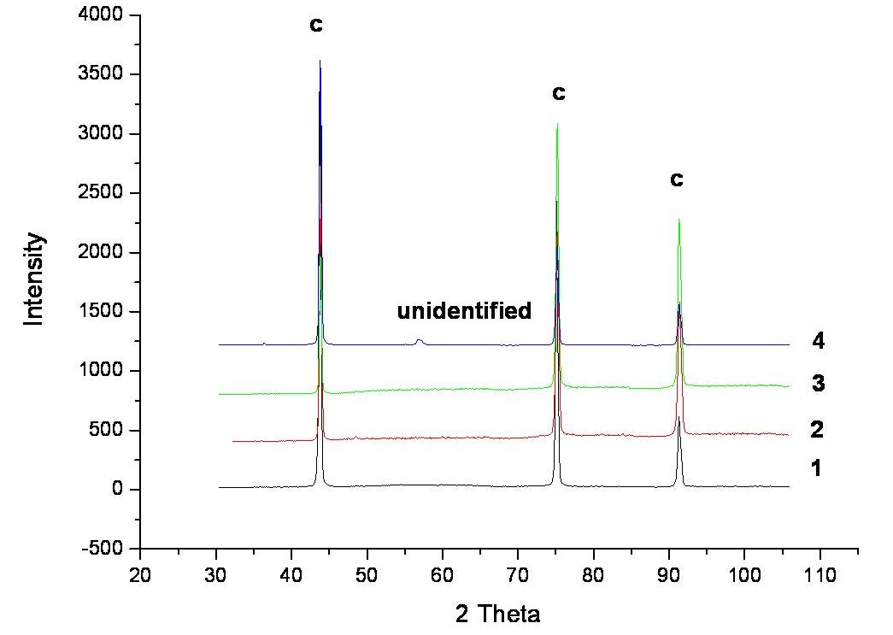
(a) (b)
Figure 4: Analyses results at the four positions of interest on the carbonado sample: (a) Elemental composition determined with the EDS function of the SEM unit; (b) Chemical phase identification using XRD.

The residual stress values vary significantly between the four positions investigated. The variation is ascribed to the irregular sample surface where the surface roughness may lead to partial screening of the incident and diffracted beam paths causing anomalous absorption of the beam, with the resulting peak fitting of the altered beam width leading to artefacts (beam centre).

To get an estimate of the surface roughness influence on the residual stress values, a control experiment was done by performing repeat measurements at the same position on the sample, position 4, for the carbonado sample, for various φ rotations of the sample around the scattering vector. For the bi-axial stress approximation the stress values needs to be similar. As an extension of the control measurement, a polycrystalline diamond (PCD) compact sample was used which has a smooth surface as if it was polished, important. Results for the two control experiments are indicated in figure 6. Analysis of the smoother PCD surface does give a smaller overall scatter of the results as would be expected. The overall variation of the results for the carbonado sample is indicative of the variation in the residual stress values of table 1.
(a) (b)
Figure 5. Strain versus sin²ψ curves (a) Carbonado sample; (b) PCD compact sample as control. The large variation of these curves at 0.9 is anomalous and ascribed to the sample roughness. Only values up to 0.7 were used for the determination of the gradients and thus the stress values.

(a) (b)
Figure 6: Residual stress variation from repeat measurements at the same position on sample surface as a function of sample rotation around the scattering vector: (a) Carbonado sample (b) PCD compact sample as control.

Conclusion
Notwithstanding the irregular sample shape and severe surface roughness of the carbonados sample, an estimate of the surface residual stress was performed by careful selection of the site of measurement. Both tensile and compressive surface stress is observed. Impurities, surface chemistry and growth conditions typically result in different surface stresses. Further work will attempt to use these results to comment on the formation mechanism. The SEM results indicated the presence of quite large O and N contents (N is trapped in as a lattice impurity and O as a termination species), but these are not observed as chemical phases in the XRD analyses. The residual stress results are inconclusive owing to the severe surface roughness. Measurements will be expanded to the study of a polished Carbonado sample. No presence of the hexagonal lonsdaleite, or amorphous carbon was observed.
Acknowledgements
Access and personnel assistance with the XRD and SEM instruments of Necsa Limited, with special thanks to Mr R van der Merwe and Ms J Kabini, who assisted with the SEM analyses, as well as financial support from the NRF Internship and SANHARP student support programs are acknowledged. Prof F Viljoen, UJ Geology department is specifically thanked for providing the Carbonado sample.

References
[1] Diamond Deposits, Eds. EI Erlich and WD Hausel, Society for Mining, Metallurgy and Exploration, Inc. USA (2002) ISBN 0-87335-213-0
[2] Y.A Litvin 2009 Russian Geology and geophysics 50 1188-1200
[3] K Shibata, H Kamioka 1993 Mineralogical Magazine 57 607-611
[4] G Kletetschka, PT Taylor, PJ Wasilewski, H.G.M. Hill 2000 Earth and Planetary Science Letters 181 279-290
[5] M Ozima, S Zashu, K Tomura, Y Matsuhisa 1991 Nature 351 472-474
[6] JV Smith, JB Dawson 1985 Geology 13 5 342-343
[7] S De, PJ Hearnay, EP Vincenzi, J Wang 2001 Earth and Planetary Science Letters 185 315
[8] Fundamentals of solid mechanics, Ed. ML Gambhir, PHI Learning Private Limited, New Delhi (2009) ISBN 978-81-203-3870-8
[9] Handbook of measurement of residual stress, Ed. J Lu, The Fairmont Press Inc. USA (1996) ISBN 0 88173-229-X, Chapter 5 pp71 – 131.

